Weekly Home Connections
Quarter 4, Week 1
This Week’s Focus Concepts:
Letters | Sight Words | Color | Shape | Number
Oo, Nn, Pp  Rr, Ss | will  up  out | blue | cone | four (4)
Our Current Study is:
Buildings

Monday
- Practice writing your first and last name. Circle any of this week’s letters you see.
- What is your favorite color? Search for at least four things this color. What did you find?
- Practice counting out objects to make sets of eleven to fifteen.
- Read a book with your child. What buildings did you see in the story?
Tuesday
- Practice saying the sound(s) of each letter of the alphabet.
- What buildings do you see in your community? Draw and write about i!
- Practice counting to 50. Go further if you can!
- Recite this week’s nursery rhyme (found below).
Wednesday
- Practice writing your first and last name. Circle any of this week’s letters you see.
- How many ways can you make the number four?
- Put these letters together: p i n What word does this spell?
- Read a book with your child. Let your child help you read.
Thursday
- Practice saying the sound(s) of each letter of the alphabet.
- What did you learn about buildings? Draw and write about it!
- Practice counting to 50. Go further if you can!
- Recite this week’s nursery rhyme (found below).

This Week’s Nursery Rhyme
“Mary, Mary, Quite Contrary
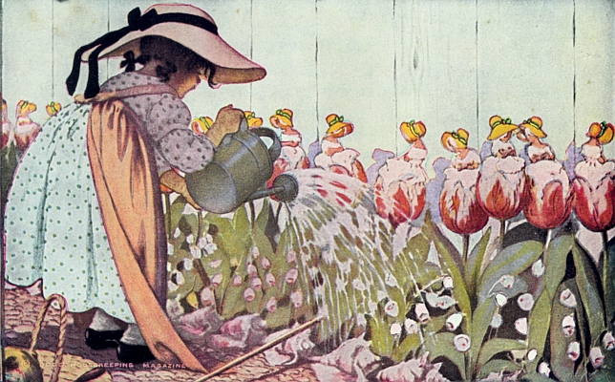

Mary, Mary, quite contrary,
How does your garden grow?
With silver bells and cockleshells,
And pretty maids all in a row.
And pretty maids all in a row.

