Weekly Home Connections
Quarter 1, Week 2
This Week’s Focus Concepts:
Letters | Sight Words | Color | Shape | Number
Aa, Bb, Ff,  Dd, Gg | Is  my  red | red | triangle | one (1)
Our Current Study is:
The First Six Weeks

Monday
- Talk about a time when you felt sad. What made you feel better?
- Practice saying your first and last name-“My name is ___.”
- Practice counting from 1 to 10. Go further if you can!
- Read a book with your child. Ask your child questions as you read together.
Tuesday
- Talk about a time when you felt scared. What scared you?
- Look around your home for triangles-what did you find?
- Practice saying (not singing!) the letters of the alphabet.
- Recite this week’s nursery rhyme (found below).
Wednesday
- Draw a picture of things that make you happy.
- Practice saying your first and last name-“My name is ___.”
- Practice counting from 1 to 10. Go further if you can!
- Read a book with your child. Ask your child questions as you read together.
Thursday
- What can you find in your home that is red? How many red things can you find?
- What is something you learned at school this week? Draw and write about it!
- Practice saying (not singing!) the letters of the alphabet.
- Recite this week’s nursery rhyme (found below).

This Week’s Nursery Rhyme
“The Itsy, Bitsy Spider”
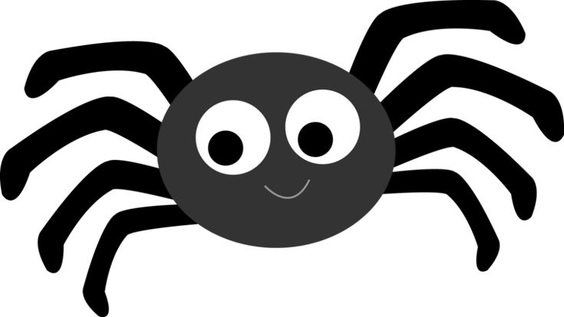
The itsy, bitsy spider
Went up the water spout.
Down came the rain
And washed the spider out!
Out came the sun
And dried up all the rain.
And the itsy bitsy spider
Climbed up the spout again.

