Weekly Home Connections
Quarter 2, Week 5
This Week’s Focus Concepts:
Letters | Sight Words | Color | Shape | Number
Ee, Hh, Jj  Ll, Mm | was  for | red | cube | one (1)
Our Current Study is:
Trees

Monday
No school today.
Happy Veteran’s Day!
Tuesday
- Practice saying each letter and its sound.
- What sound do you hear at the end of these words? sun, bed, rug, pin
- Help your child write their first and last name.
- Recite this week’s nursery rhyme (found below).
Wednesday
- Can you find anything in your home shaped like a cube?
- Go on a walk-how many different colors of leaves can you find?
- Practice counting from 1 to 20. Go further if you can!
- Read a book with your child. Who are the characters in the story?
Thursday
- Practice saying each letter and its sound.
- What does a tree look like during fall? Draw and write about it!
- Practice saying your address.
- Recite this week’s nursery rhyme (found below).

This Week’s Nursery Rhyme
“Old MacDonald Had a Farm”
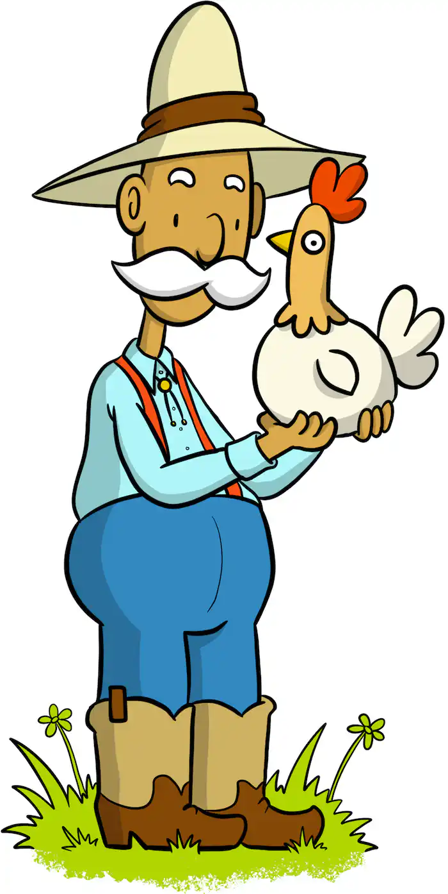

Old MacDonald had a farm,
E-I-E-I-O.
And on his farm, he had some cows,
E-I-E-I-O.
With a moo-moo here and a moo-moo there,
Here a moo, there a moo,
Everywhere a moo-moo,
Old MacDonald had a farm, E-I-E-I-O.

(repeat with other animals)

