Weekly Home Connections
Quarter 4, Week 8
This Week’s Focus Concepts:
Letters | Sight Words | Color | Shape | Number
Ee, Hh, Jj  Ll, Mm | time  has  look | pink | square  hexagon | ten (10)
Our Current Study is:
Water

Monday
- Practice writing your first and last name. What other words can you write?
- Play a game of “I Spy.”
- What was your favorite story or song in Pre-K? Draw and write about it!
- Read a book with your child. Ask him/her to retell the story!
Tuesday
- Practice naming each letter and its sound(s) as fast as you can.
- Practice writing your numbers from one to twenty.
- How high can you count all by yourself?
- Recite this week’s nursery rhyme (found below).
Wednesday
- Practice writing your first and last name. What other words can you write?
- How many ways can you make the number seven?
- Can you write your own sentence using sight words?
- Read a book with your child. Ask him/her to retell the story!
Thursday
- Practice naming each letter and its sound(s) as fast as you can.
- How does water change? Draw and write about it!
- How high can you count all by yourself?
- Recite this week’s nursery rhyme (found below).

This Week’s Nursery Rhyme
“Five Little Ducks”

Five little ducks went out one day,
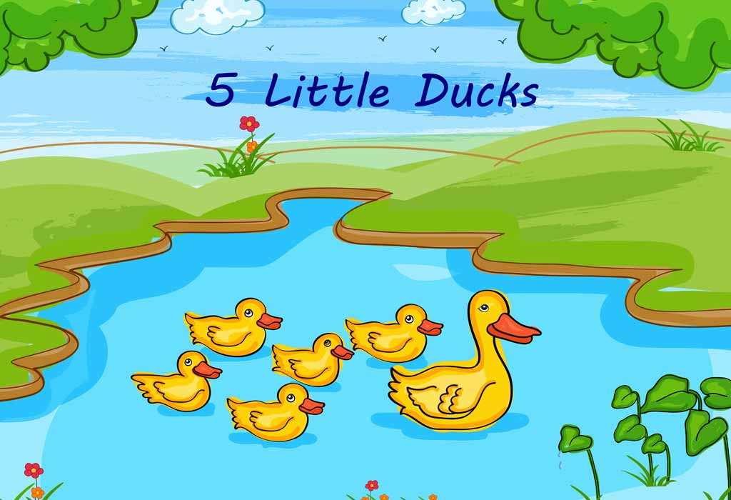
Over the hill and far away.
Mother duck said, “Quack, quack, quack, quack.”
But only four little ducks came back.

(Repeat with 4, then, 3, then 2 ducks.)

One little duck went out one day,
Over the hill and far away.
Mother duck said, “Quack, quack, quack, quack.”
But none of the five little ducks came back.

Sad mother duck went out one day,
Over the hill and far away.
Mother duck said, “Quack, quack, quack, quack.”
And all five little ducks came back.

