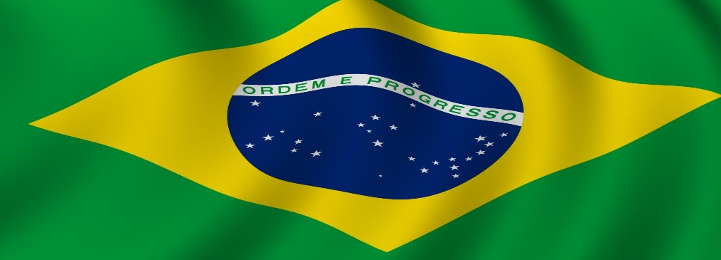

**Brazil**

Brazil is a country located in South America and its capital is Brasilia. The major language spoken in Brazil is Portuguese. It is the fifth largest country in the world, exceeded in size only by, Russia, Canada, China, and the United States. Brazil is the fifth most-populous country on Earth and accounts for one-third of Latin America’s population. It is home to large sporting events, shopping, history, famous beaches, and entertainment.

**History**

Brazil was founded on April 22, 1500.  New evidence shows there were people living there at least 32,000 years ago. When Europeans first reached Brazil's coast, it was home to about 30 million Amerindians. In 1822, son of Portuguese King declares independence from Portugal and crowns himself Peter I, Emperor of Brazil. Brazil has ten neighboring counties. The last war fought was against Paraguay in 1864 to 1870. In World War II, Brazil had 25,000 men help the U.S. Fifth Army and was sent to Italy. They helped defeat Hitler.

**Geography**

Brazil contains most of the Amazon River basin, which has the world’s largest river system and the world’s most-extensive virgin rainforest. The country contains no desert, high-mountains, or arctic environments. Rio de Janeiro, in the eyes of many of the world, continues to be the distinguished icon of Brazil. The nation’s increasing cities, industrial complexes, mines, and fertile farmlands make it one of the world’s major economies. Christ the Redeemer is one of the most remarkable Brazil landmarks, which also happens to be the biggest and most famous Art Deco statue in the world.

**Culture**

Approximately 80% of the population ascribes to the Roman Catholic faith. This is due to the intense Portuguese occupation of centuries ago. These European settlers taught the indigenous tribes Catholicism, built churches, and established traditions and customs that originated in this church. The government of Brazil is considered a federal representative democratic republic under a presidential system. Under this system, the President is both the Head of State and the Head of Government. Brazilians wear clothing that is comfortable yet richly colored and sophisticated. However, there are some preferred clothing types depending on region. Some holidays/traditions in Brazil are November 2, AllSouls day, where Brazilians go to the cemeteries and visit their deceased loved ones. They usually take flowers and candles. October 12th is a national holiday in Brazil called Children’s Day where kids receive presents from their parents and close relatives.

**Economy**

The Brazilian Real is the currency of the money. The plural form of the modern real is “reais’’ and its sign is “R$.’’ Brazil's largest economic sectors are agriculture, mining, and manufacturing. Due to an abundance of natural resources (in large part due to the Amazon Rain Forest), the economy of Brazil is one of the strongest in South America.

**Climate**

Most parts of Brazil have moderate annual rainfall of between 900 and 1600 mm (38 and 61 in). The Brazilian winter lasts for only three months from June to August. From December to February, it is summer and most rain is seen in these months. Weather can have a strong impact on people who often live without electricity and running water and may even be homeless. Many homes do not have electricity, which can be a greater problem in the winter when it gets colder. People do not always have adequate clothing and often get sick. The problem only worsens with a lack of food.

**Interesting Facts**

1. The country’s name comes from a native plant called the Brazilwood tree.
2. Brazil has the largest biodiversity in the world and is home to around 3000 freshwater fishes, 70,000 insects, and 55,000 different plants.
3. Due to floods and landslides, **916 people died in a hilly region of Rio de Janeiro in January 2011** and 345 people were missing. It was one of the biggest catastrophes in the history of the country.
4. There are **more species of monkeys in Brazil than in any other nation.**