Weekly Home Connections
Quarter 3, Week 9
This Week’s Focus Concepts:
Letters | Sight Words | Color | Shape | Number
Oo, Nn, Pp  Rr, Ss | an  each  do | orange | sphere | three (3)
Our Current Study is:
Buildings

Monday
- Practice writing your first and last name. Circle any of this week’s letters you see.
- Practice saying, “My phone number is _____.”
- Make a set of two objects. Now make a set of three objects. Which has more?
- Read a book with your child. What buildings do you see in the story?
Tuesday
- Practice saying the sound(s) of each letter of the alphabet.
- Who builds buildings? Draw and write about it!
- Practice counting to 50. Go further if you can!
- Recite this week’s nursery rhyme (found below).
Wednesday
- Practice writing your first and last name. Circle any of this week’s letters you see.
- Practice saying, “My phone number is _____.”
- Put these letters together: c a p What word does this spell?
- Read a book with your child. What buildings do you see in the story?
Thursday
- Practice saying the sound(s) of each letter of the alphabet.
- What is your home made of? Draw and write about it!
- Practice counting to 50. Go further if you can!
- Recite this week’s nursery rhyme (found below).

This Week’s Nursery Rhyme
“Five Little Monkeys”
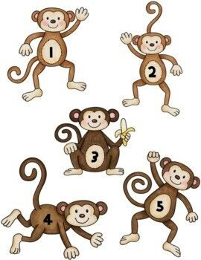

Five little monkeys jumping on the bed.
One fell off and bumped his head.
Mama called the doctor and the doctor said,
“No more monkeys jumping on the bed!”
(Repeat with 4, then 3, then 2 monkeys.)

One little monkey jumping on the bed.
One jumped off and bumped his head.
Mama called the doctor and the doctor said,
“Put those monkeys right to bed!”

