Weekly Home Connections
Quarter 2, Week 8
This Week’s Focus Concepts:
Letters | Sight Words | Color | Shape | Number
Oo, Nn, Pp  Rr, Ss | his  this  from | yellow | triangle | four (4)
Our Current Study is:
Clothes

Monday
- Practice writing your first and last name.
- Can you create a pattern? Use yellow and another color to create your pattern.
- What colors are the clothes you are wearing now?
- Read a book with your child. Let your child help read and tell the story.
Tuesday
- Practice saying each letter and its sound.
- What sound do you hear in the middle of these words? cub, hat, rod, ten, pig
- Practice saying your address.
- Recite this week’s nursery rhyme (found below).
Wednesday
- Practice writing your first and last name.
- Make two sets of objects. Which one has more? Which one has less?
- Practice counting from 1 to 20. Go further if you can!
- Read a book with your child. Let your child help read and tell the story.
Thursday
- Practice saying each letter and its sound.
- What is your favorite clothing that you have? Draw and write about it!
- Practice saying your address.
- Recite this week’s nursery rhyme (found below).

This Week’s Nursery Rhyme
“Baa, Baa, Black Sheep”
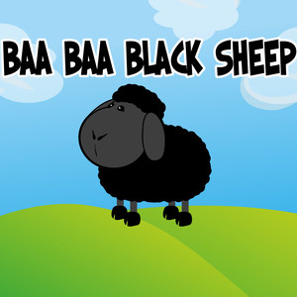

Baa, baa black sheep,
Have you any wool?
Yes sir, yes sir,
Three bags full.
One for the master,
And one for the dame.
And one for the little boy who lives down the lane.
Baa, baa, black sheep,
Have you any wool?
Yes sir, yes sir,
Three bags full.

