Classroom Label Template

Use this template to create labels for your classroom materials. Each label in this template includes a photo of the object (rather than a clip art image), the name of the object in English, and the name of the object in Spanish (use Google Translate to get this information). On the template, you will see one label copied 4 times. A best practice is to label most items in your classroom 4 times: 1 label on the front of the bin/container, 1 label on the back of the bin/container, 1 label on the inside bottom of the container, and 1 label on the spot on the shelf where the bin is stored. This method is illustrated in the Model Classroom. You are welcome to copy, paste, and edit this template to meet your classroom needs.

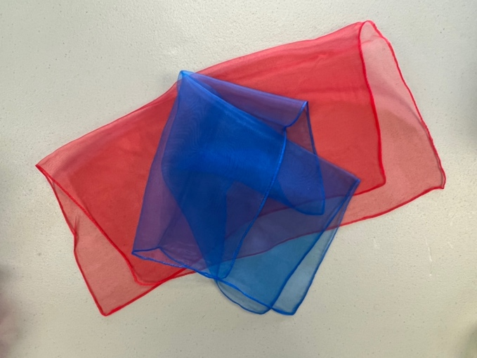  Scarves  bufandas | Scarves  Bufandas
Scarves  bufandas | Scarves  bufandas

