Colombia Sports

Colombia has many sports including football, cycling and roller skating. Those are the three most popular sports in Colombia. Football was associated to the FIFA since 1936. The Colombia national team joined in a FIFA World Cup in 1962, tracked by others in 1990, 1994, 1998 and 2014. Its best performance was in 2014, when the team reached the quarter-finals and James Rodríguez became top player of the tournament. James Rodríguez is a Colombian expert footballer for Spanish club Real Madrid and captains the Colombia national team as an attacking midfielder or winger. Cycling in Colombia became very common, after the triumphs of Martín Emilio "Cochise" Rodríguez in European cycling races, which in turn helped to grow the Colombian Cycling Federation. The nickname "Cochise" is resulting from the fact that he was a great lover of the Apache main Cochise.

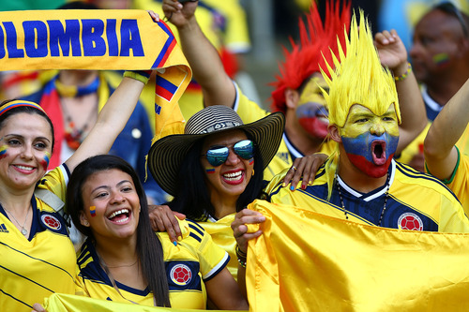

Cycling in Colombia

Cycling in Colombia became popular after the victories of Martin Emilio “Cochise” Rodriquez in cycling races. After, which turn helped to grow the Colombian Cycling Federation. Martin was trailed by professional Colombian cyclists known as the Colombian beetles. The Colombian beetles include; Luis Lucho Herrera, Luis Felipe Laverde, Fabio Parra, Víctor Hugo Peña, Santiago Botero, Mauricio Soler and Nairo Quintana. Colombian cycling has loved a regeneration in the early 2010s, with Colombian riders liking international victory. The Colombian Coldeportes team competed at the 2013 and was the first all Colombian team to do so for 21 years. The two strongholds of the sport in Colombia are the Altiplano Cundiboyacense in the center of the country and Antioquia in the west. The team extends throughout the city with bicycles using increasing almost 5 times in the city. There’s an estimated 300,000 to 400,000 trips made every day in Bogota by bicycle.

Colombia’s Cycling Champions

* María Luisa Calle won bronze medal winner in the 2004 Summer Olympics in Athens and World Champion.
* Fabio Parra won 3rd place in the tour de France, 1988.
* Martín Emilio "Cochise" Rodríguez won hour world record holder and world champion in 4,000 m pursuit.
* Marlon Pérez won the Youth World Champion in the points race in 1994.
* Víctor Hugo Peña was the only Colombian cyclist to wear the yellow jersey in the Tour de France, 2003.
* Rigoberto Urán, silver medal winner in the Men's Olympic Road Race, 2012 Summer Olympics, second place in the Giro d'Italia 2013, 2014.
* Mariana Pajón, gold medal winner at the 2012 Summer Olympics in the women's BMX event, gold medal winner at the 2016 Summer Olympics in the women's BMX event.

Boxing in Colombia

Boxing in Colombia is practiced in Caribbean region and the Pacific region. Boxing was also introduced by Europeans in the 19th century but became popular in the 20th century. Antonio Cervantes became a two-time world Jr. Welterweight champion in the 1960s. He was followed boxers like Cardona, Rodrigo, and Bassa. They created a large fan base so many people started to try the sport. They also created a National Boxing Commission of Colombia to practice boxing in Colombia. In the 1990s, Irene Pacheco became a world champion in the Flyweight category. In the 2000s, Fulgencio Zuniga became a Super middleweight champion.

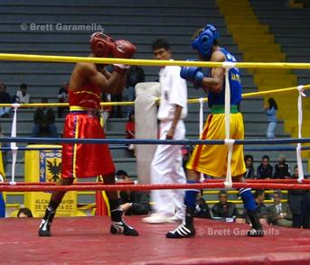

Colombia’s Boxing Champions

* Tomas Molinares won World Boxing champion, welter jr division 1988
* Prudencio Cardona, World Boxing champion, light division 1982
* Ricardo cardona, World Boxing champion
* Elvis Álvarez, World Boxing champion, light division 1989-1990 1991
* Irene Pacheco, World Boxing champion FIB, fly division 1999
* Kermin Guardia, World Boxing champion OMB, minimum division
* Beibis Mendoza, World Boxing champion AMB, minifly division
* Camilo el "Bambino" García, World Boxing champion FIB, fly division 1992
* Daniel Reyes, World Boxing champion FIB, minimum division
* Rodrigo Valdéz WBC Middleweight Champion, Undisputed World Middleweight Champion

Roller Skating in Colombia

Inline skates were made in Colombia during the 1990s and roller skating grew widely in most of the main cities in the country. Such as Cartagena, Cali, Bogota, Pasto, Barrancabermeja, Barranquilla, Medellin, and Valledupar. Colombia is a hub for roller skaters. The team has a powerhouse at the World Roller Speed Skating Championships and they have won the overall title nine times in 12 years. Colombia brings out the technology in this sport. Cecilia Baena is female inline speed skating world champion in Colombia. She was champion of Central America and the Caribbean in Mayagüez 2010.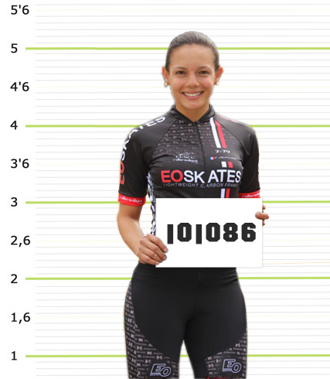 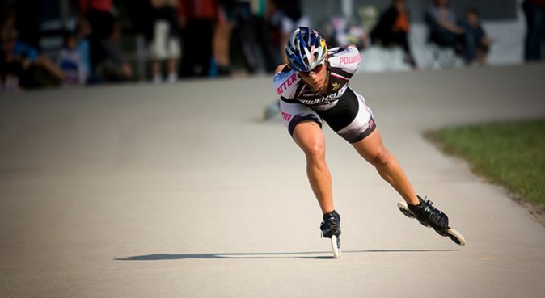

Colombia’s Roller Skating Champions

* Claudia Ruizm, Female Inline speed skating world champion 300 meters, 1990
* Guillermo Leon Botero, Inline speed skating world champion 20,000 meters, 1990
* Luis Eduardo Moreno, Inline speed skating world champion in China, 300 meters
* Liana Holguín, Female Inline speed skating world champion in China
* Andrés Felipe Muñoz, 15,000 meters’ Inline speed skating Junior world champion in Abruzzo, 2004 in China 2005
* Juan Nayib Tobón, Multiple World Champion Inline speed skating in China
* Silvia Natalia Niño, Multiple Inline speed skating world champion
* Diego Rosero, Multiple Inline speed skating world champion

Colombia also has many other sports like Motorsports, Basketball, Athletics, Golf, and Weightlifting. In the motorsports category, Juan Pablo Montoya is the best positive sportsman in motorsports in Colombia. He has a career in Formula One and of 2006 in the NASCAR, United States. In the basketball category, Colombia has hosted the 1982 Basketball World Cup, which one of the most watched events the country has ever hosted. In the athletics category, Catherine Ibaguen won a gold medal at the 2016 Summer Olympics, silver medal in the 2012 Summer Olympics, two gold medals in the IAAF World Championships, and two gold medals in the 2011 Pan American Games and 2015 Pan American Games. Camilo Villegas is the best-known Colombian golfer in the world. He has attended in the PGA Tour since 2006. In 2008, Camilo was the first PGA player in 11 years to win his first two events back to back. Those are most of the sports in Colombia that are still happening right now.