Weekly Home Connections
Quarter 3, Week 1
This Week’s Focus Concepts:
Letters | Sight Words | Color | Shape | Number
Uu, Tt, Vv  Ww, Xx, Yy | at  be | black | rectangle | five (5)
Our Current Study is:
Clothes

Monday
- Practice writing your first and last name.
- Practice saying your whole name in a complete sentence.
- Do these words begin with the same sound? fish/fan hat/bat boy/ball
- Read a book with your child. Let your child help read and tell the story.
Tuesday
- Practice saying each letter and its sound.
- Practice saying your age in a complete sentence.
- Show three fingers on one hand and two on your other hand. How many fingers do you have up?
- Recite this week’s nursery rhyme (found below).
Wednesday
- Practice writing your first and last name.
- Practice saying your birthday in a complete sentence.
- Do these words end with the same sound? arm/can bow/row sad/bed
- Read a book with your child. Let your child help read and tell the story.
Thursday
- Practice saying each letter and its sound.
- Practice saying your address in a complete sentence.
- Hold up five fingers. Now take four fingers down. How many fingers are left?
- Recite this week’s nursery rhyme (found below).

This Week’s Nursery Rhyme
“Five Little Snowmen”
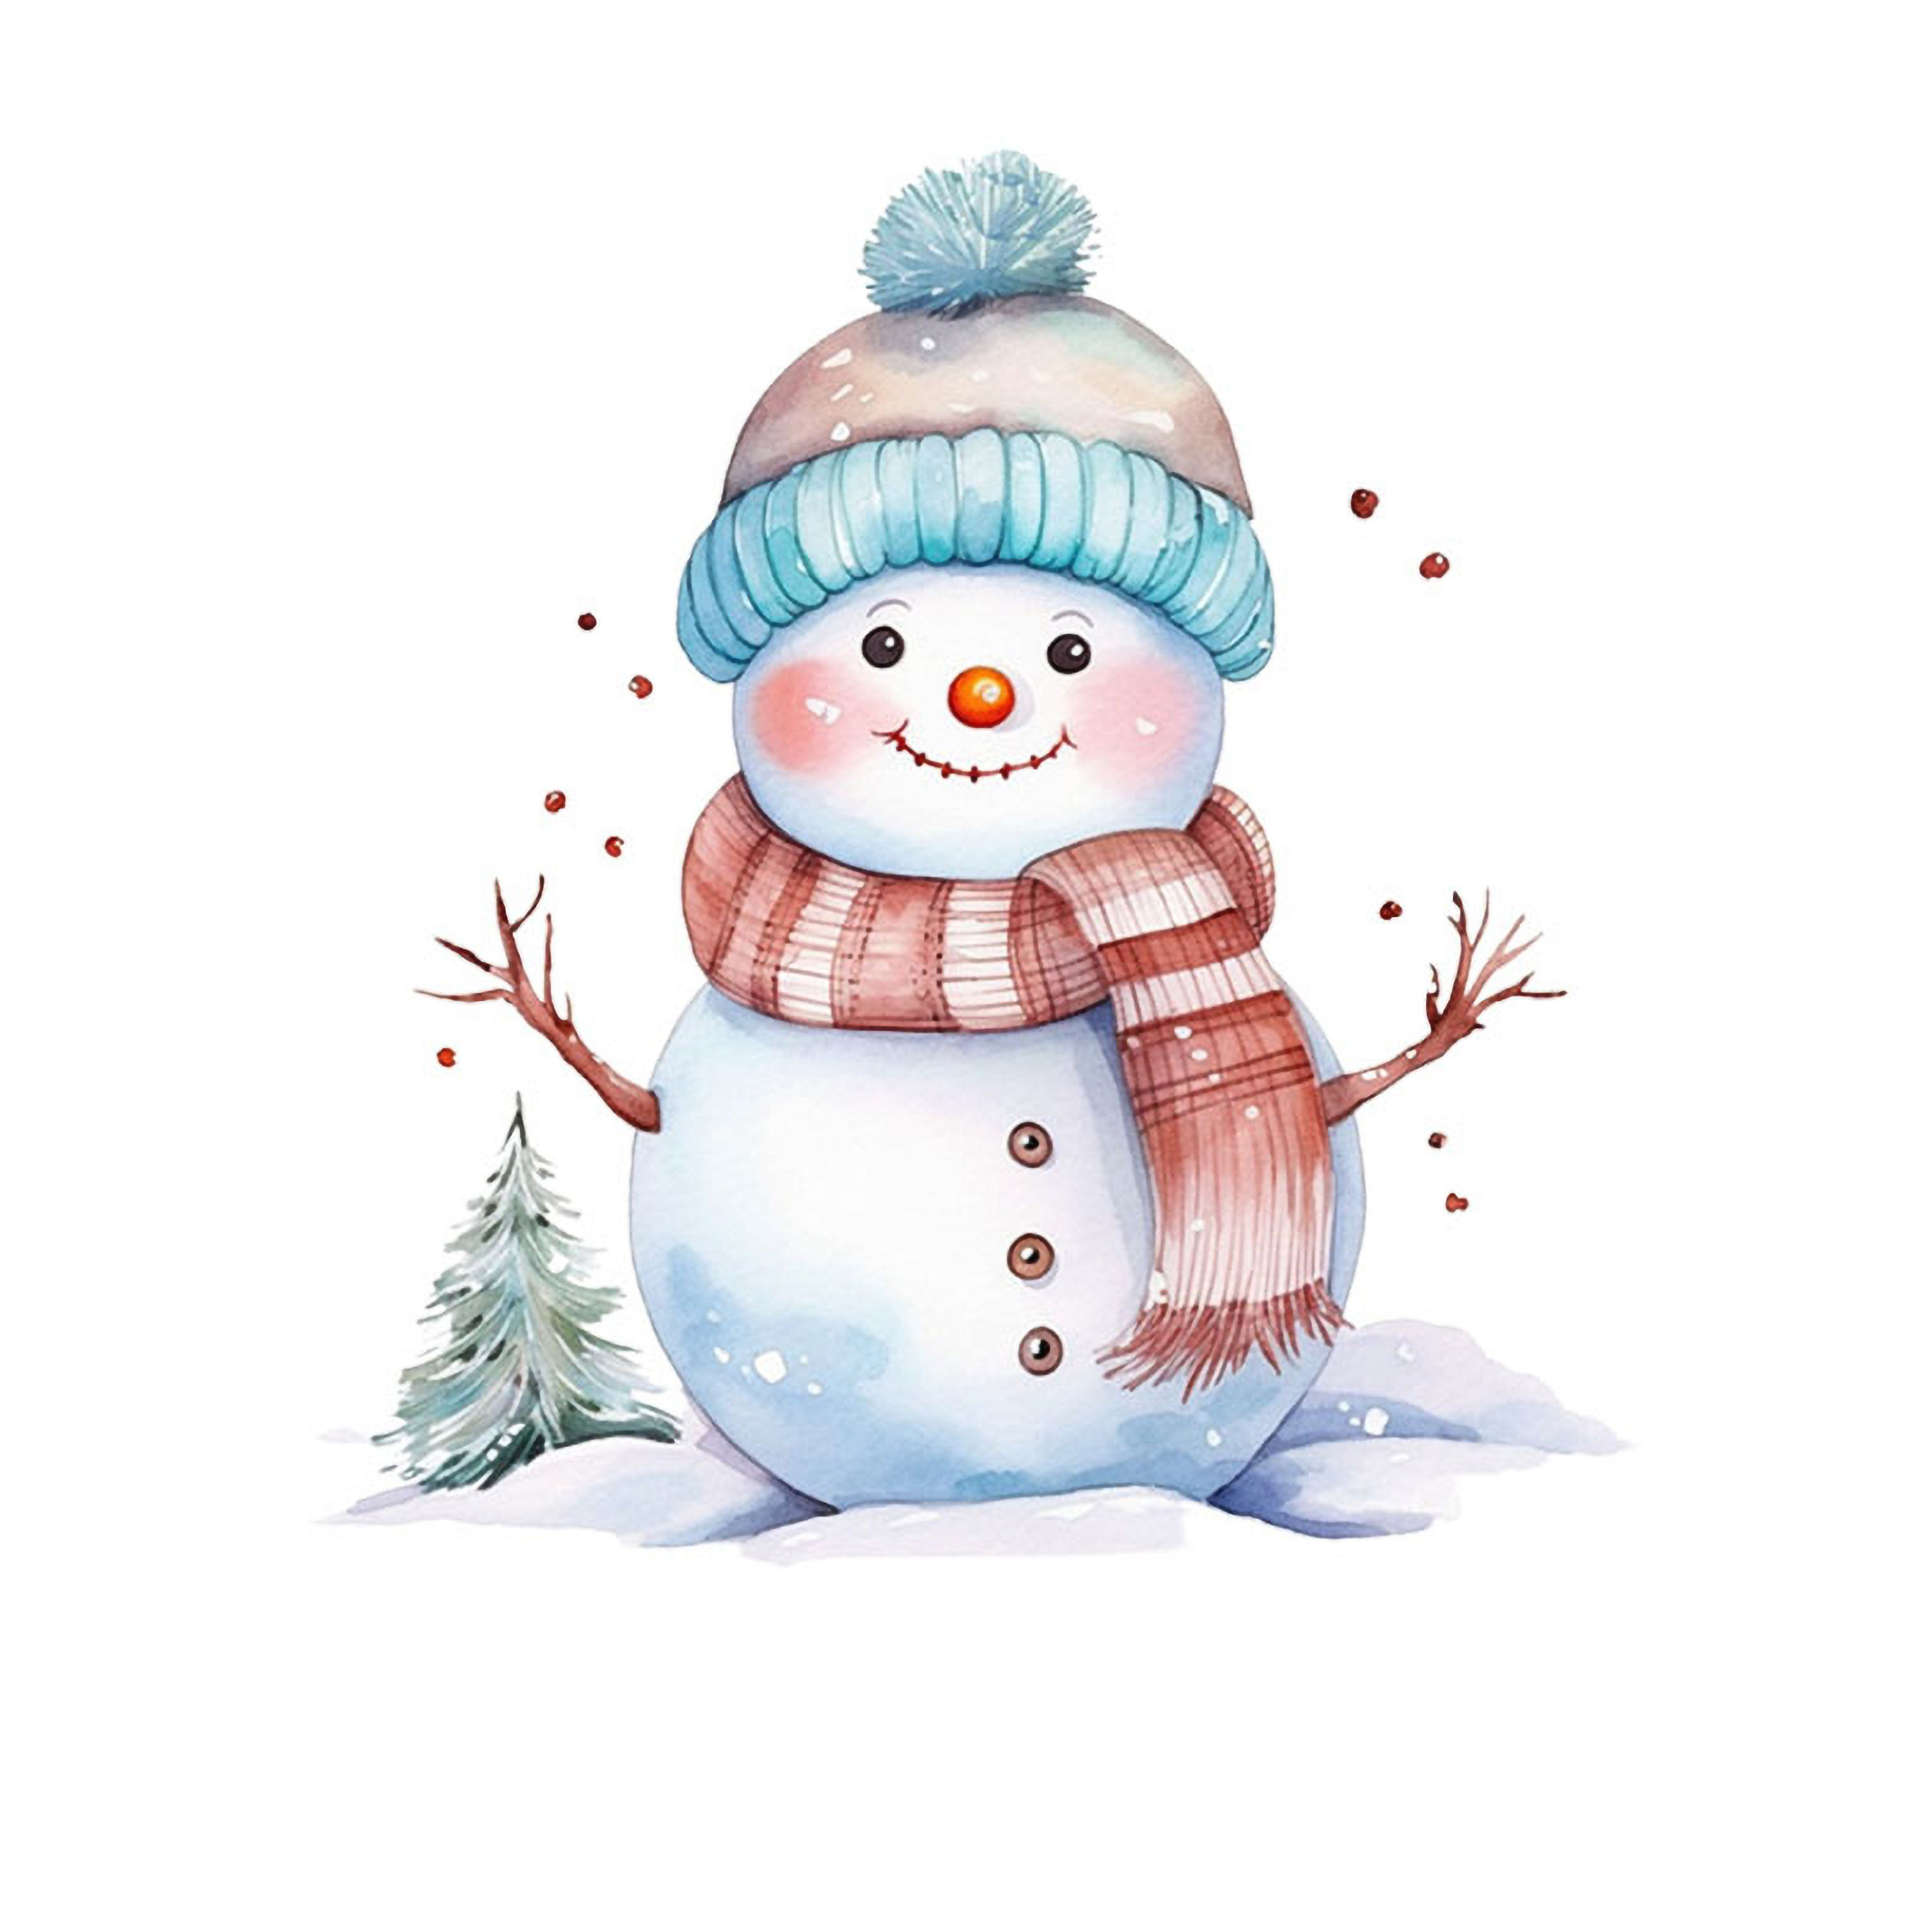

Five little snowmen standing in a row,
Each with a hat and a big red bow.
Along came the sun and it shone all day.
And one of those snowmen melted away!

Repeat with 4, 3, 2, and 1.

