Building Capacity for Involvement
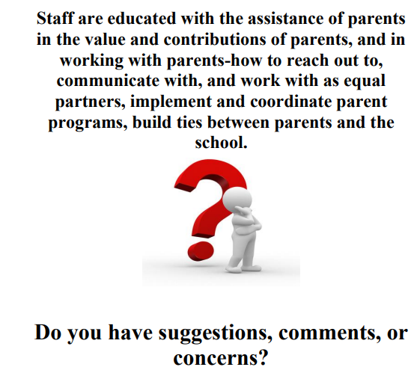
Please email johnsonsh@scsk12.org or contact our school at 901-416-7431.

