**Please follow the steps below to create a login as a first time user starting at step #1. If you have already created an account for the TSAC Dual Enrollment grant or TN Promise, please begin at step #6.**

**For the TSAC Student Portal go to**: [https://clipslink.tsac.tn.gov/studentsignon/.](https://clipslink.tsac.tn.gov/studentsignon/.%20)

1. Click on the create a login tab.
2. Enter a username that contains 6-25 characters. Fill in all the information. **Make sure you type your social security number correctly. Please be sure to write down your username and password as you will need it to continue the application.**

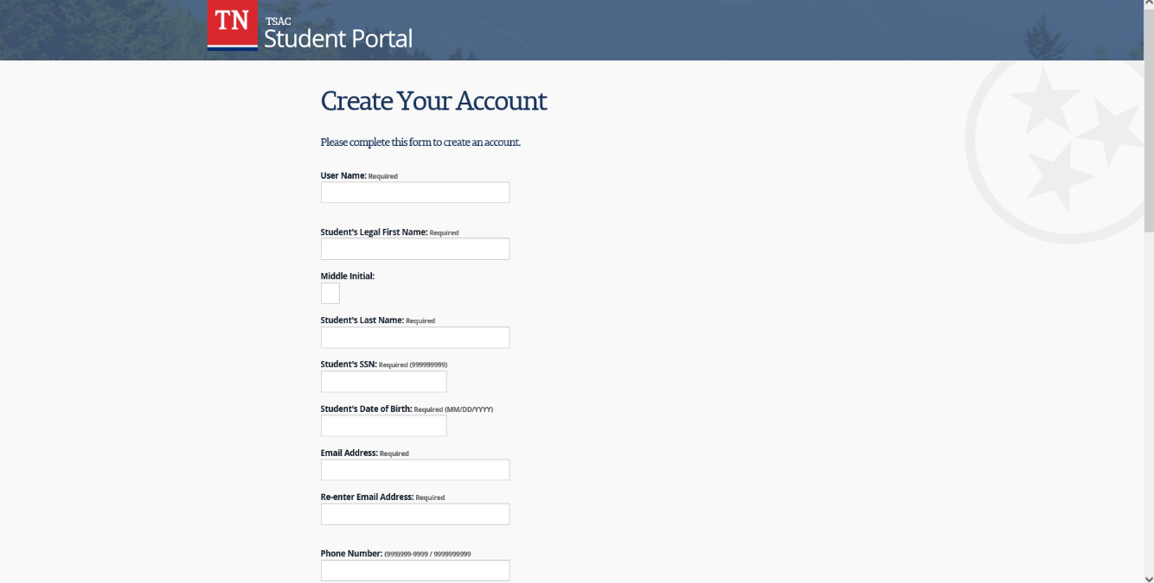

1. Select three security questions and answers. Make sure that you remember them, because three random choices will be given each time you log on (**password and answers are case sensitive).**
2. Choose a picture and check the box at the bottom after agreeing to the statement.
3. Click the “Create My Account” tab. You will then be directed to a confirmation screen. Click on the blue text to log in. You will then be sent back to the log in screen.
4. Enter your username name and password and click “Log In.”
5. You will then be prompted to answer one of your three questions. Please make sure your answers are the exact same as you entered previously (**case sensitive).** Then click continue.
6. Enter your password, and click “Log In.” The next page will be the User agreement. If you agree with the agreement, click accept.
7. You will then be directed to the TSAC financial summary page. At the top of the page click the first tab that says “Apply.” Scroll down to Dual Enrollment Grant and select the year in which you will be enrolled.
8. General Requirements and Instructions page: Read the statement and click “I Understand” and then click Dual Enrollment Grant.
9. Complete the information sections. Please use your legal name. **Be sure to indicate citizenship status correctly. Select “YES” for Tennessee Resident if you have been lived in TN for at least a year. For Tennessee Resident date, enter your date of birth.**
10. **There are four pre-filled questions under “Additional Student Information Section, make no changes.**
11. Select your High School from the drop down box.
12. Answer **YES** to having completed 10th grade and **NO** to having received your GED.
13. Under the College/University Information section, select the college you plan to attend for **Dual Enrollment.**
14. Click “Continue” to see a confirmation page. Click the box next to the agreement statement and next. You will receive your confirmation. Click the PDF and print the confirmation for your records. **Done!!!!**

**If you need assistance, please contact the TSAC HELP desk at 1-800-342-1663.**