Weekly Home Connections
Quarter 2, Week 2
This Week’s Focus Concepts:
Letters | Sight Words | Color | Shape | Number
Ii, Zz, Qq  Cc, Kk | in  like  pink | pink | crescent | nine (9)
Our Current Study is:
Balls

Monday
- Help your child write their first and last name.
- Have your child circle or cut out this week’s letters in newspapers or magazines.
- Practice counting from 1 to 20. Go further if you can!
- Read a book with your child. Ask your child to tell you what happened in the story.
Tuesday
- Hunt for something pink at home-what did you find?
- Play a family game using a ball.
- Practice identifying all the letters of the alphabet.
- Recite this week’s nursery rhyme (found below).
Wednesday
- Help your child practice writing their first and last name.
- What sounds do these words begin with? mop, pan, cut, bed
- Practice counting from 1 to 20. Go further if you can!
- Read a book with your child. Ask your child to tell you what happened in the story.
Thursday
- Make a set of nine objects using things you find around your home.
- What did you learn about balls? Draw and write about it!
- Practice identifying all the letters of the alphabet.
- Recite this week’s nursery rhyme (found below).

This Week’s Nursery Rhyme
“Little Bo Peep”
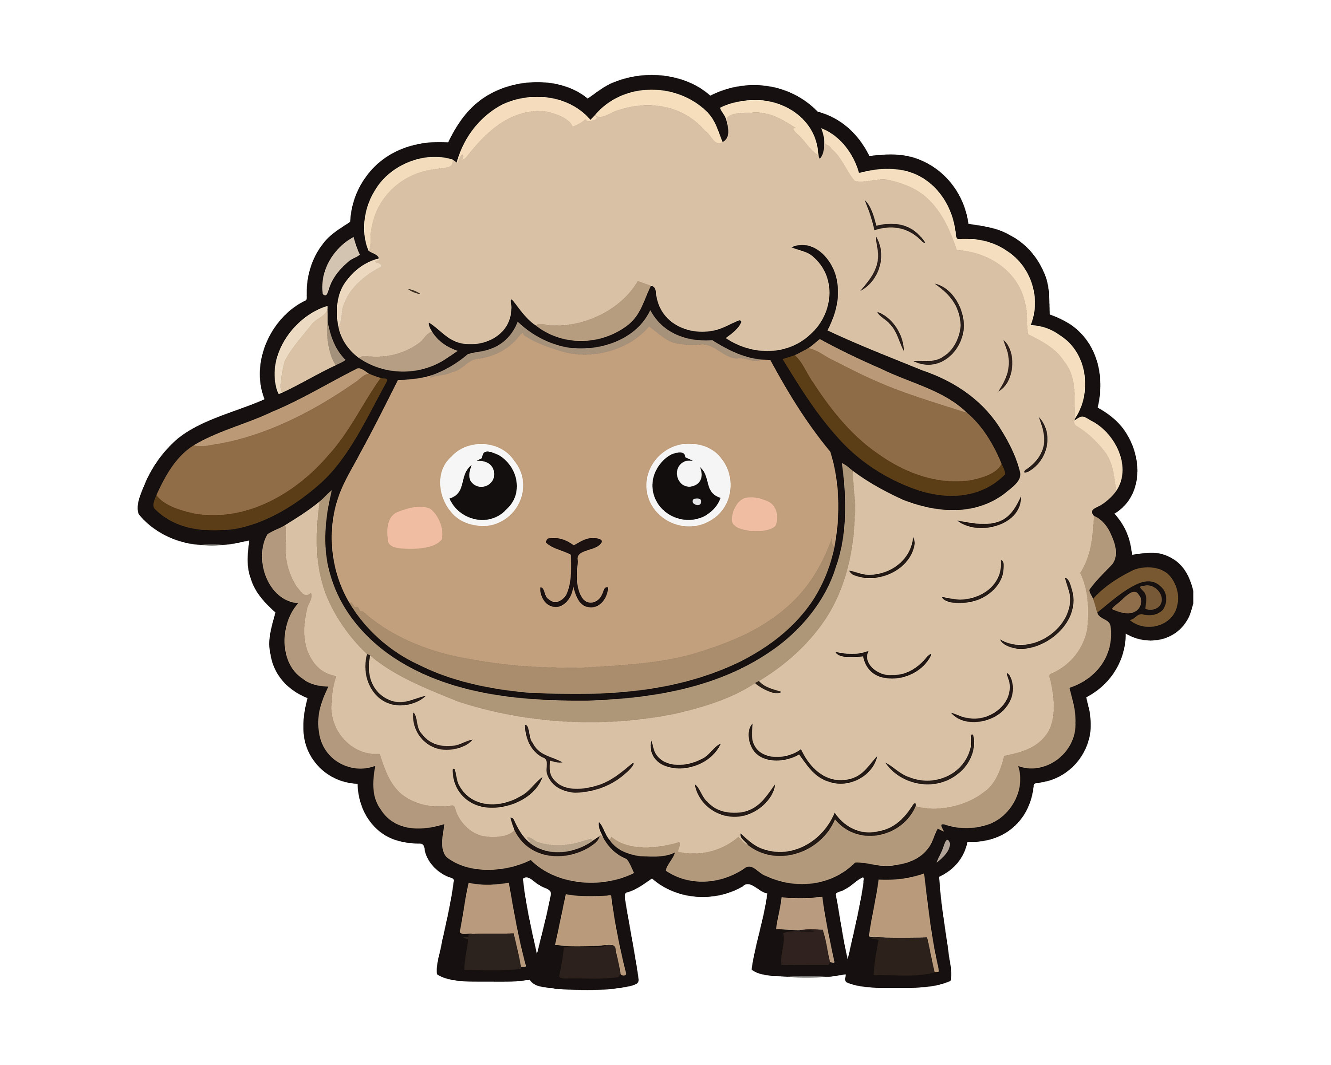

Little Bo Peep has lost her sheep,
And can’t tell where to find them;
Leave them alone, and they’ll come home,
Bringing their tails behind them.

Little Bo Peep fell fast asleep,
And dreamt she heard them bleating;
But when she awoke, she found it a joke,
For they were still all fleeting.

Then up she took her little crook,
Determined for to find them;
She found them indeed, but it made her heart bleed,
For they’d left their tails behind them.

