Weekly Home Connections
Quarter 3, Week 7
This Week’s Focus Concepts:
Letters | Sight Words | Color | Shape | Number
Ee, Hh, Jj  Ll, Mm | they  said  she | green | oval | one (1)
Our Current Study is:
Buildings

Monday
No school today!
Happy President’s Day.
Tuesday
- Practice saying the sound(s) of each letter of the alphabet.
- Draw and write two words that rhyme.
- You have six items. Then, a family member takes away six. How many are left?
- Recite this week’s nursery rhyme (found below).
Wednesday
- Practice writing your first and last name. How many letters can you identify?
- Practice writing your letters. Can you write all the letters of the alphabet?
- Put these letters together: f o x What word does this spell?
- Read a book with your child. Do you see any buildings in the story?
Thursday
- Practice saying the sound(s) of each letter of the alphabet.
- What type of building do you live in? Draw and write about it!
- Practice counting to 40. Go further if you can!
- Recite this week’s nursery rhyme (found below).

This Week’s Nursery Rhyme
“Ten in a Bed”
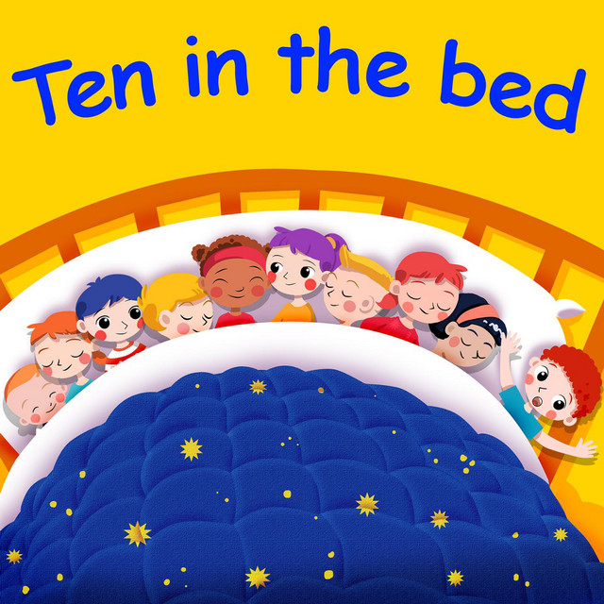

There were ten in the bed,
And the little one said,
“Roll over! Roll over!”
So, they all rolled over and one fell out.

(Repeat with 9, 8, 7, 6, 5, 4, 3, and 2.)

There was one in the bed,
And the little one said,
“I’m lonely…[sigh].”

