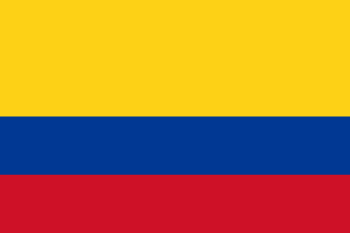 Colombian Flag

The national flag of Colombia was founded on November 26, 1861. It’s a tricolor of yellow, blue and red. The yellow stripe takes up the top half of the flag and the blue and red take up a section of the space each. According to the current interpretation, the colors signify:

**Yellow**: represents all the gold found in the Colombian land and all its wealth not only referring to gold but also to its diverse nature and its incredible people.

**Blue**: represents the seas on the Colombia's shores, the rivers that run through, and the sky above.

**Red:** represents the blood spilled for Colombia's independence and also the effort of Colombian people, the determination and the perseverance.

Places to visit in Colombia

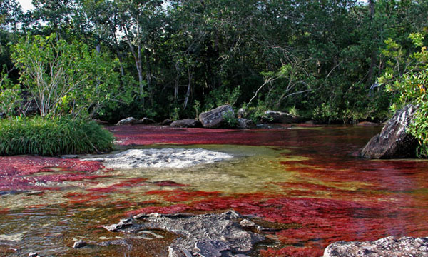Colombia has many lovely and diverse places to visit. There’s so much to see in Colombia going from historical cities to natural parks or virgin beaches.

Caño Cristales is the beautifulness river in

Colombia and one of the most perfect natural

places to visit in this country. Caño Cristales

is located inside the National Natural Park La Macarena.

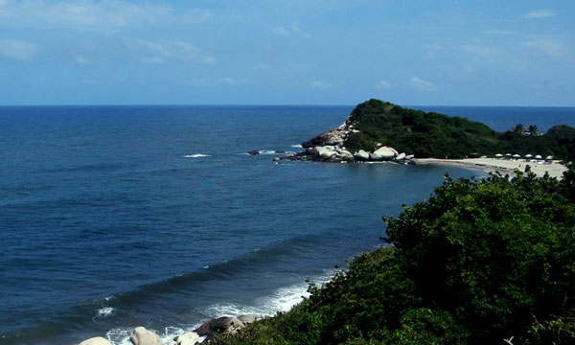

The Tayrona National Natural Park is another

place of natural beauty with fauna and flora.

The park is at the Caribbean coast near Santa Marta.

It’s home of the most beautiful beaches in the country.

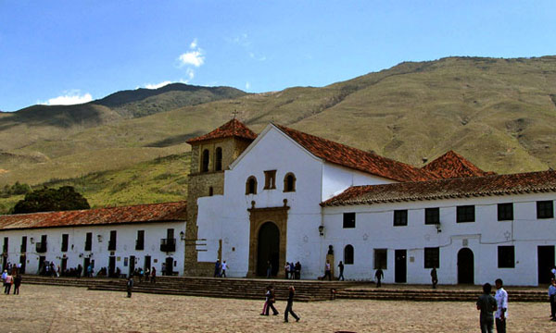

Villa de Leyva is absolutely the most crowded and popular

town in Boyaca. This colonial village frozen in time will

make you feel like you’ve been transported back to

the colonial times.

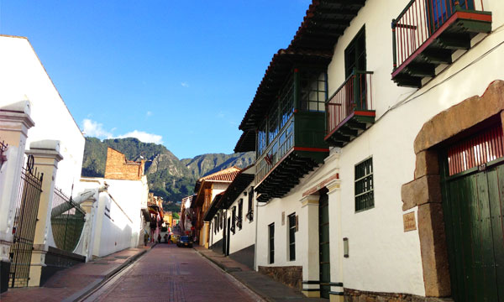

The historic center of Bogota is an incredible place.

It’s impossible to miss history when you are there.

Important Rivers in Colombia

The Amazon is the largest river by discharge Negro is the largest tributary of

globally, and is also considered the Amazon, the largest black-

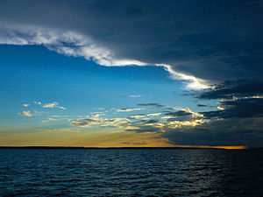to be the longest by some measures. water river in the world.

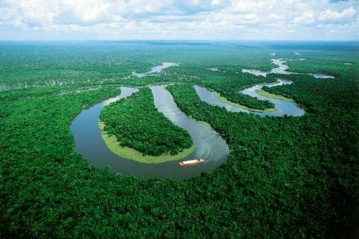

The River Orinoco is one of the longest rivers in The Putumayo is one of the major

South America at 1,330 miles in length, and having tributaries of the Amazon River,

a drainage basin which covers 340,000 square miles. Of the Amazon River, flowing west

of the Japura River.

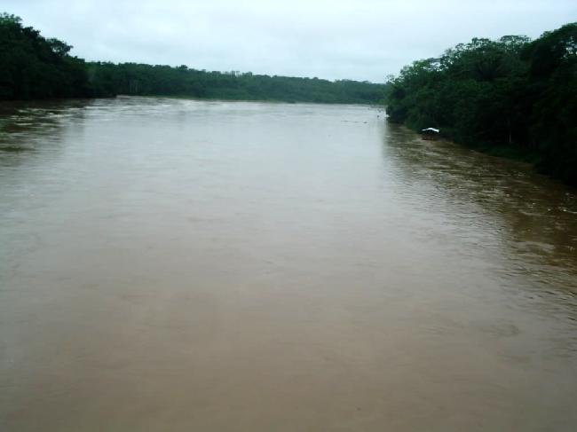

Government in Colombia

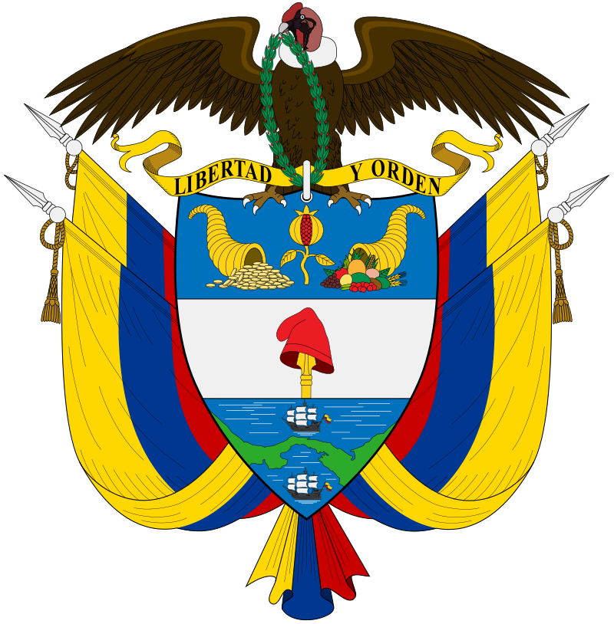**The Government of Colombia is a state with parting of powers into executive, judicial and legislative branches. Its legislative has a congress, its judicial has a supreme court, and its executive branch has a president. The citizens of Colombia cast votes about their government, and they hire a public-sector office for an inspector overall to direct the public border of the government. This protects the public, and pledge the human rights brought out in the Constitution of 1991, which delivers the outline for a good state and a unitary republic. The executive branch of power in Colombia is headed by the President of the Republic. The legislative branch is the branch that makes laws. The judiciary of Colombia is the branch that takes and applies the laws of Colombia.**

Fun Facts About Colombia

* The name Colombia is resulting from the last name of the explorer Christopher Columbus.
* Most of the population speak Spanish which is the official language of Colombia.
* Colombia bonds a land border with 5 countries including Panama, Venezuela, Brazil, Ecuador and Peru.
* Colombia is the only country in South America that has a coastline on both the Pacific Ocean and the Caribbean Sea.
* Bogotá is the capital of Colombia. It is the second largest capital city in South America.
* Colombia has a population of over 45 million people as of July 2013.
* The currency of Colombia is called the Colombian peso.
* Colombia is the world's leading source of emeralds and its coffee is world-renown.
* The traditional national sport of Colombia is called Tejo.

Interesting Facts About Colombia

* Colombians loves to dance. The rule of Colombia: If you hear music, start dancing.
* The music is also loud and pumping in Colombia. World famous pop singer, Shakira, from good Colombia.
* Age is a significant issue in Colombia. The older you grow, the more powerful your voice becomes.
* Colombia hosts the world’s largest theater festival, the Iberoamericana.
* One out of every five butterfly species is found in Colombia.
* Colombia is a place of fun, thriller and party. Colombians love their holidays, organizing salsa parades, flower parades, carnivals and more.
* Bogota is the capital of Colombia and mecca is for street artists. The government not only tolerates graffiti, but also encourages and sponsors street art.
* Elders are deeply respected and revered in this tropical nation.

Colombian Clothing

Most Colombians wear Western style clothing. Urban experts from the Andean central tend toward traditional, dark colored suits, while farmers and members of the lower classes favor loose skirts or pants. Recent dresses in Colombia’s sea regions are a little more freewheeling, with loose fitting styles and bright colors or prints that replicate the region’s Caribbean impacts.

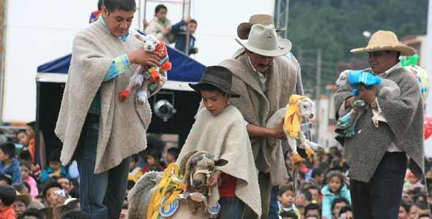One piece of traditional Colombian clothing that's still a common piece of everyday wear, especially in the cooler Andean regions, is the Ruana.

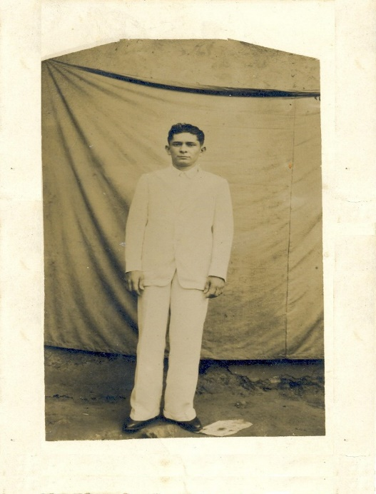The liqui liqui is the national costume for men in Colombia. It’s usually made of linen or cotton cloth, though garment and wool can be used.

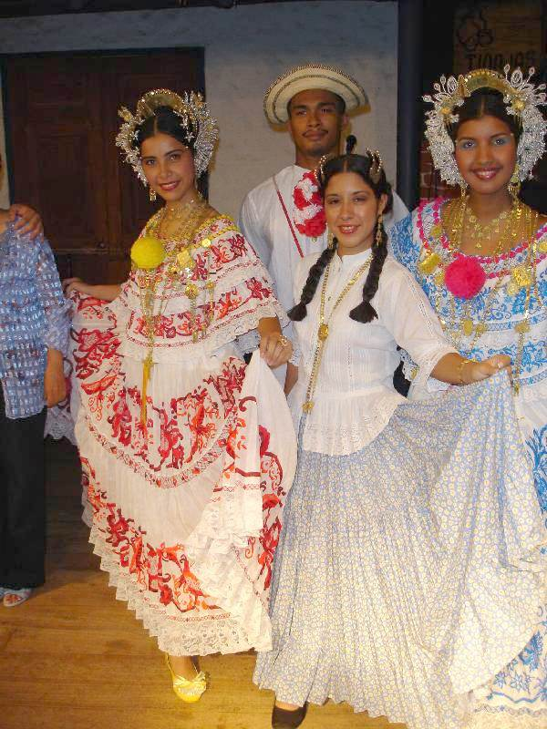 A pollera is a Spanish time for a big one-piece skirt used typically in traditional festivities and legends through Spanish-speaking Latin America. Polleras are made from changed resources, such as cotton or wool and tend to have colorful ribbons. Most of the decorations are inflated, flowers and local animals are between the most shared projects found in polleras.

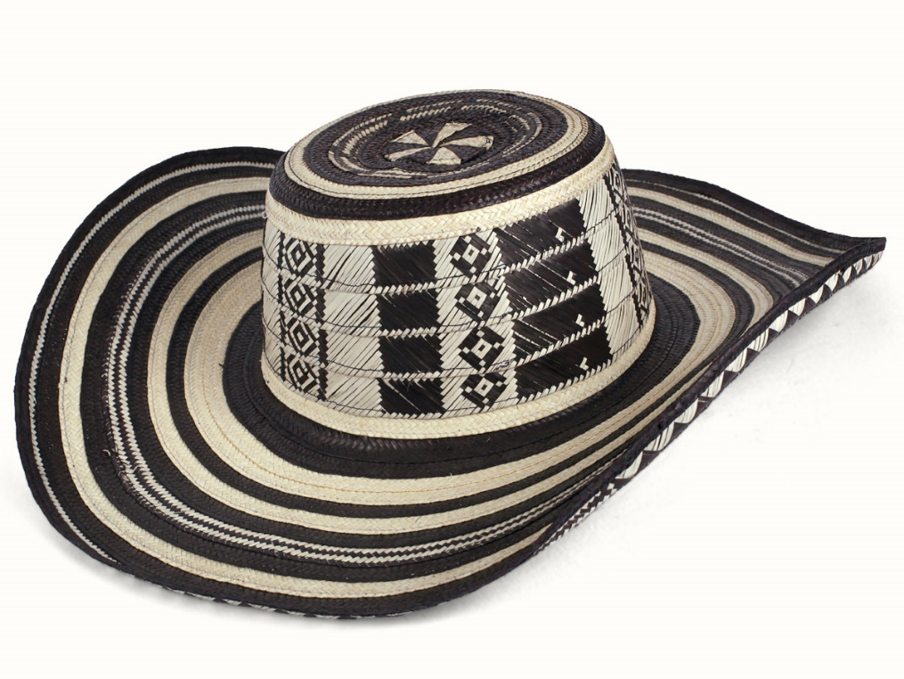 The sombrero vueltiao is a traditional hat from Colombia and one of its symbols. It is made from Gynerium sagittatum known locally as caña flecha, a type of cane that grows in the region.