SAFETY PLANS



**MEMPHIS SHELBY COUNTY SCHOOLS**

**Early Childhood**

### Temperature Safety Plan

**School/ Center:**

**Principal/Director:**

**Teacher:**  **Phone #:**

**Teacher Assistant:**  **Phone #:**

**School Start Time:**

# Malfunctioning Unit Process:

Steps for ensuring appropriate classroom temperature ranges:

Step 1: Teachers will post classroom thermometers on walls in every classroom to monitor appropriate temperature ranges.

Step 2: Principals and teachers will contact the Early Childhood director and/or manager immediately upon knowledge of malfunctioning units.

Step 3: The facility maintenance director will be notified immediately upon notification of malfunctioning units for immediate attention to specific sites**.**

Step 4: Students will be moved to a temporary location in the building until the unit is fixed**.**

Name two alternate locations in your building for the Pre-K class in the event the heating and/or air conditioning is not functioning properly.

**1.**

**2.**

**Teacher:** **Date:**

**Assistant:** **Date:**

**Principal:** ____________________________________________________________________________

### Early Childhood Classroom Coverage Plan

**School/ Center:**

**Principal/Director:**

**Teacher:**  **Phone #:**

**Teacher Assistant:**  **Phone #:**

**School Start Time: 8:00 AM**

# Absence Notification Process:

Define the steps for ensuring coverage in case of an absence. Step 1: Call & email the Principal

Step 2: Copy the secretary on the email

Step 3: Place the sub into Subfinder Express System Step 4:

Step 5:

Step 6:

**Name 2 assistants or building personnel that can cover the Pre-K class in the event a substitute does not show up.**

**1.**

**2.**

**Teacher:** ____________________________________________

**Date:**

**Assistant:** **Date:**

**Principal:** **Date:**

### Early Childhood

**Playground and Equipment Maintenance Plan**

**School/ Center:**

**Principal/Director:**

**Teacher:**  **Teacher Assistant:**

### Playground/Equipment owned and operated by:

(i.e., Name of School, Name of Gymnasium/Equipment or Memphis Park Commission)

## Elementary

### Type of equipment used if no playground is available:

(i.e., tricycles, balls, hula hoops, etc.) Balls, jump ropes, hula hoops, parachute

### Accessed and used by:

(i.e., Pre-K and school-aged children, only Pre-K, etc.) Pre-K and school aged children

### Assessment of condition of recess area:

(i.e., Safety Inspection Checklist, Daily Playground walkthrough)

### Plan to report damaged playground material and/or equipment, unanchored climbing items, resilient surface, etc.:

, the building engineer, will be informed immediately of any damaged playground material/equipment.

Teacher:_____________________________________________

Date:

Assistant: Date:

Principal: ____________________________________________ Date: ______________

### Early Childhood Recess Supervision Plan

**School/ Center:**

**Principal/Director:**

**Teacher:**  **Teacher Assistant:**

**Arrival Procedures:** TA counts the students to make sure they all arrival on the playground. Teacher goes over playground rules. She will ask the student to repeat the rules. Then she allows students to go play on playground.

**Departure Procedures:** TA rings her bell 3 times and the students line up in front of the teacher. TA will count the students before leaving the playground. We will work in a single file line back into the building. We count the students

again, once we are in the building.

**Supervision Assignments:** Four adult will stand by the blue pole on each corner to monitor the students as they play.

### Emergency Plans:

Child Injury:

We will take care of the child's injury using the first aid kin in our backpack. We will write an incident report and notify the parent.

Orange Alert:

We will stay in the building. We will do our recess in the gym or in our classroom.

Severe Weather:

We will stay in the building. We will do our recess in the gym or in our classroom.

Fire Alarm:

We will follow our school protocol for fire drills. We will line up in the appropriate area, count students, call the roll and use our emergency handbook to let them know "all clear".

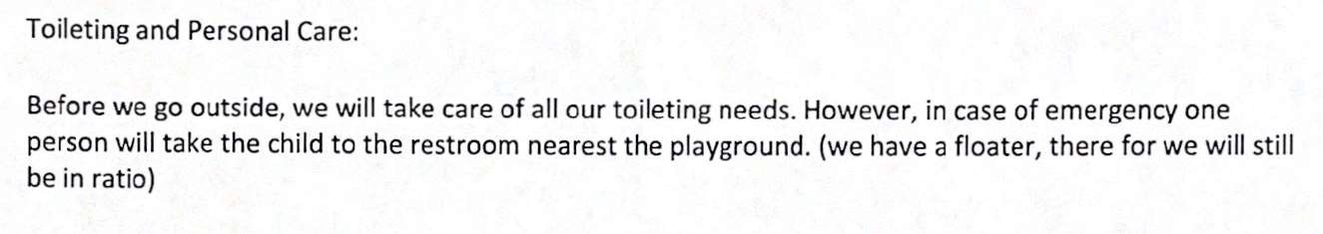

Other Emergencies:



Teacher: ____________________________________________

Date:

Assistant: Date:

**Early Childhood Arrival and Departure Plans**

School:

Teacher(s):

Teachers’ Assistant (s):

Arrival Procedures: TA/T counts the students and checks the classroom sign-in sheet to ensure that all students are present to walk from the designated pick-up area to the classroom.

Additional Information:

Departure Procedures: The school bell rings, and the students line up in front of the teacher. T/TA will count the students before leaving the classroom. As parents arrive the T/TA will check the Parent Permission to Pick up List to confirm parent or designee, ask for ID or Driver’s License. Parent(s) or approved pick-up person will sign-out.

Additional Information:

Closing Procedures: All teachers will check to ensure ALL students are gone from building.

Teacher: ______________________________________

Date:

Assistant: Date:

Principal: Date:

## Early Childhood Restroom Safety Plan

School/Center:

Principal/Director:

Teacher(s): Teacher Assistant(s):

Teacher(s) and Teacher Assistant(s) roles and responsibilities during restroom breaks:

Location of Restroom(s):

Time of Restroom Breaks:

Restroom Procedures:

Teacher Signature: Date:

Teacher Assistant Signature: Date:

Principal Signature: Date: