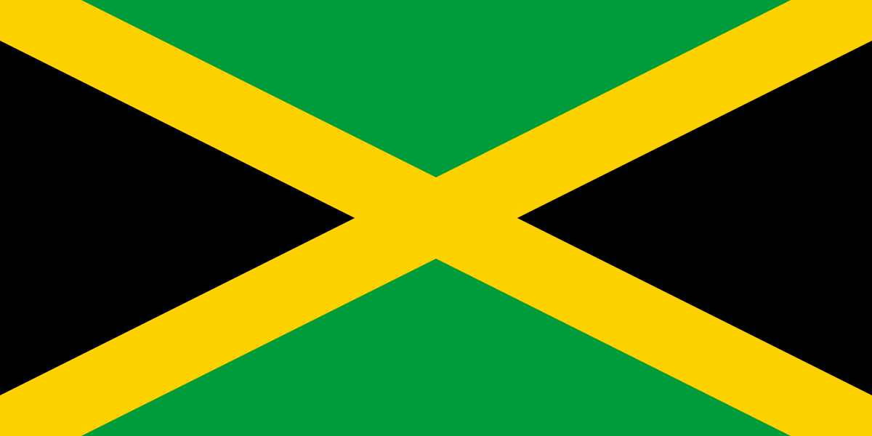

As you can see, by the flag, I chose to do Jamaica for my International Festival research. Jamaica is located in North America. The capital of Jamaica is Kingston, and the major spoken languages are English and Jamaican Patois. Jamaican Patois is an English based creole language with Western African influences.

Jamaica was founded on August 6,1962 and was once referred to as the island of Xaymaca. Before Jamaica, gained its independence from England, Jamaica and ten other Caribbean countries formed the Federation of the West Indies. This Caribbean unity was abandoned in 1961, and Jamaica was granted independence on August 6,1962. Jamaica first prime minister as in independent nation was Sir Alexander Bustamante. During his time in office, he ordered the army to “ bring in Rastas died or alive” and over 100 were detained and unknown number were killed. Rastas is a religion developed in Jamaica during the 1930s, still being worshipped till this day. After becoming free, major events happened in Jamaica such as Festival office, the order of National Hero of Jamaica, Jamaica gets its own money, JCDC was created and etc.

Jamaican culture consists of the religion, traditions, values, and way of life that characterize the Jamaican people. The culture is eclectic, having an ethnically varied civilization that stems from a history of occupants that began with the Taino people. The largest religion in Jamaica is the Christian faith. The Rastafari movement is influence by the consciousness of Africa and is a derivative of larger Christian culture. The Rastafari culture is what bought reggae to African-Caribbean culture. Some of the most popular reggae artists are Beres Hammond, Dennis Brown, and Bob Marley. The Jamaican government didn’t favor the Rastafari movement influence, they would harass, persecute, and even shave their heads and cut their locks off. As of today, the Jamaica government had grown and became more open to it.

Jamaican clothing is gauzy but well-cut. Most of the textiles used to produce colorful clothes, such as the quadrille dress, Kariba suit, or so-called Yucatan shirt, allow the skin to breathe in hot temperatures without sacrificing elegance. Although Jamaicans had a deep connection to their heritage, they did not mind absorbing features from other civilizations. Fusion is an aesthetic approach popularized by music and theater that has inspired fashion designers to produce one-of-a-kind creations. For example, consider the Kariba suit, which debuted in Jam.

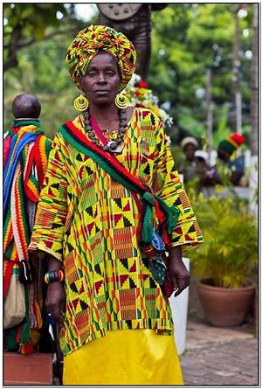

Jamaican cuisine is a fusion of culinary techniques, flavors, and spices inspired by the island's Amerindian, African, Irish, English, French, Portuguese, Spanish, Indian, Chinese, and Middle Eastern inhabitants. Crops imported to the island from tropical Southeast Asia also have an impact. All of which are currently farmed on the island of Jamaica. There is a great selection of seafood, tropical fruits, and meats. Some Jamaican meals are adaptations of cuisines brought to the island from other parts of the world. These are frequently adapted to include fresh local food and spices. Others are unique or fusion creations that have emerged locally. Curry goat and fried dum are popular Jamaican meals.

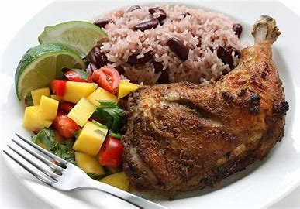

In conclusion, Jamaica is a beautiful country with a great diversity of cultures and languages. Jamaica gained independence from England on August 6, 1962. Before independence, the Caribbean unity was abandoned, and Jamaica was only granted independence on August 6, 1962.The culture of Jamaica is varied and has a history that originated from the Taino people. The biggest religion in the country is the Christian faith. Rastafari movement is influenced by the African-Caribbean culture. Although they are known for their gauzy clothes, Jamaicans are also known for their well-cut ones. They do not mind sacrificing style for practicality. Inspired by the various cultures that live on the island, Jamaican cuisine is a fusion of various culinary techniques and spices. There is a great variety of fresh produce and meat to choose from.

Links:

<https://en.wikipedia.org/wiki/Jamaican_Patois>

<https://jis.gov.jm/information/jamaican-history/>

<https://en.wikipedia.org/wiki/Culture_of_Jamaica>

<https://www.theatlantic.com/entertainment/archive/2019/04/meet-koffee-jamaicas-teenage-reggae-sensation/586138/>

<https://www.my-island-jamaica.com/rastafarian_jamaica.html>

[Traditional Jamaican Clothing: Everything You Need to Know - Mummy Matters (deepinmummymatters.com)](https://deepinmummymatters.com/traditional-jamaican-clothing/)

[Jamaican cuisine - Wikipedia](https://en.wikipedia.org/wiki/Jamaican_cuisine)