**Logging into i-Ready**

**Admins must login at:** <https://login.i-ready.com>

* *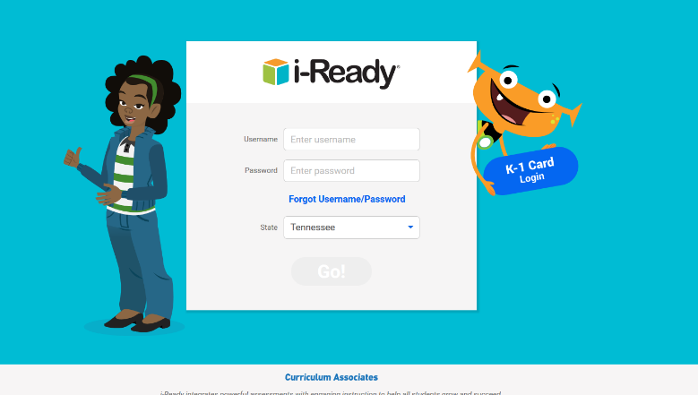Need help resetting username or password? Click the “Forgot Username/Password” link on the login screen)*

**Teachers and Students must login via Clever at:** <https://clever.com/in/scs>

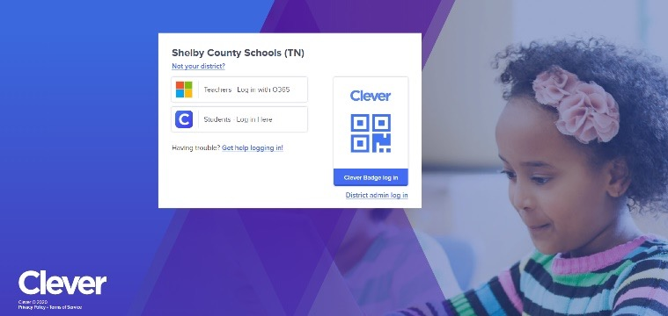

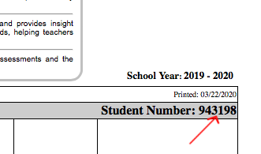

* The student will login to Clever using their Student# as their username (this is also their cafeteria number, and the # from their report card/progress report) and their 8-digit Date of Birth (without dashes or slashes) as their password. For example, if a student was born 3/22/2010 their password would be 03222010

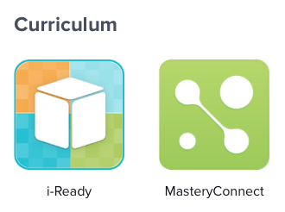

* Once logged into Clever, they will select the i-Ready icon and go from there! The icon will look like the one pictured at right (it can typically be found under “Curriculum” or “Favorite Resources”)
* *For additional help retrieving student#:* You can also get your login credentials, or view the student’s Student#, from the student/parent portal by logging into the portal (you will have to set up a parent or student account, or already have one, to login to the portal) and select the “Online Education” link from the left hand menu. The parent/student portal can be found at: <https://scstn.powerschool.com/public/>