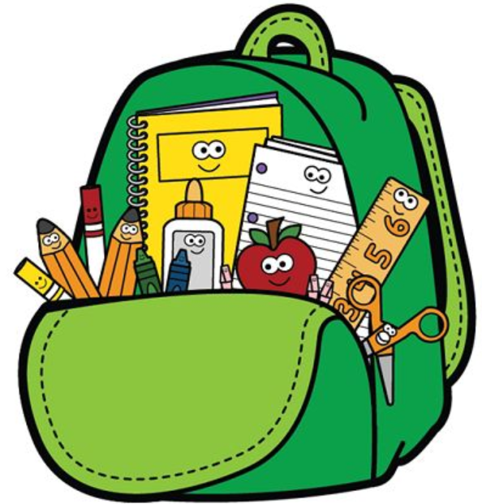3rd Grade Supply List

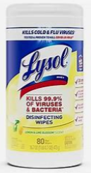

1. 2-inch Clearview Binder
2. Pencil Pouch with zipper (No Boxes)
3. LARGE Lysol/Clorox Wipes
4. Folders with prongs and pockets (Red, Blue, Purple, Yellow)
5. A green box with yellow pencils

   Description automatically generatedSpiral Notebooks (Wide Rule)
6. 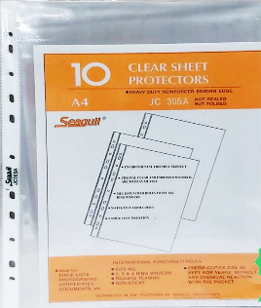24 count Wooden Pencils
7. 4 Count Expo Markers

8 oz Hand Sanitizer with pump

A pair of Headphones

8 pack Crayola Crayons

10 Sheet Protector sheets

