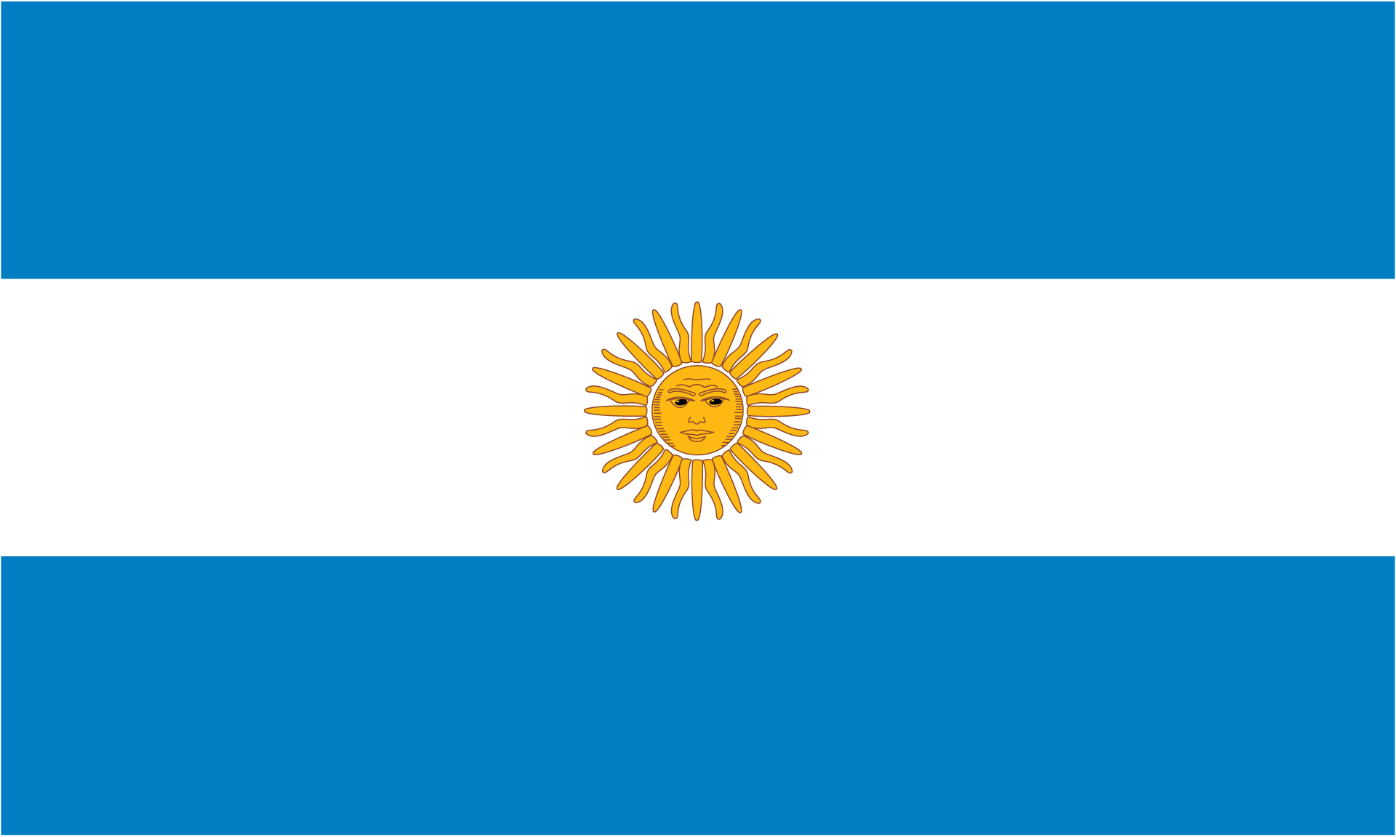

Argentina

Argentina is a country located in the southern half of South America. It is home to a population of around 44,694,198. The capital of Argentina is Buenos Aires, which is also the largest city in that country. The dominant language spoken is Spanish. Some other languages spoken there are Italian, German, English, and French.

History

Prehistory in the present territory of Argentina began with the first human settlements on the southern tip of Patagonia around 13,000 years ago. Written history began with the arrival of Spanish chroniclers in the expedition of Juan Díaz de Solís in 1516 to the Río de la Plata, which marks the beginning of Spanish occupation of this region. Some famous people from Argentina are Bernardino Rivadavia, Pope Francis, Lionel Messi, and Diego Maradona. In 1516 the first European to visit Argentina was Spanish explorer Juan Diaz de Solis. In 1810 the May Revolution in Buenos Aires and the Argentine War of Independence began. In 1816, Argentina declared its independence from Spain. In 1944 Argentina joined the Allies and declared war on Japan and Germany. By 2013, Pope Francis was named the first pope from the Americas. Argentina became a country when they revolted against Spain and won their independence from them.

Geography

Major landforms in Argentina are Mesopotamia, the rainforest region in the northeast of the country. Gran Chaco, a hot lowland region that boasts the world’s tallest volcano, Ojos de Salado. Pampas, a large area of flat plains, with the river Parana snaking through it. The Andean region, on Argentina’s western border, includes the longest mountain range in the world, the Andes. The most important landform here is Aconcagua, the tallest mountain outside of Asia. Major bodies of water in Argentina include Lake Buenos Aires, Lake Argentino, Parana River, and Iguazu River. Major cities in Argentina are Buenos Aires, Cordoba, Rosario, and Mendoza.

Culture

The cuisine of Argentina is greatly influenced by Mediterranean (Spanish and Italian) cuisines and the cuisines of its indigenous population. Asado (a barbeque) is an integral part of the Sunday family lunch. Homemade patties, pasta, and french fries are served on special occasions. Restaurants in Argentine cities serve a variety of local and international cuisines. Beef is the most important component of the diet. Some holidays celebrated in Argentina are Malvinas War Veterans Day (April 2), Labor Day (May 1), Revolution Day (May 25), General Belgrano Memorial Day (June 20), Independence Day (July 9), and Day of the Immaculate Conception (December 8). Argentina’s religions consists of Roman Catholic (92%), Protestant (2%), Jewish (2%), and other (4%). The government of Argentina, within the framework of a federal system, is a presidential representative democratic republic. The President of Argentina is both head of state and head of government. Executive power is exercised by the President. Legislative power is vested in the National Congress. The Judiciary is independent from the Executive and from the Legislature.

Economy

Some of the major natural resources of Argentina are agriculture and mining. Fertile agricultural land is one of the reasons why the agricultural sector in the country is so crucial. Presently, about 10% of the country’s total land area is cultivated. The capital-intensive sector is responsible for providing around 7% of the country’s employment as well as more than 50% of the country’s revenue from exports. Mining is a crucial sector of the economy with some of the natural resources including minerals like aluminum, zinc, gold, silver, copper, and lead. Fuel minerals include natural gas and petroleum. In 2003, non-fuel minerals had a worth of about $1.1 billion with copper making up about $467 million of the total figure. Cordoba is the globally recognized industrial center in Argentina housing motor assembly and metalworking among other manufacturing sites. Bestowed with rich fertile lands, Argentina has vast agricultural and energy resources which are used in the industry sector in the country. Most Argentinians now work in the service sector, the oil and gas industry, mining, shipbuilding, or the food, tobacco and automotive industries. Most factories are in port cities. For this reason, the port cities have attracted job seekers from rural areas and immigrants. The peso (established as the peso convertible) is the currency of Argentina, identified by the symbol $ preceding the amount in the same way as many countries using dollar currencies.

Climate

The climate in Argentina varies. Buenos Aires and the Pampas have a temperate climate which means it can be cold in winter, but hot and humid in summer. In the deserts of Cuyo it can be extremely hot and dry in summer and temperatures can reach to a staggering 50 degrees Celsius (122° Fahrenheit). The average yearly rainfall in Argentina is 3.3 inches. The average yearly temperature is 66 F. Climate change in Argentina is predicted to have significant effects on the living conditions in Argentina. The climate of Argentina is changing with regards to precipitation patterns and temperatures. The highest increases in the precipitation (from the period 1960–2010) have occurred in the eastern parts of the country. The increase in precipitation has led to more variability in precipitation from year to year in the northern parts of the country, with a higher risk of prolonged droughts, disfavoring agriculture in these regions. Though temperatures have increased at a slower rate than the global average, nonetheless these impacts have occurred in many areas. Higher temperatures can reduce winter snowfall, causing river flow to decrease (less water available), which can reduce hydroelectric energy production; losses of up to 40% have been observed. If these trends continue, it is predicted that climate change will exacerbate existing natural disasters such as increasing the intensity and frequency of floods or create new ones.

Interesting Facts

With an area of 1,073,500 square miles, Argentina is the second largest country in Latin America, the eighth largest country in the world, and the largest Spanish speaking country in the world.

Buenos Aires, the country’s capital, is one of the world’s largest metropolitan areas by population.

Argentina is home to the highest and lowest points in the southern hemisphere. Aconcagua is 22,831ft above sea level, and Laguna del Carbon is 344ft below sea level.

Argentina has the world’s largest waterfall system in its Iguazu falls on the Iguazu River. The falls have 275 drops and a width of 269ft.

Biodiversity in Argentina is one of the highest in terms of animals, plants and ecological regions.