## horizontal line

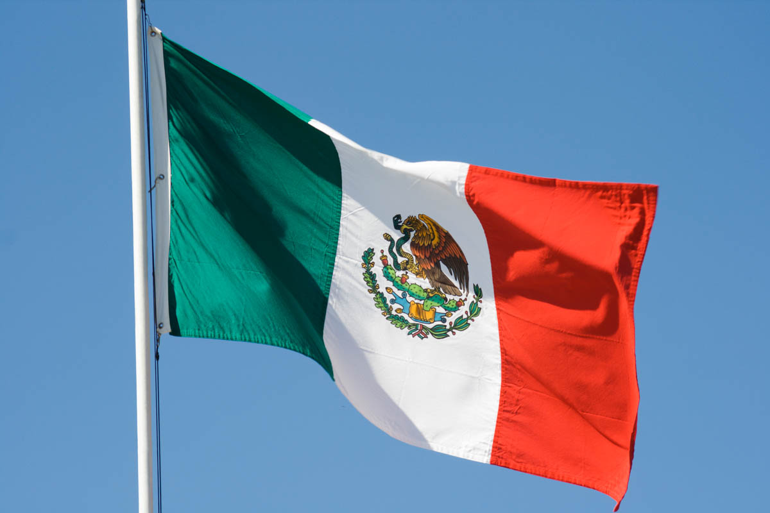

Welcome to Mexico

# 

# Introduction

Welcome to the Country of Mexico located in southern portion of North America where there are so many beautiful landscapes, cultures, and history that creates this country. The capital of this country is called Mexico city and its located in the valley of Mexico. It is the oldest capital in the Americas and was built by the Aztecs in 1325. At that time it was known as Tenochtitlan. The major languages spoken in this country are Spanish. There are many other languages that are spoken throughout the country. For example, in Eastern Mexico Otomi and Totonac are spoken languages in Mexico. Citizens of southeastern Mexico speak Mayan languages.

# History

In 1400 BCE the Olmec civilization which prehistoric people inhabited the coast of Veracruz and western Tabasco on the Gulf of Mexico started to uprise and develop. Then, In 1000 BCE the Mayan civilization began to form which consisted of Maya people developing sophisticated writing, systems in pre-Columbian Americas as well for its arts, architecture mathematics, a calendar, and an astronomical system. In 100 BCE the Mayans built the first pyramids. The great ancient city of Teotihuacan was built between 100 BC and 250 AD. It was the largest city in the area and had a population of about 150,000 people. The Aztec Empire was the last great civilization prior to the arrival of the Spanish, which they ruled from 1325 to 1521. In 1521 Spanish Conquistador Hernan Cortes who conquered the Aztecs and Mexico became a Spanish colony. For 300 years Spain ruled the land until the early 1800s. At the time Mexicans revolted against Spanish rule. Father Miguel Hidalgo declared Mexico’s independence and cried out “Viva Mexico”. On September 16, 1810, Mexico declared its independence.

Important Events that Happened in Mexico Included the founding of Tenochtitlan on April 19, 1325, which was the Aztec’s main Capitol and was known for making human sacrifices. Aztec priests used sharp obsidian blades and would open the chests of the sacrificial humans and cut their hearts out and offer it to the gods. The Mexican-American war on May 14, 1847, which was a major conflict caused by the idea “Manifest Dynasty” which was the belief the expansion of the U.S was inevitable and justified. The Mexican Revolution on August 14, 1910, which was the idea to overthrow General Porfirio Diaz who had been in power for 30 years. North American Free Trade Agreement On January 1st, 1994 is an agreement signed by the governments of Canada, Mexico, and the United States, creating a trade bloc in North America. April 3rd, 1930 the Mexican Economic Miracle the miracle was that when everyone was poor and penniless the stocks and everything went up. July 15, 1990, the war against drugs The War on Drugs is a campaign of prohibition of military aid and is being undertaken by the United States government, with the assistance of other countries, intended to both define and reduce the illegal drug trade. May 22nd, 2012, Mexico's economically collapsed and debt began to rise. During the 1970s two large oil price shocks created current account deficits in many Latin American countries. With the encouragement of the United States government, large US money center banks were willing intermediaries between the two groups and provided exportation with a safe liquid place for their funds and then lensed those funds to Latin America. This led to Latin America’s $29 billion dollars in debt by 1970.

Some important historical people that were born in Mexico are Antonio López de Santa Anna, who was born on February 21, 1794, in Jalapa, Mexico. He became a military captain and was elected president in 1833. He was known for his efforts in staving off Spain's attempt to recapture the country. Andrés Manuel López Obrador, who is a Mexican politician, served as the president of Mexico since 2018.

# Geography of Mexico

Mexico’s geography is quite beautiful and is highly recommended to see because of the civilizations that left historic monuments. Some examples of the country’s landmarks included [Juxtlahuaca](https://www.wondermondo.com/juxtlahuaca/), [Oxtotitlán](https://www.wondermondo.com/oxtotitlan/) and Guerrero. L[a Venta](https://www.wondermondo.com/la-venta/), Tabasco is an achievement of ancient urban planning, art, and architecture, one of the important centers of the ancient Olmec culture. It has occupied since 1200 BC and becoming important center 900 – 400 BC. A complex of clay buildings extending for some 20 km, includes 33 m tall pyramid. Renowned monuments of ancient art four colossal sculptures of heads. [Tres Zapotes](https://www.wondermondo.com/tres-zapotes/), Veracruz. An important center of the ancient Olmec culture founded around 1000 BC and flourished in 900 – 800 BC. Here have been found such unique monuments of Olmec art as two colossal heads, monuments of some of the earliest writing systems, and earliest calendar in the Western Hemisphere.

Mexico also has major Landforms such as Mexican Plateau, It is located between the Sierra Madres Mountains, in the center of the country. The plateau receives a large amount of rain, and because volcanoes surround it has very fertile soil. The central portion of the Mexican Plateau is home to the capital of the nation, Mexico City. It has also been the home of the center of the Mexican people for well over 2000 years. Another landform is the Sierra Madres are the major mountain ranges in Mexico. They are an extension of the Rocky Mountains in the neighboring U.S. The ranges are divided into the Sierra Madre del Sur, Sierra Occidental, and Sierra Oriental. The Sierra Occidental and Oriental run from north to south through Mexico. Another landform is Volcanoes according to the U.S. Department of Interior’s National Atlas website, the area categorized as the Trans-Mexican Volcanic Belt (TMVB) runs horizontally in the southern portion of Mexico. It contains 20 volcanoes, four of which are the highest peaks in the country. Those volcanoes are Popocatepetl, Colima, Paricutin, and Iztaccihuatl. Popocatepetl is one of great concern, as it is located very close to two major cities, Mexico City and Puebla. Chichen Itza is one of Mexico's most visited monuments in Mexico and the largest of the Maya cities in the Yucatan Peninsula. The temple-pyramid of El Castillo is the most famous landmark in Mexico.

There are also major bodies of water in Mexico which include, the Gulf of California locally known as the Mar de Cortes, the Gulf of Mexico, the San Juan River, and Lake Chapala the largest freshwater lake.

Major cities in Mexico include Mexico City, It is the capital and the largest city in Mexico. Architectural buildings, historic places, museums, palaces, monuments, malls, official buildings, Mexico City simply has it all. Guadalajara, the capital of Jalisco state, is the second-largest city in Mexico. Although known as a major business center of Mexico, this city is popular as the birthplace of tequila and mariachi music. The colonial roots and Mexican culture are seen in Guadalajara. Plazas, churches, and cathedrals depicting Mexican history are the famous tourist attractions here. Lake Chapala located at the state of Jalisco. Monterrey, the capital of state Nuevo León, is the third-largest city in Mexico. It is a major financial center and the second richest city in Mexico. The unique Cerro de la Silla or the saddle mountain is a distinct landmark of the city of Monterrey. Apart from various art galleries, museums, forests, and monuments, Monterrey is also the industrial capital of Mexico with the headquarters of several large industries situated here. Leon a city in the state of Guanajuato. It’s a major industrial city where 60% of belts and shoes are made. Veracruz is popular as a major port and for being one of the oldest cities in Mexico. Officially known as Heroica Veracruz, it is located in the state of Veracruz. The city is also known for its historical significance. Although the historical monuments have been lost the city id responsible for making exports and imports. Tijuana It is a major commercial city and, has been a popular tourist destination for more than 100 years. It is one of the most populous cities in Mexico, having a global city status. Puebla, the capital of Puebla state, is the major industrial center in Mexico. Earlier known only for its textile industry, today Puebla is an important commercial center for automobile, iron and steel industries.

# Culture

Mexico's culture is diverse, colorful, and lively, inspired by ancient civilizations such as the Aztec and Maya, as well as European colonization.It is a one-of-a-kind civilization that is perhaps one of the most intriguing in the world.The Mexican people have a wide range of traditions and customs.

### **Government and Currency**

Mexico’s government consists of, a multi-party system and a federal presidential representative democratic republic whose administration is based on a legislative system, with the President of Mexico serving as both head of state and head of government. According to the Political Constitution of the United Mexican States, issued in 1917, the federal government represents the United Mexican States and is organized into three branches: executive, legislative, and judiciary. According to their separate constitutions, the component states of the federation must likewise have a republican form of government based on a legislative system.

The Mexican peso, which is the country's official currency, is abbreviated as MXN. The Mexican peso is made up of 100 centavos and is usually denoted by the letters $or Mex$.

# Population and Native Animals

Mexico’s population is around, 127.6 million citizens and many states have pueblos (villages, or towns) which many people live in and some citizens live in suburban areas. Some native animals that Mexico has is, the Spider monkey, Axolotl Cacomistle, Mexican prairie dog, Ocelot, Vaquita porpoise( sea cow), and the mexican grey wolf.

# Conclusion

This Country has many beauutiul places to visit, the culture, people and history is kept sacred and is told with great pride. Many citizens enjoy their homes and their country because, of the family, animails, and ancestry.