Weekly Home Connections
Quarter 3, Week 2
This Week’s Focus Concepts:
Letters | Sight Words | Color | Shape | Number
Uu, Tt, Vv  Ww, Xx, Yy | or  one  had | white | diamond | six (6)
Our Current Study is:
Clothes/Wheels

Monday
- Practice writing your first and last name.
- Make patterns with household items. How many different patterns can you make?
- Do these words end with the same sound? arm/ham ball/towel fox/buzz
- Read a book with your child. Ask them to retell the events from the story.
Tuesday
- Practice saying each letter and its sound.
- Draw a picture that begins with the sound of each of this week’s letters.
- Make a set of six objects. Then make a set of three objects. How many objects are there in all?
- Recite this week’s nursery rhyme (found below).
Wednesday
- Practice writing your first and last name.
- Practice saying your birthday in a complete sentence.
- Do these words begin with the same sound? man/money water/wheel sad/mad
- Read a book with your child. Ask them to retell the events from the story.
Thursday
- Practice saying each letter and its sound.
- What did you learn about clothes? Draw and write about it!
- Practice counting to 30. Go further if you can!
- Recite this week’s nursery rhyme (found below).

This Week’s Nursery Rhyme
“Little Miss Muffet”
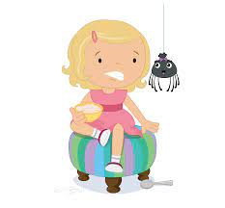

Little Miss Muffet,
She sat on a tuffet,
Eating her curds and whey.
Along came a spider,
Who sat down beside her,
And frightened Miss Muffet away.

