Colombia’s Culture

Colombian culture can be taken back to the early culture of Spain of the 16th century. The Spanish brought Catholicism, Africans, and a caste system that favored born whites. Cultures of the native populations of Colombia were destroyed by the Spanish. The spirit of Colombian culture lies in the mixing of Cumbia and is said to be the copied of the cumbe dance of Equatorial Guinea. The hydrography of Colombia is one of the richest in the world. Its main rivers are Magdalena, Cauca, Guaviare, and Caquetá. Colombia has 4 drainage systems and they are: The Pacific drain, the Caribbean drain, the Orinoco Basin and the Amazon Basin. The signal variety in temperature and precipitation results principally from changes in elevation. Temperatures range from hot at sea level to cold at higher raises but differ little with the season. Colombians usually label their country in terms of the climatic zones. Colombian officials, academics, and members of best society turned to France for motivation in the period, next freedom from Spain.

Education in Colombia

The education in Colombia begins with a preschool academy until the child turns five. Basic education is required by law in Colombia. It has two phases: Primary education which goes from first to fifth grade with children from six to ten years old, and Secondary education which goes from sixth to ninth grade. Basic education is followed by Middle professional education that includes the tenth and eleventh grades. After the positive completion of all the basic and middle education years, a high-school diploma is given. High-school graduates are known as Bachilleres, and secondary school and middle education are traditionally considered together as a unit called bachillerato. Bachilleres may enter into an expert scholar career program offered by a university. Those programs last up to five years. In Colombia, there’s not an organization such as college. Students enter a career program at the university they applied to or any other educational foundation. Some professional career programs, students are required to take the Saber-Pro test, in their final year of undergraduate academic education.

Family in Colombia

Family in Colombia is filled with nearly all of Latin Americans. Members of the long family are close and children hardly move far away from their parents. There’s a deep sense of familial charge that gives through many generations. Men are usually the head of the household and in charge of earning most of the family’s income. Women are usually responsible for cooking, housework, and raising their children. The starting of the 20th century brought forth an enabling power for women to vote. The Constitution of 1991 gave a wider opportunity for women, and today, most families have two working parents due to the need of an income to sustain a family. The parents of the child pick the godparents at the baptism of the child. They play an important role in the child’s life.



Food in Colombia

There’s a large change of dishes that consider the difference in local climates. Colombian cuisine contains the cooking backgrounds and performs of Colombia’s Caribbean shoreline, Pacific coast, mountains, apples, and ranchlands. Colombian cuisine contrasts locally and is partial by the original Chibcha, Spanish, Africa, Arab, and some Asian cuisines. Colombia is one of the world’s largest consumers of fruit juces, more than three quarters of a cup each day. Colombian dishes and ingredients vary usually by region. Most of the common ingredients are: cereals, rice, maize, tubers such as potato and cassava, assorted legumes, meats, including beef, chicken, pork and goat, fish, and seafood. Colombia’s cuisines also have a variety of tropical fruits such as cape gooseberry, feijoa, arazá, dragon fruit, mangostino, granadilla, papaya, guava, blackberry, lulo, soursop and passionfruit.

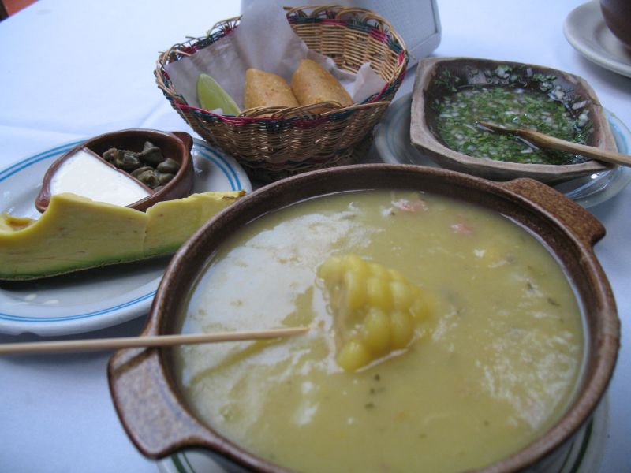Colombian Cuisines

Ajiaco is a soup common to Colombia,

Cuba and Peru. In Bogotá, the capital

of Colombia, the dish is popular and

is typically made with chicken, three

varieties of potatoes, and the Galinsoga

parviflora herb.

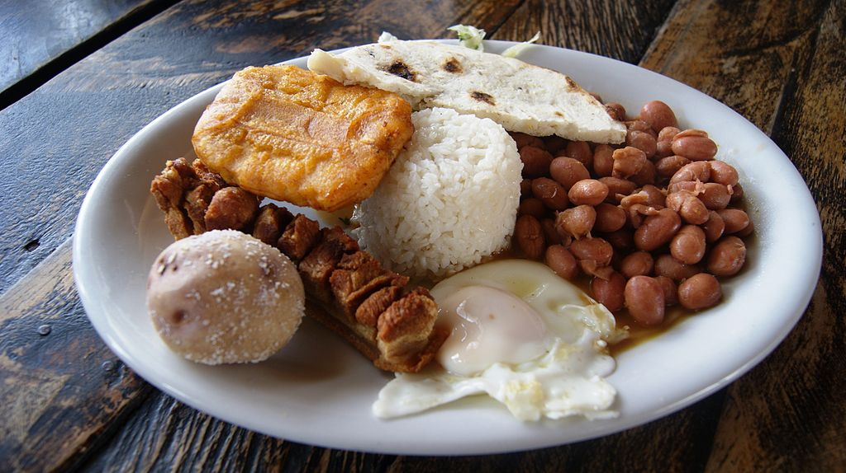The main characteristic of this dish is

the generous amount and variety of

food in a traditional bandeja paisa:

red beans cooked with pork, white rice,

carne molida, chicharrón, fried egg,

plantain, chorizo, arepa, hogao sauce,

black pudding, avocado and lemon.

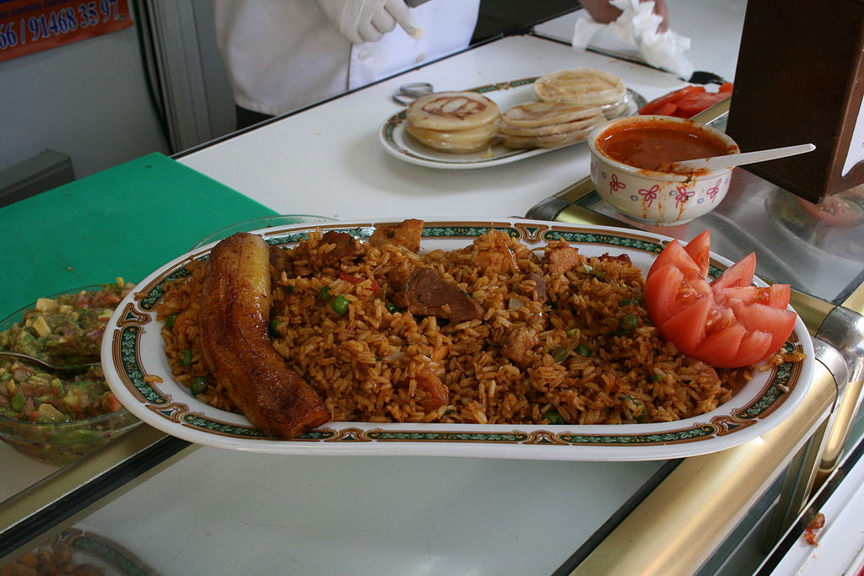

Lechona consists of a roast pig stuffed,

yellow peas, green onion, yellow rice,

and spices cooked in an outdoor, brick

oven for about ten hours.

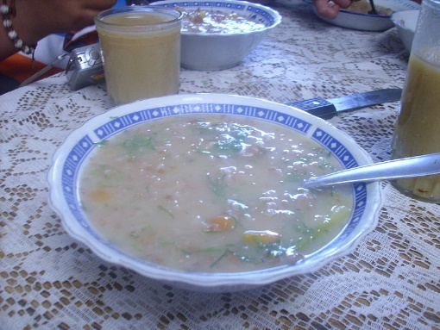Cuchuco is a soup made with corn, barley

or wheat and mashed beans to make Colombian

cuisine soup, especially altiplano of the Boyacá

and Cundinamarca Departments of Colombia.

Colombian Tropical Fruits

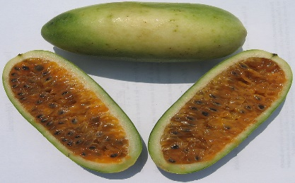Banana passionfruit is the fruit of

several plants in the genus Passiflora.

They look somewhat like a straight,

small banana with rounded ends.

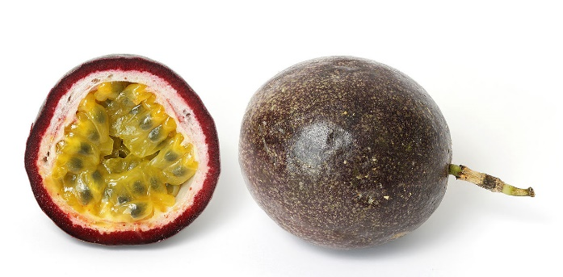Passiflora edulis is a pepo, a type of

berry, round to oval, either yellow or

dark purple at maturity, with a soft to

firm, juicy interior filled with numerous

seeds.

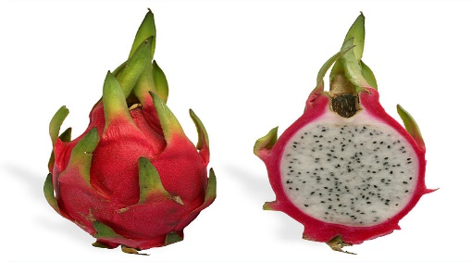

A pitaya is the fruit of several cactus

species indigenous to the Americans.

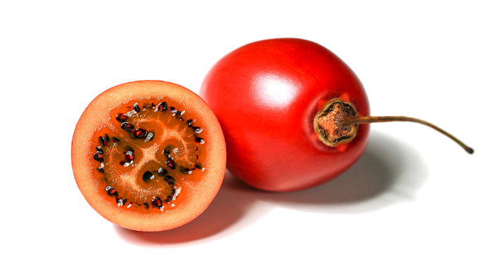

The tamarillo is a small tree or shrub in

the flowering plant family Solanaceae. It’s

also, known as the tree tomato, tamamoro,

and tomate de árbol in South America.

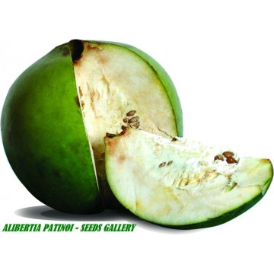

Alibertia patinoi is a small dioecious tropical

rainforest tree. It grows in the northwest area

of Colombia.

Colombian Art

Colombian art has 3000 years of history and styles reaching from Spanish Baroque religious painting to Quimbaya gold skill effort to the “lyrical Americanism” of painter Alejandro Obregon.

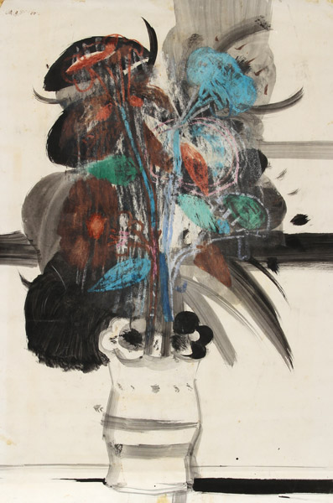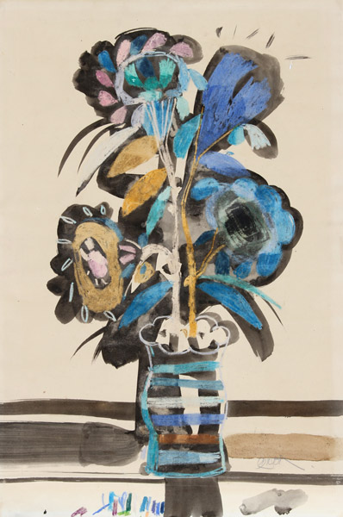 Alejandro Obregón was born in Barcelona, Spain. Most of his childhood was spent in Barranquilla, Colombia. In 1939, he studied fine arts in Boston for a year and returned to Spain to help as Vice Consul of Colombia for years. In 1948, Alejandro was named Director of the School of Fine Arts in Santafé de Bogotá. Alejandro is above all a painter. His arrangements are usually divided straight into two areas of different graphic value or size. Color plays an important role in the structures of his designs. Color has always been a crucial role in his work and they’re on a moving level of the element of the arrangement. Alejandro died on April 11, 1992 due to a brain tumor.

Colombian Music

The music of Colombia contains various music genres giving the features of each physical region, although it’s not common to find unlike musical styles in the same area. The variety in musical looks found in Colombia is the mark of a combination of African, Indigenous, European, and American. Colombia has a bright collage of talent that traces a full variety of beats reaching from Pop music, Classical music, and Rock music. Colombian music is helped mainly by the support of the largest record labels.

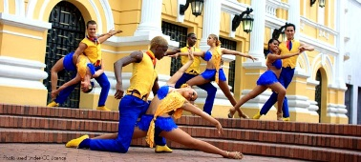Salsa music was among the Puerto Ricans and Cubans of Colombia.

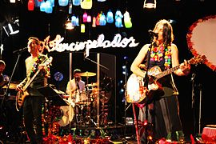Mexican rock artists like Enrique Guzmán and César Costa became very popular in Colombia.

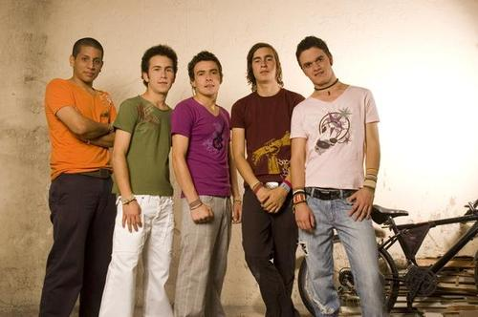Pop with strong traces of traditional Colombian music, named Tropipop, is also rising currently.

Cinema in Colombia

Cinema in Colombia concerns the film business in Colombia. Colombian cinema started in 1897 and has had silent and animated films. The Government of Colombia helped develop the Cinematographic Development Company. It helped produce films that they struggled on before the company was there. The Colombian congress approved the General Law of Culture so they could create a film production named Corporación Proimagenes. They also approved the Law of Cinema, to restart the cinematographic industry in Colombia.

