Weekly Home Connections
Quarter 2, Week 4
This Week’s Focus Concepts:
Letters | Sight Words | Color | Shape | Number
Aa, Bb, Ff  Dd, Gg | it  he  have | green | cone | zero (0)
Our Current Study is:
Trees

Monday
- Give your child a number and have them make a set of that many objects.
- Play “I spy” with different colors.
- Help your child practice writing their first and last name.
- Read a book with your child. Were there any trees or plants in the story?
Tuesday
No school today.
Enjoy your day off!
Wednesday
- Can you find anything shaped like a cone in your home?
- Go on a walk-can you find any leaves or other parts of trees?
- Practice counting from 1 to 20. Go further if you can!
- Read a book with your child. Were there any trees or plants in the story?
Thursday
- Practice saying each letter and its sound.
- Draw and label the parts of a tree.
- Practice saying your birthday (month, date, and year).
- Recite this week’s nursery rhyme (found below).

This Week’s Nursery Rhyme
“Here We Go Round the Mulberry Bush”

Here we go round the mulberry bush,
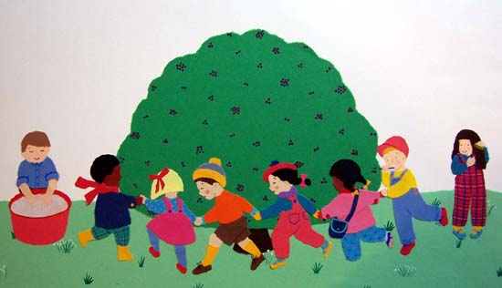
The mulberry bush, the mulberry bush,
Here we go round the mulberry bush
So early in the morning.

Additional verses:
This is the way we bale the hay…
This is the way we feed the chicks…
This is the way we sweep the porch…
This is the way we paint the fence…
This is the way we groom the horse…
This is the way we milk the cows…

