Weekly Home Connections
Quarter 2, Week 3
This Week’s Focus Concepts:
Letters | Sight Words | Color | Shape | Number
Aa, Bb, Ff  Dd, Gg | you  that  gray | gray | sphere | ten (10)
Our Current Study is:
Trees

Monday
- Help your child write their first and last name.
- Draw five circles and five squares-how many shapes do you have in all?
- Practice counting from 1 to 20. Go further if you can!
- Read a book with your child. Ask your child to tell you what happened in the story.
Tuesday
- Practice saying each letter and its sound.
- How many different trees do you see around your home?
- Practice saying your birthday (month, date, and year).
- Recite this week’s nursery rhyme (found below).
Wednesday
- Help your child practice writing their first and last name.
- Draw six triangles and four rectangles-how many shapes do you have in all?
- Practice counting from 1 to 20. Go further if you can!
- Read a book with your child. Ask your child to tell you what happened in the story.
Thursday
- Practice saying each letter and its sound.
- What sounds do these words begin with? dig, fan, lap, mud
- Practice saying your birthday (month, date, and year).
- Recite this week’s nursery rhyme (found below).

This Week’s Nursery Rhyme
“Jack and Jill”
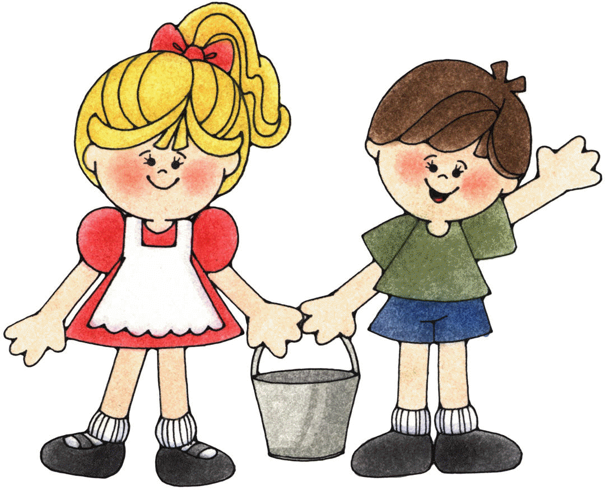

Jack and Jill went up the hill
To fetch a pail of water.
Jack fell down,
And broke his crown,
And Jill came tumbling after.

