Weekly Home Connections
Quarter 2, Week 9
This Week’s Focus Concepts:
Letters | Sight Words | Color | Shape | Number
Review all  letters | Review all  sight words | Review all  colors | Review all shapes | Review all numbers
Our Current Study is:
Clothes

Monday
- Practice writing your first and last name.
- Make a pattern using your favorite colors.
- How does your family clean clothes when they get dirty?
- Read a book with your child. Let your child help read and tell the story.
Tuesday
- Practice saying each letter and its sound.
- What sound do you hear in the middle of these words? dug, bad, hot, peg, fin
- Practice saying your address.
- Recite this week’s nursery rhyme (found below).
Wednesday
- Practice writing your first and last name.
- Make two sets of objects. Which one has more? Which one has less?
- Practice counting from 1 to 20. Go further if you can!
- Read a book with your child. Let your child help read and tell the story.
Thursday
- Practice saying each letter and its sound.
- What has been your favorite part of school so far? Draw and write about it!
- Practice saying your address.
- Recite this week’s nursery rhyme (found below).

This Week’s Nursery Rhyme
“Three Little Kittens”
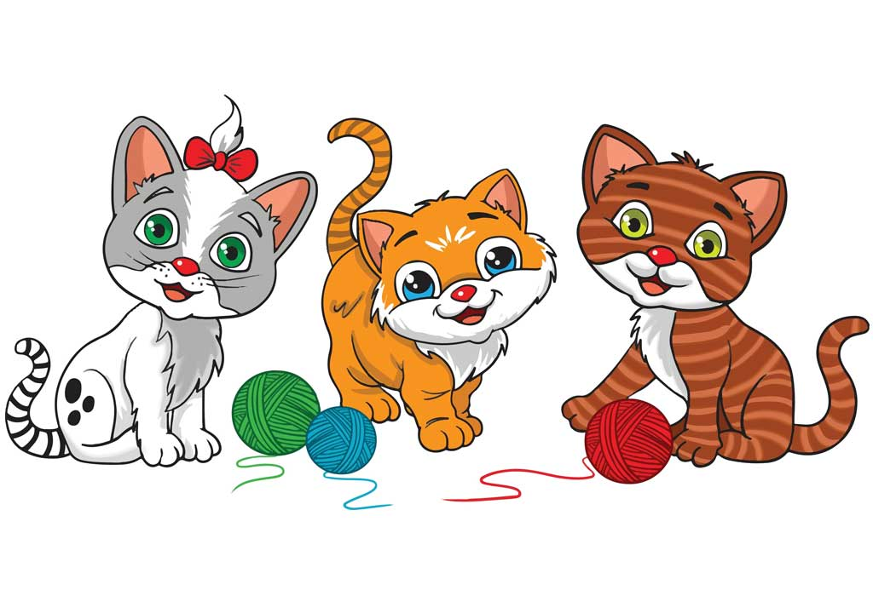
Three little kittens,
They lost their mittens
And they began to cry.
Oh, mother dear, we sadly fear
Our mittens we have lost.
What? Lost your mittens?
You silly kittens!
Then you shall have no pie.
Meow, meow, meow, meow (x2)

Oh, Mother Dear see here, see here
Our mittens we have found!
Put on your mittens,
You silly kittens!
Now you shall have some pie.
Meow, meow, meow, meow (x2)

