Weekly Home Connections
Quarter 3, Week 6
This Week’s Focus Concepts:
Letters | Sight Words | Color | Shape | Number
Aa, Bb, Ff  Dd, Gg | when  your | gray | hexagon | ten (10)
Our Current Study is:
Wheels/Buildings

Monday
- Practice writing your first and last name. How many letters can you identify?
- Put these letters together: b a g What word does this spell?
- Practice counting to 40. Go further if you can!
- Read a book with your child. Do you see any wheels in the story?
Tuesday
- Practice saying each letter and its sound. Name the letters as fast as you can!
- Go on a color hunt-how many gray things can you find?
- You have ten items. Then, a family member takes away eight. How many are left?
- Recite this week’s nursery rhyme (found below).
Wednesday
- Practice writing your first and last name. How many letters can you identify?
- Practice saying, “My birthday is _____.”
- Put these letters together: g u m What word does this spell?
- Read a book with your child. Do you see any wheels in the story?
Thursday
- Practice saying each letter and its sound. Name the letters as fast as you can!
- What did you learn about wheels? Draw and write about it!
- Practice counting to 40. Go further if you can!
- Recite this week’s nursery rhyme (found below).

This Week’s Nursery Rhyme
“Teddy Bear, Teddy Bear”
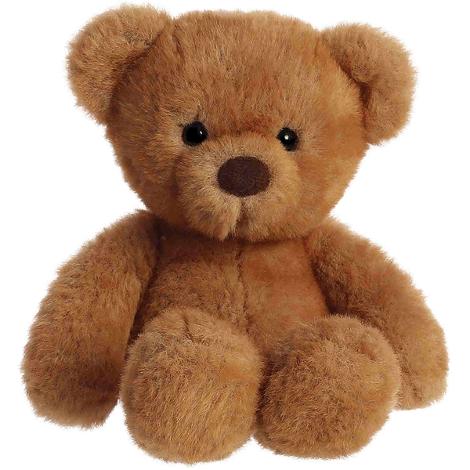

Teddy bear, teddy bear, turn around!
Teddy bear, teddy bear, touch the ground!
Teddy bear, teddy bear, jump up high!
Teddy bear, teddy bear, touch the sky!

Teddy bear, teddy bear, bend down low!
Teddy bear, teddy bear, touch your toes!
Teddy bear, teddy bear, turn out the light!
Teddy bear, teddy bear, say goodnight!

