Weekly Home Connections
Quarter 4, Week 5
This Week’s Focus Concepts:
Letters | Sight Words | Color | Shape | Number
Ii, Zz, Qq  Cc, Kk | some  her  him | brown | rectangle  diamond | eight (8)
Our Current Study is:
Exercise

Monday
- Practice writing your first and last name. What other words can you write?
- Practice writing your numbers from one to twenty.
- Look around your home for circles and triangles. Which shape did you find more of?
- Read a book with your child. Let your child help you read.
Tuesday
- Practice naming each letter and its sound(s) as fast as you can.
- Practice saying, “My phone number is _____.”
- Practice counting by 10s to 100.
- Recite this week’s nursery rhyme (found below).
Wednesday
- Practice writing your first and last name. What other words can you write?
- How many ways can you make the number ten?
- Can you read this sentence? I see the little blue ball.
- Read a book with your child. Let your child help you read.
Thursday
- Practice naming each letter and its sound(s) as fast as you can.
- What did you learn about exercise? Draw and write about it!
- Practice counting to 50. Go further if you can!
- Recite this week’s nursery rhyme (found below).

This Week’s Nursery Rhyme
“Head, Shoulders, Knees and Toes”
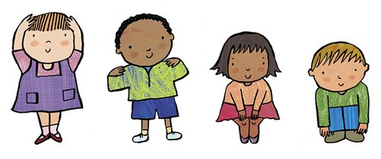

Head, shoulders, knees and toes, knees and toes.
Head, shoulders, knees and toes, knees and toes.
Eyes and ears and mouth and nose,
Head, shoulders, knees, and toes, knees and toes.

