Weekly Home Connections
Quarter 2, Week 7
This Week’s Focus Concepts:
Letters | Sight Words | Color | Shape | Number
Oo, Nn, Pp  Rr, Ss | as  with | blue | circle | three (3)
Our Current Study is:
Trees/Clothes

Monday
- Practice saying each letter and its sound.
- Count out sets of 0-5 items. Use objects you find around the house.
- Help your child write their first and last name.
- Read a book with your child. What is the setting of the story?
Tuesday
- Can you find three things that are blue? What did you find?
- What sound do you hear at the end of these words? red, top, cob, kit
- Practice saying your address.
- Recite this week’s nursery rhyme (found below).
Wednesday
- Practice writing this week’s letters (upper and lowercase).
- Draw a circle. Color it blue. Does your circle have any sides?
- Practice counting from 1 to 20. Go further if you can!
- Read a book with your child. What is the setting of the story?
Thursday
- Practice saying each letter and its sound.
- What did you learn about trees? Draw and write about it!
- Practice saying your address.
- Recite this week’s nursery rhyme (found below).

This Week’s Nursery Rhyme
“Little Boy Blue”
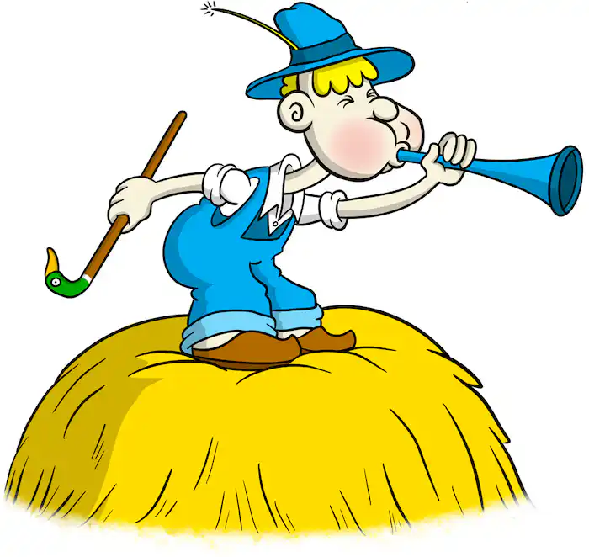

Little boy blue come blow your horn,
The sheep’s in the meadow, the cow’s in the corn.
But where’s the boy who looks after the sheep?
He’s under a haystack, fast asleep.
Will you wake him?
No, not I.
For if I do, he’s sure to cry.

