CLUE Supply List

Ms. Rauch

[rauchce@scsk12.org](mailto:rauchce@scsk12.org)

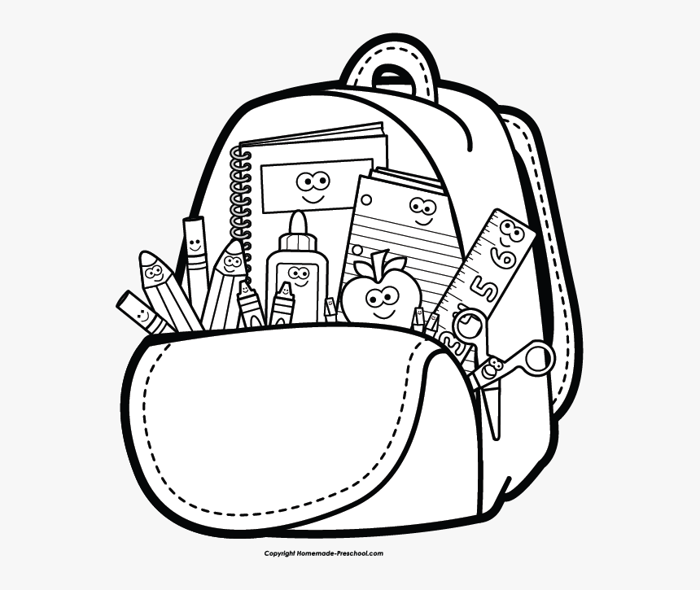

* 1 Ream of White Copy Paper
* A bag of individually wrapped candy (dealer’s choice)
* A gift card (any amount will help!) from one of the following places: Target, Wal-Mart or Amazon