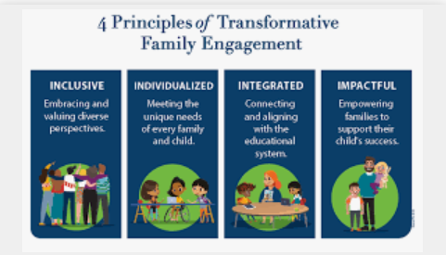  May 23rd, 2023  Parent Resource Center 11:00 a.m.  Douglass high school Auditorioum 4:30 P.M.  Home/School & Family Engagment Meeting  Purpose:    Home/School Compact and Family Engagement Plan identifies activities that parents, the entire school staff, students and all other stakeholders will undertake to share the responsibility for improving student academic achievement. In addition, the school-parent compact outline activities that the parents, school staff and students will undertake to build and develop a partnership to help scholars achieve the state’s rigorous academic standards. |   ────  Panorama Family – School Relationship Survey  ────  Parent Engagement Opportunities  ────  Parent Needs Assessment  ────  Douglass high School  3200 Mt. Olive Road  Memphis, TN 38108  901-416-0990  Web Address  https://schools.scsk12.org/frederickdouglass-hs

