Weekly Home Connections
Quarter 3, Week 4
This Week’s Focus Concepts:
Letters | Sight Words | Color | Shape | Number
Ii, Zz, Qq  Cc, Kk | what  all | purple | star | eight (8)
Our Current Study is:
Wheels

Monday
- Practice writing your first and last name. How many letters can you identify?
- Find at least five things that begin with the first letter of your name. What did you find?
- Go on a star hunt. What did you find?
- Read a book with your child, letting them “read” through words and pictures.
Tuesday
- Practice saying each letter and its sound.
- Practice writing and saying, “My phone number is _____.”
- Make a set of seven objects. Now make a set of eight different objects. Which set has more? Which set has less?
- Recite this week’s nursery rhyme (found below).
Wednesday
- Practice writing your first and last name. How many letters can you identify?
- Practice making patterns. How many different patterns can you make?
- Play “I spy” with purple and other colors.
- Read a book with your child, letting them “read” through words and pictures.
Thursday
- Practice saying each letter and its sound.
- What wheels do you see at home? Draw and write about it!
- Practice counting to 40. Go further if you can!
- Recite this week’s nursery rhyme (found below).

This Week’s Nursery Rhyme
“Humpty Dumpty”
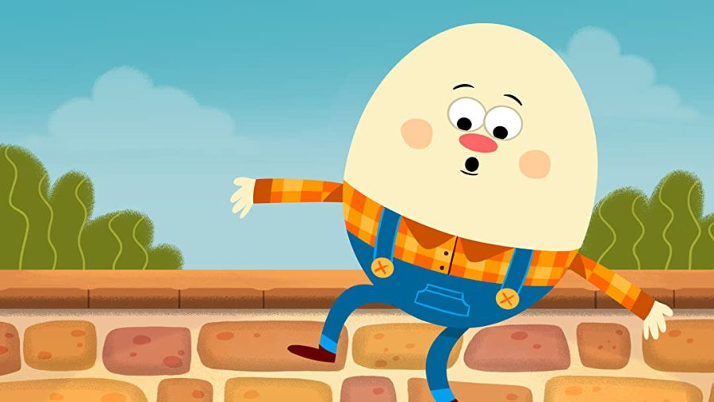

Humpty Dumpty sat on a wall,
Humpty Dumpty had a great fall;
All the king’s horses and all the king’s men
Couldn’t put Humpty together again.

