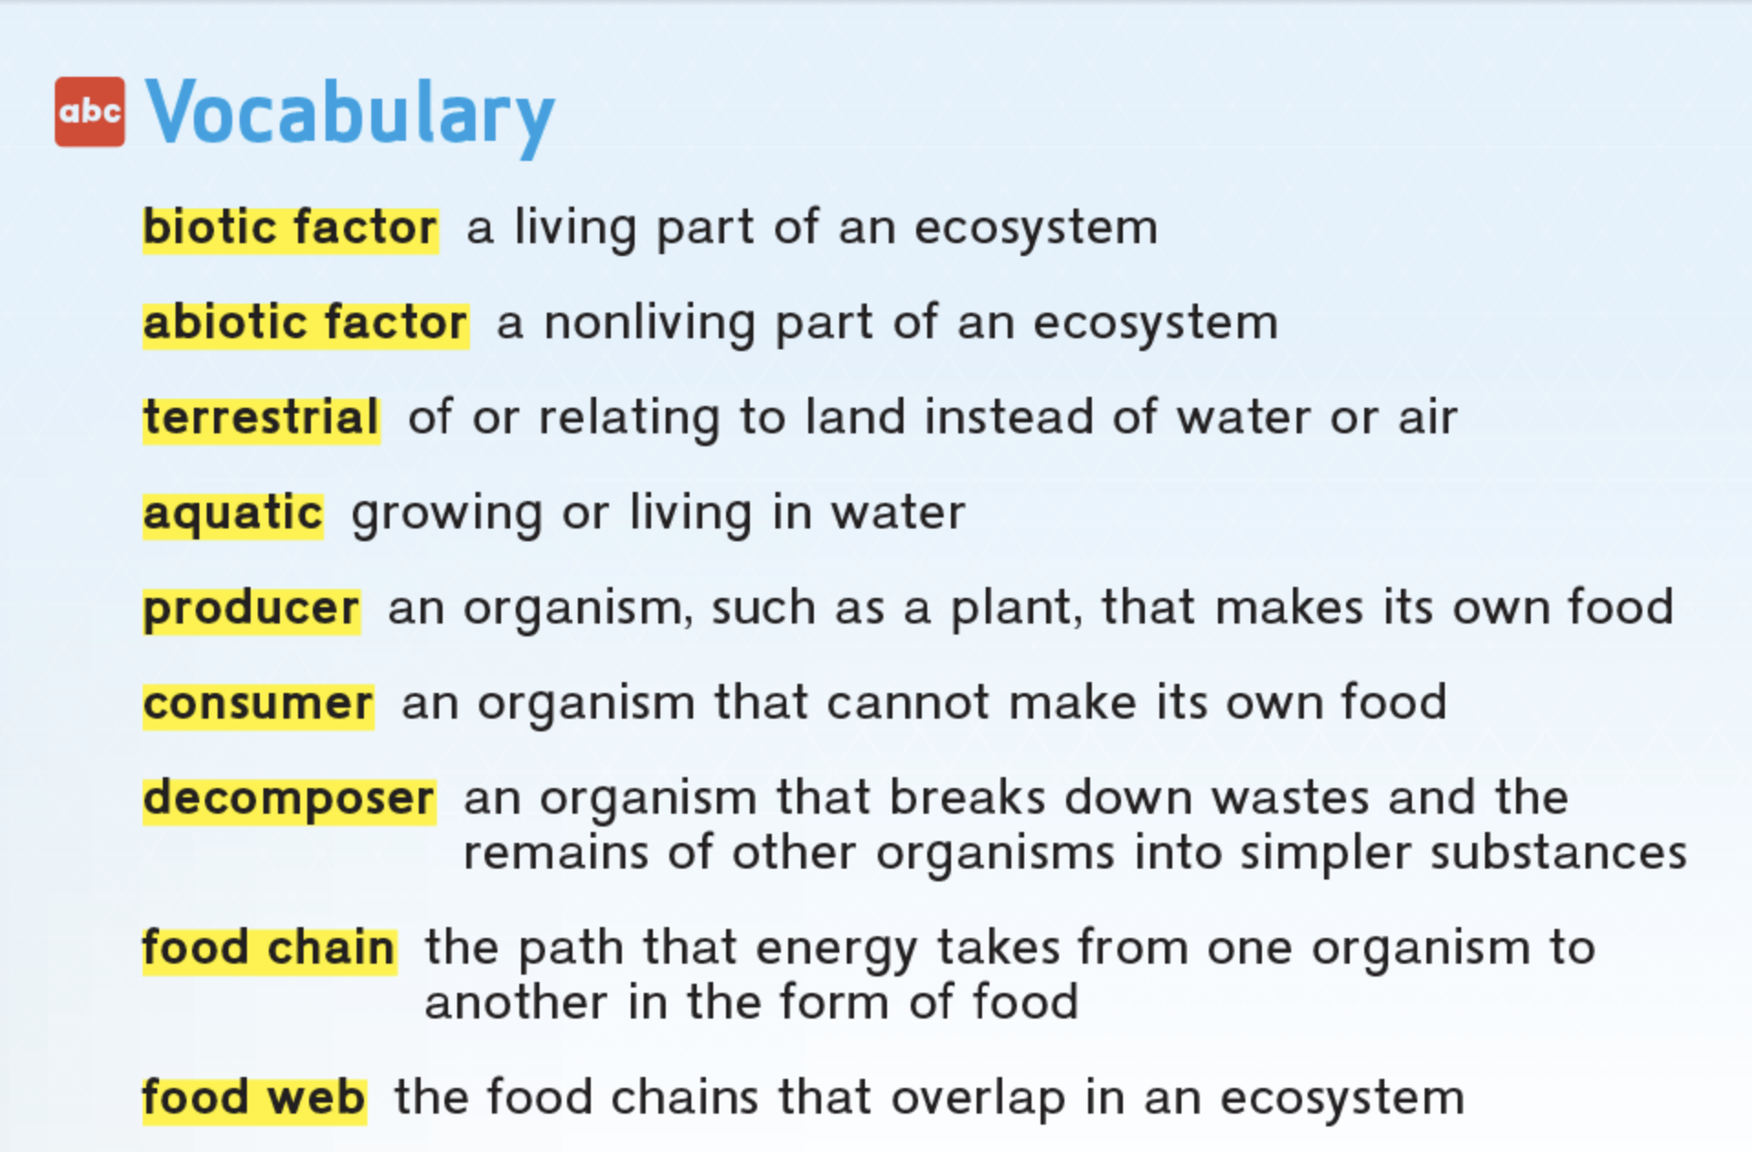

Transfer- To change or move from one object to another

Microbe- an organism that is too small to see

Succession- a series of changes in a community of an ecosystem

Competition- When two or more organisms need to use the same limited resource to survive

Stable- Steady or unchanging

Cycle- a series of events that repeats itself

Increase- to become larger in size or number
Decrease- to become smaller in size or number
Reduce- to become smaller in size or number

