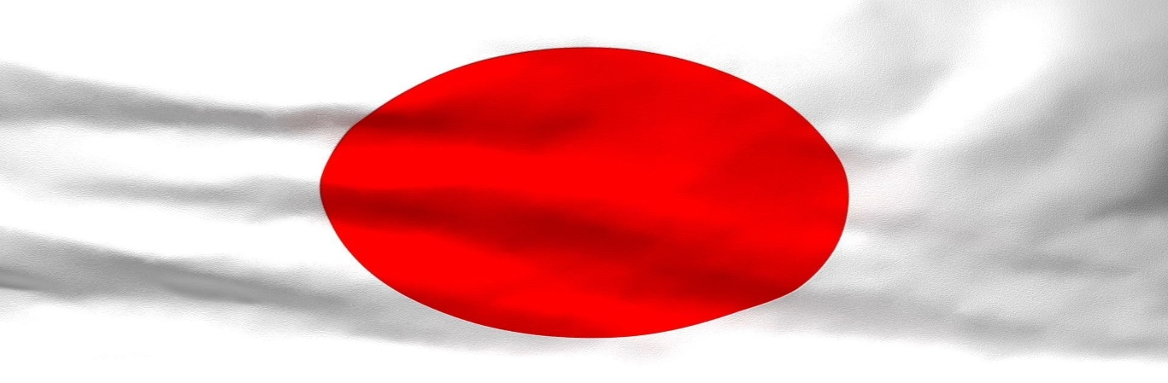

**Japan**

Japan is an island country in East Asia, located in the northwest Pacific Ocean. It is bordered on the west by the Sea of Japan (East Sea) and extends from the Sea of Okhotsk in the north toward the East China Sea and Taiwan in the south. Japan’s capital is Tokyo. The major language spoken in Japan is Japanese.

**History**

Japan was discovered in 660BC. Japan was unified in **1590** under Toyotomi Hideyoshi. During the 1500s, the Portuguese arrived in Japan. They began to trade and learn about European society and the west. In 1974, The Constitution of Japan goes into effect. In, 1952, the United States occupation comes to an end. In 1964, the summer Olympics were held in Tokyo. In 1968, Japan becomes the second largest economic power in the world. In 1972, the United States returns Okinawa to Japan. Sakachi Toyoda, Emperor Akihito, and Fujita Den are well known people in Japan’s history.

**Geography**

Japan’s major landforms are Mount Fuji, tectonic lines, beaches, and coastlines. Japan’s major landmarks are Kyoto’s Machiya, Jigokudani Monkey Park, and Tokyo Tower. Japan’s major bodies of water are Jogasaki Coast, Lake Kawaguchiko, and Kabira Bay. Japan’s major cities are Tokyo, Yokohama, and Osaka.

**Culture**

Three of Japan’s famous clothing styles are Kimono, Hakama, and Obi. Some of Japan’s famous holidays are Children's Day, Coming of Age Day, and the Tanabata Festival. Japan’s well-known foods are Sushi, Tempura, and Sukiyaki. Japan’s famous songs are “Tegami” by Angela Aki, “Yuki no Hana” by Mika Nakashima, and “Minna Yume no Naka” by Kyoko Takada. Shinto and Buddhism are the two major religions in Japan. The government of Japan consists of legislature, executive and judiciary branches and is accountable to the Emperor of Japan. The Prime Minister of Japan is the chief executive of the government and is responsible for selecting ministers to serve in the Cabinet of Japan.

**Economy**

Japan’s natural resources consists of Forestry, Fisheries, and Agricultural Land. Japan’s manufacturing areas are **semiconductors, consumer electronics, optical fibers, automobile manufacturing, optoelectronics, copy machines, facsimile,**and**optical media**. Japan’s land use is Arable land: 11.7%; permanent crops: 0.8%; permanent pasture: 0%. Major occupations in Japan are IT professionals, Business Analyst, and Sell staff. The yen is the official currency of Japan. It is the third most traded currency in the foreign exchange market after the United States dollar and the Euro.

**Climate**

Japan experiences most of its rainfall during the summer months, beginning in June. The country's rainy season usually lasts just three or four weeks and is the typical time for rice-planting. This is a hot and humid time to visit Japan, with temperatures often exceeding 85 degrees Fahrenheit (30 degrees Celsius). The average yearly rainfall in Japan is 5.6 inches. The average yearly temperature in Japan is 15.6 °C.

**Interesting Facts**

1.Origami Originated in Japan. Origami cranes on the tree.

2. Square Watermelons Make an Expensive Gift in Japan.

3. Japan Has the World's Largest Wholesale Fish Market.

4. Japan Has the World's Shortest Escalator.