Riverwood Elementary Optional School
Mathematics – Grade 5
Quarter 1
Remote Learning
Practice and Enrichment Packet



Quarter 1 Fifth Grade Standards-Aligned Tasks
Hello SCS Family,
This resource packet was designed to provide students with activities which can be completed at home independently or with the guidance and supervision of family members or other adults. The activities are aligned to the TN Academic Standards for Mathematics and will provide additional practice opportunities for students to develop and demonstrate their knowledge and understanding.

A suggested pacing guide is included; however, students can complete the activities in any order over the course of several days. Below is a table of contents which lists each activity.
Batting Averages and Dancing Digits 2
Vacation Plans and The Stopwatch 5
Place Value Game and Repeated Decimal Products 8
Jayden’s Gym Class and Trendy T-Shirts 12
Decimal Sums and Differences 15
Ten Times as Much as or One-Tenth of and Less than, Equal to, Greater than 20
Using Multiplication Vocabulary and Equivalent Multiplication Expressions 25
Represent Decimal Products 30

Quiz 35

Week 1
Fifth Grade Math Standards-Aligned Learning: Batting Averages and Dancing Digits
Grade Level Standard(s) | 5.NBT.A.1 Recognize that in a multi-digit number, a digit in one place represents 10 times as much as it represents in the place to its right and 1/10 of what it represents in the place to its left.  5.NBT.A.3 Read and write decimals to thousandths using standard form, word form, and expanded form (e.g., the expanded form of 347.392 is written as 3 x 100 + 4 x 10 + 7 x 1 + 3 x (1/10) + 9 x (1/100) + 2 x (1/1000)). Compare two decimals to thousandths based on meanings of the digits in each place and use the symbols >, =, and < to show the relationship.
Caregiver Support Option | Encourage students to draw/use a place value chart when solving  the problems. Encourage students to use the correct language  when reading the symbols > (greater than) < (less than) = (equal  to)to answer questions.
Materials Needed | Recording sheet, pencil
Question to Explore | Why did you put each digit in its own place?  The value of a digit in a written numeral depends on its place, or position, in a number. For any number, the place of a digit tells how many ones, tens, hundreds, and so forth are represented by that digit.  How do you know which number is smaller?  Whole numbers and decimals can be compared by analyzing corresponding place values. A number to the right of another on the number line is the greater number
Student Directions | Read each problem. Respond the directions.

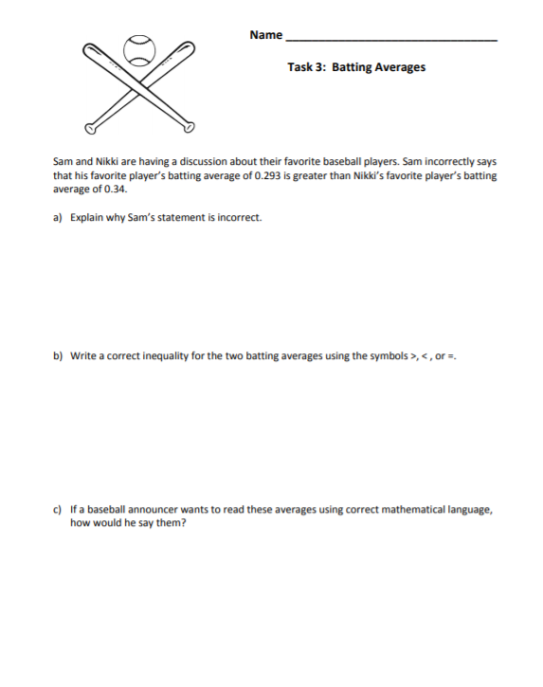
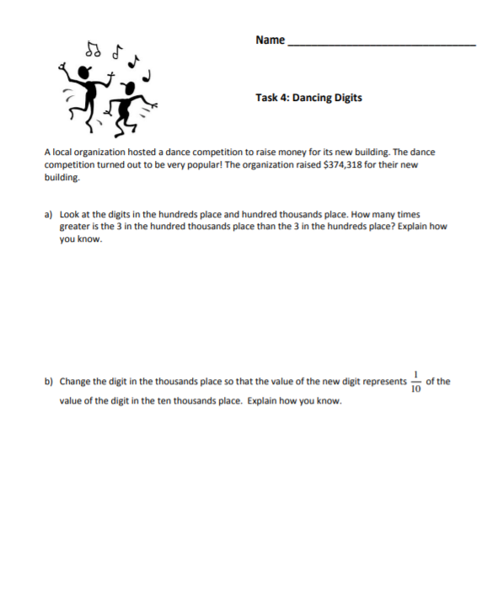
Week 2
Fifth Grade Math Standards-Aligned Learning: Vacation Plans and The Stopwatch
Grade Level Standard(s) | 5.NBT.A.2 Explain patterns in the number of zeros of the product when multiplying a number by powers of 10, and explain patterns in the placement of the decimal point when a decimal is multiplied or divided by a power of 10. Use whole-number exponents to denote powers of 10.  5.NBT.A.3 Read and write decimals to thousandths using standard form, word form, and expanded form (e.g., the expanded form of 347.392 is written as 3 x 100 + 4 x 10 + 7 x 1 + 3 x (1/10) + 9 x (1/100) + 2 x (1/1000)). Compare two decimals to thousandths based on meanings of the digits in each place and use the symbols >, =, and < to show the relationship.  5.NBT.A.4 Round decimals to the nearest hundredth, tenth, or whole number using understanding of place value.
Caregiver Support Option | Encourage students to draw a place value chart or base ten  blocks to help them solve the problems.
Materials Needed | Recording Sheet, pencil
Question to Explore | Why did you put each digit in its own place? The value of a digit in a written numeral depends on its place, or position, in a number. For any number, the place of a digit tells how many ones, tens, hundreds, and so forth are represented by that digit.  How does this pattern of going right in the place value chart relate to going left on the place value chart? Each place value to the left of another is ten times greater than the one to the right (e.g., 100 = 10 x 10).
Student Directions | Read each question and solve.

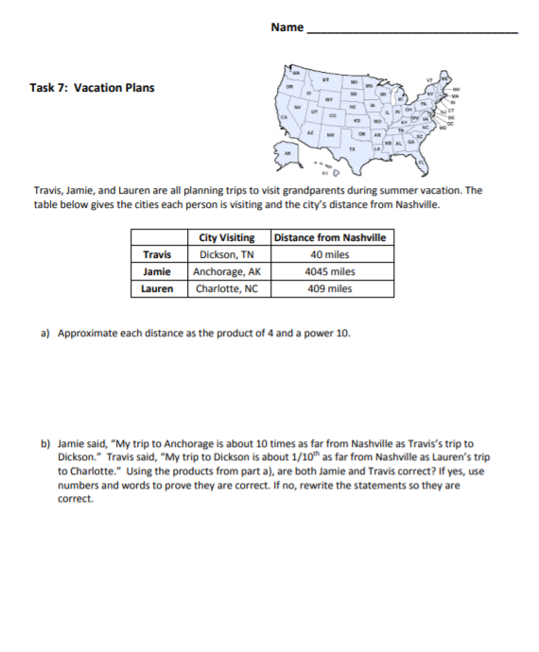
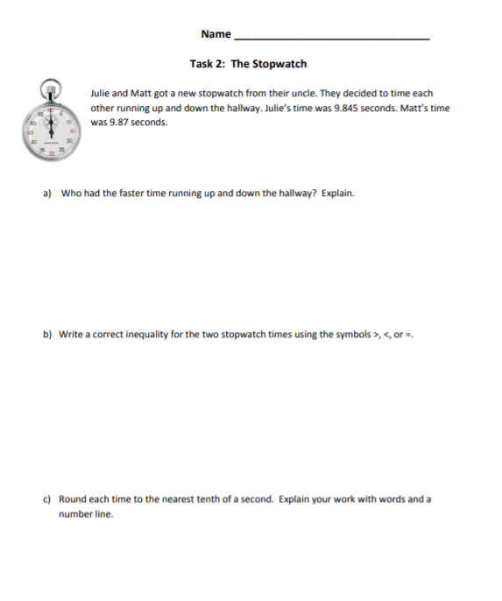

Week 3
Fifth Grade Math Standards-Aligned Learning: Place Value Game (Addition and Subtraction) and Represent Decimal Products
Grade Level Standard(s) | 5.NBT.A.1 Recognize that in a multi-digit number, a digit in one place represents 10 times as much as it represents in the place to its right and 1/10 of what it represents in the place to its left.  5.NBT.B.7 Add, subtract, multiply, and divide decimals to hundredths, using concrete models or drawings and strategies based on place value, properties of operations, and/or the relationship between operations; assess the reasonableness of answers using estimation strategies. (Limit division problems so that either the dividend or the divisor is a whole number.)
Caregiver Support Option | Students must understand the place value system in order to be successful  in this task. As a variation on the interactive activity, students may be  given the grid and an ink pen (to prevent changing answers). Parents can  state the goal (largest sum, smallest sum, largest difference, etc.) and  draw the cards one at a time. Students must place each number in the  grid AS IT IS DRAWN FROM THE DECK in order to meet the goal. Once the  number is placed, students cannot change the placement. This variation  requires not only an understanding of place value but also a basic  understanding of probability (knowing how many of each digit is left in the  deck and the probability that a particular digit will be drawn).
Materials Needed | Recording sheet, pencil, number cards,
Question to Explore | How can you compare numbers and decimals? Whole numbers and decimals can be compared by analyzing corresponding place values.
Student Directions | Place Value Game  To play the game, draw eight number cards then use the numbers to fill in the grid.  Students can then either add or subtract the two numbers they have formed using the number cards.  Represent Decimal Products  Look carefully at the area models and decide which one goes with your partial products.
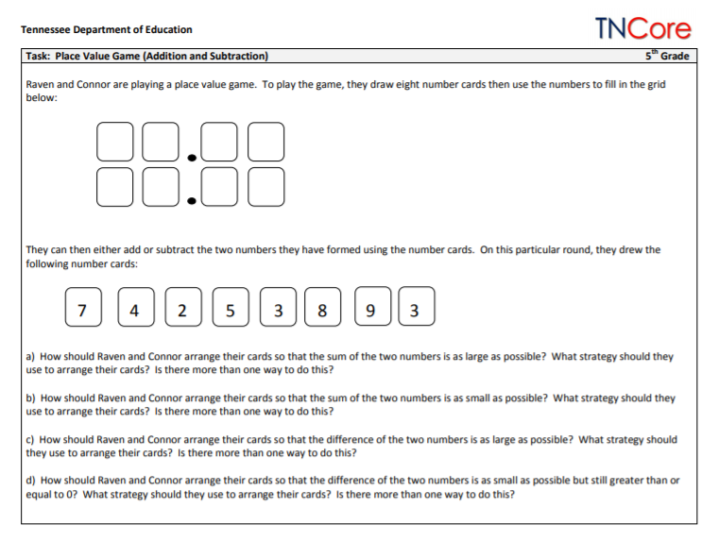
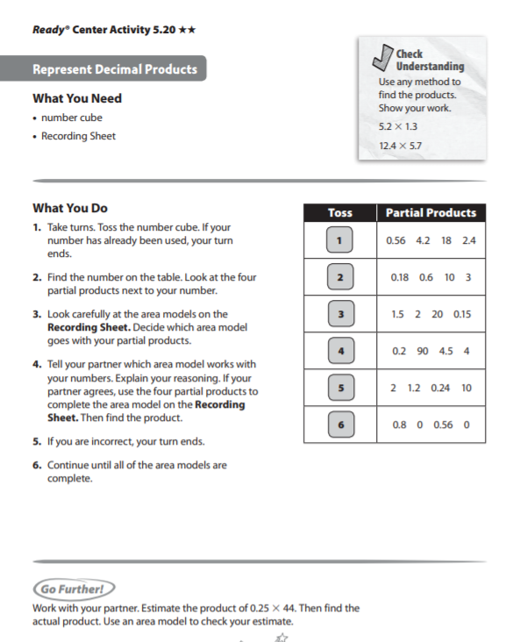
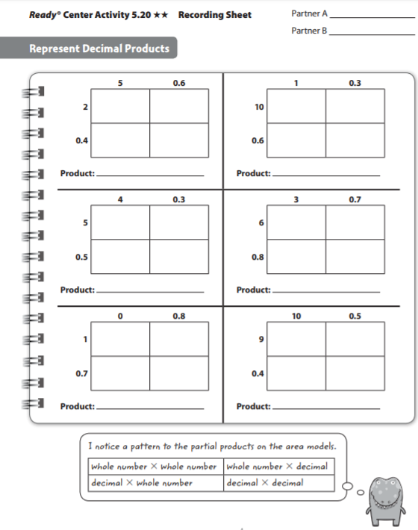

Week 4
Fifth Grade Math Standards-Aligned Learning: Jayden’s Gym Class and Trendy T-Shirts
Grade Level Standard(s) | 5.NBT.A.2 Explain patterns in the number of zeros of the product when multiplying a number by powers of 10, and explain patterns in the placement of the decimal point when a decimal is multiplied or divided by a power of 10. Use whole-number exponents to denote powers of 10.
Caregiver Support Option | Encourage students to read the statements/question carefully.  Encourage students to follow the directions carefully.
Materials Needed | Recording sheet, pencil
Question to Explore | How did you choose the exponent in each expression?  Can you explain how you found the correct answer?  Is there more than one way to find the correct answer? Explain.
Student Directions | Read the problem at the top of the page. Respond to each statement/question.

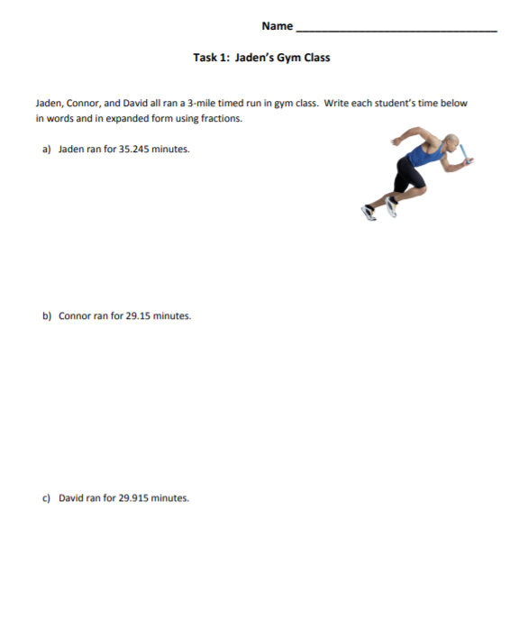

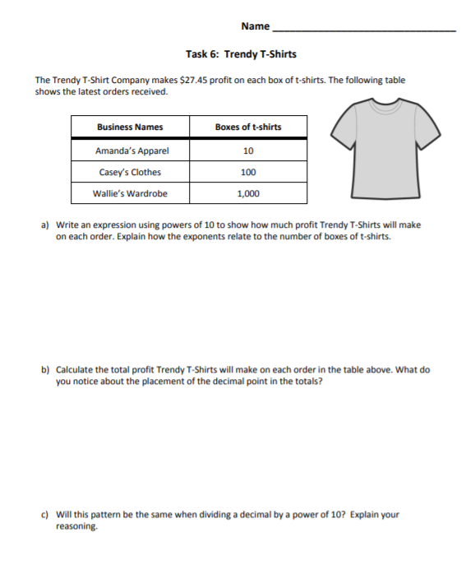

Week 5
Fifth Grade Math Standards-Aligned Learning: Decimal Sums and Differences
Grade Level Standard(s) | 5.NBT.B.7 Add, subtract, multiply, and divide decimals to hundredths, using concrete models or drawings and strategies based on place value, properties of operations, and/or the relationship between operations; assess the reasonableness of answers using estimation strategies. (Limit division problems so that either the dividend or the divisor is a whole number.)
Caregiver Support Option | Students add and subtract decimals through hundredths. They  apply the standard algorithm for addition and subtraction t  decimals. By using visual models such as place-value charts,  number lines, and base-ten models, they conceptualize adding  and subtracting decimals.
Materials Needed | Recording Sheet, pencil
Question to Explore | How does using expanded form in words help you add  decimals? Using expanded form helps understand the  relationship of place value to the addition process and the  importance of adding hundredths and hundredths, tenths and  tenths. Expanded form helps avoid place value errors, such as  adding tenths and hundredths instead of tenths and tenths.
Student Directions | Decimal Sums and Differences  Use number sense, estimation, or mental math to decide if the equation is true or false. Explain your reasoning to your partner.  Have a partner check your work by simplifying both sides of the equation.  Write the equation in the correct column on the recording sheet.

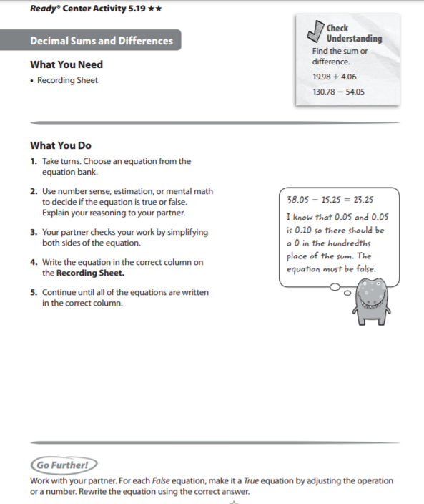
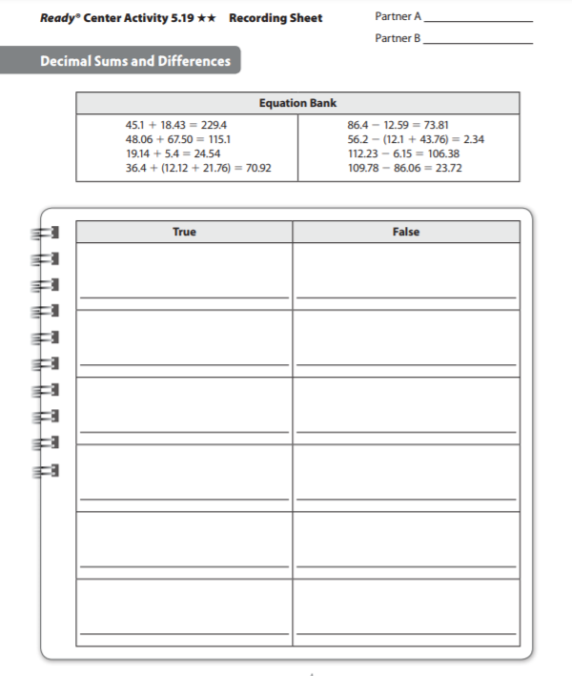

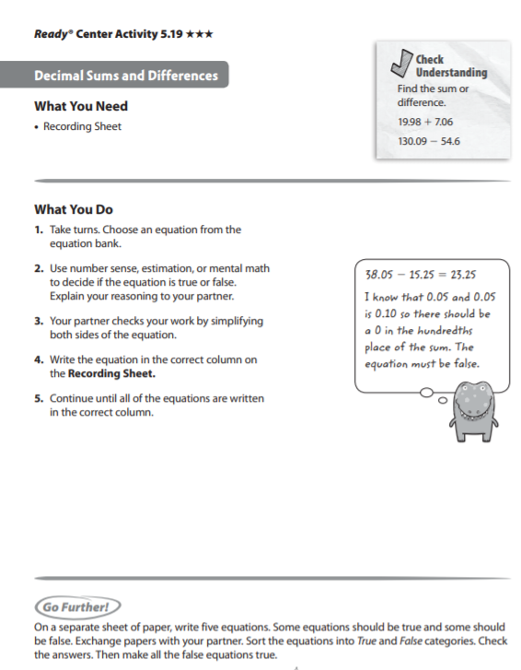

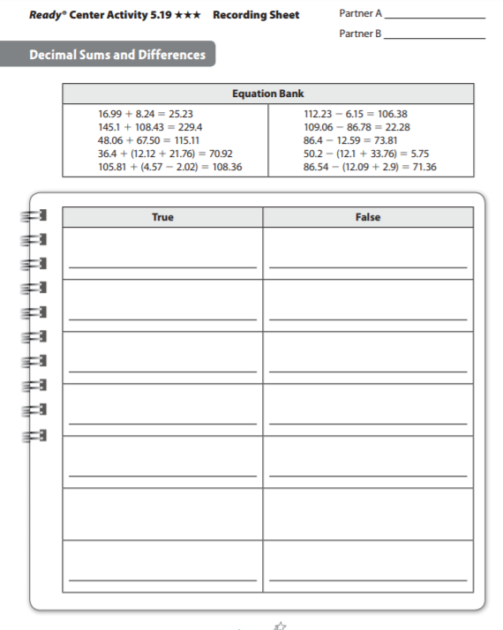

Week 6
Fifth Grade Math Standards-Aligned Learning: Ten Times as Much as or One-Tenth of and Less than, Equal to, Greater than
Grade Level Standard(s) | 5.NBT.A.1 Recognize that in a multi-digit number, a digit in one place represents 10 times as much as it represents in the place to its right and 1/10 of what it represents in the place to its left.  5.OA.A.1 Use parentheses and/or brackets in numerical expressions and evaluate expressions having these symbols using the conventional order (Order of Operations). 5.OA.A.2 Write simple expressions that record calculations with numbers and interpret numerical expressions without evaluating them. For example, express the calculation "add 8 and 7, then multiply by 2" as 2 x (8 + 7). Recognize that 3 x (18,932 + 921) is three times as large as 18,932 + 921, without having to calculate the indicated sum or product.
Caregiver Support Option | They use grouping symbols (parentheses and fraction bars) to  evaluate and write numerical expressions, such as 2 x (5 + 8), in  order to find solutions to problems. They recognize the importance  of the placement of parentheses and understand that numerical  expression such as 2 x (5 + 8) and 2 x 5 + 8 have different values.  Students also extend their understanding of place value to include  decimals to the thousandths place.
Materials Needed | Recording sheet, pencil
Question to Explore | What is the order of operations? Students’ responses should  indicate an understanding that multiplication and division are  performed before addition and subtraction.  How does division relate to multiplication when finding the value of  each place in a number? Students have learned that each place  value is ten times the value of the place to its right. Listen for  students understanding that division is the inverse of multiplication  and reasoning that if the value of one place is equal to the value  of the place to the left divided by 10.
Student Directions | Ten Times as Much as or One-Tenth of-Look at the number in the second column. Decide if that number is 10 times as much as (or 1/10 of ) your number. Less than, Equal to, Greater than-Use your number sense to evaluate each expression. Tell if you think the value is less than, equal to, or greater than 18.
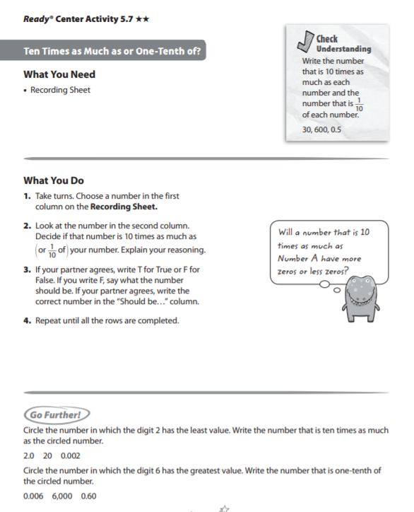
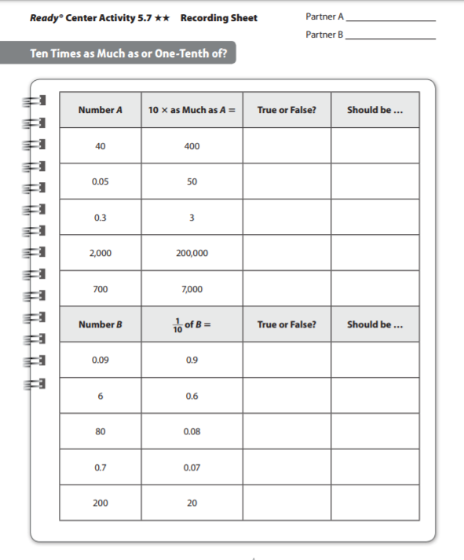
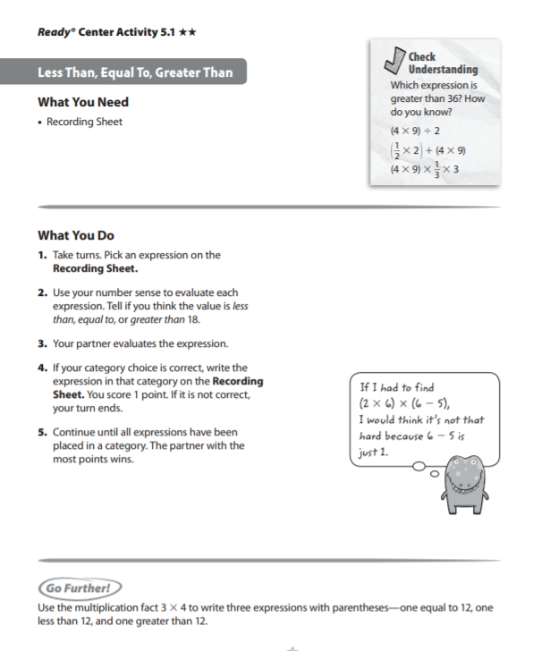

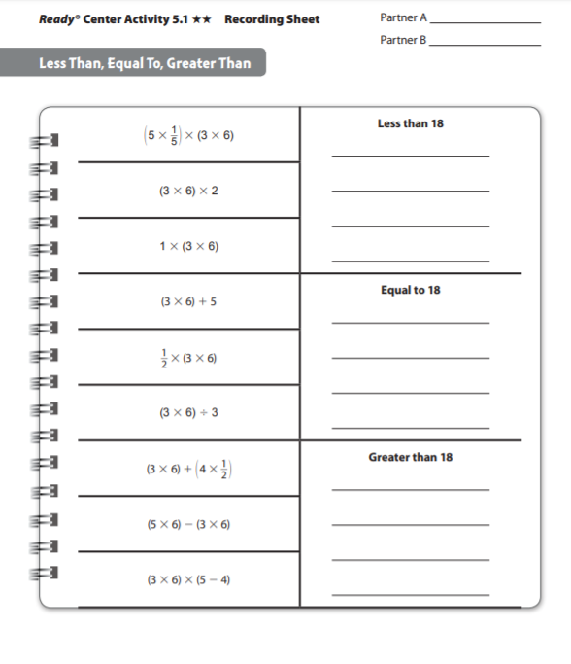

Week 7
Fifth Grade Math Standards-Aligned Learning: Using Multiplication Vocabulary and Equivalent Multiplication Expressions
Grade Level Standard(s) | 5.NBT.B.5 Fluently multiply multi-digit whole numbers (up to three-digit by four-digit factors) using appropriate strategies and algorithms.
Caregiver Support Option | Students are exposed to multiply fluently using the standard  algorithm. Students will need to be able to multiply fluently using the  standard algorithm when they learn to multiply decimals.
Materials Needed | Recording Sheet
Question to Explore | How does the area model help you solve the problem? It shows a  picture of the product and breaks apart the factors to easily  identify them and help find the partial products.  Why is it okay to add the partial products? The area model shows  that the sum of the partial products is the total area, or the entire  product.
Student Directions | Use Multiplication Vocabulary  Read the problem on the Recording Sheet. Read the paragraph that tells how to solve the problem. Use word from the word bank to fill in the blank.  Equivalent Multiplication Expressions  Pick an expression in the table. Decide if the expression is equivalent to the multiplication expression in the header row. Use any method to determine if the expressions are equivalent.

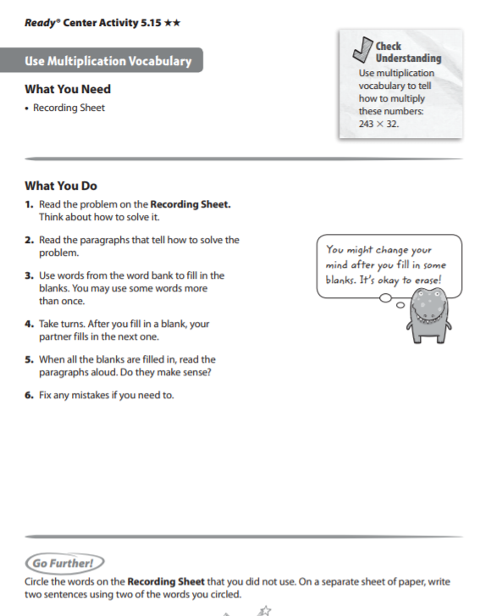
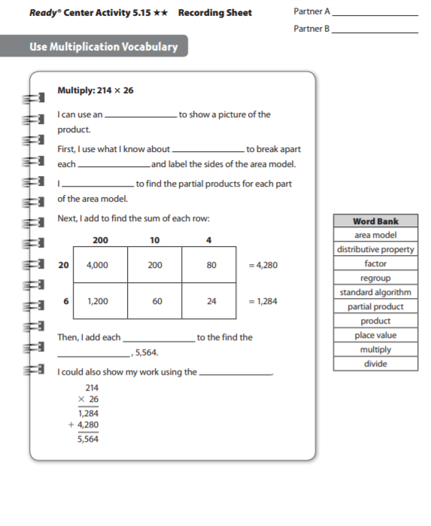
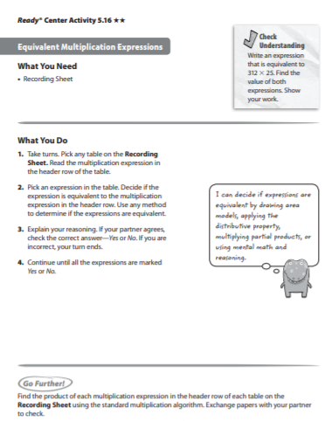

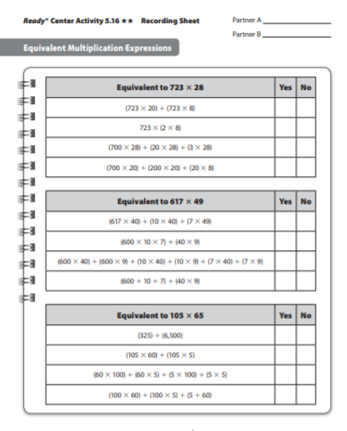

Week 8
Fifth Grade Math Standards-Aligned Learning: Represent Decimal Products
Grade Level Standard(s) | 5.NBT.B.7 Add, subtract, multiply, and divide decimals to hundredths, using concrete models or drawings and strategies based on place value, properties of operations, and/or the relationship between operations; assess the reasonableness of answers using estimation strategies. (Limit division problems so that either the dividend or the divisor is a whole number.)
Caregiver Support Option | Students multiply decimals through hundredths. They use  connections between patterns in decimal multiplication and whole  number multiplication. They expand their previous conceptual  understanding of multiplication by using decimals grids and area  models to multiply tenths and hundredths decimals.
Materials Needed | Recording sheet
Question to Explore | Why do you estimate the product? Estimating the product helps  you know how much the actual product should be.  Look at your estimate and look at the product you found. Does  the answer make sense? How can you tell? The product ___  makes sense because it is close to the estimate of ___.
Student Directions | Find the number on the table. Look at the four partial products next  to your number. Look carefully at the area models on the Recording  Sheet. Decide which area model goes with your partial products.

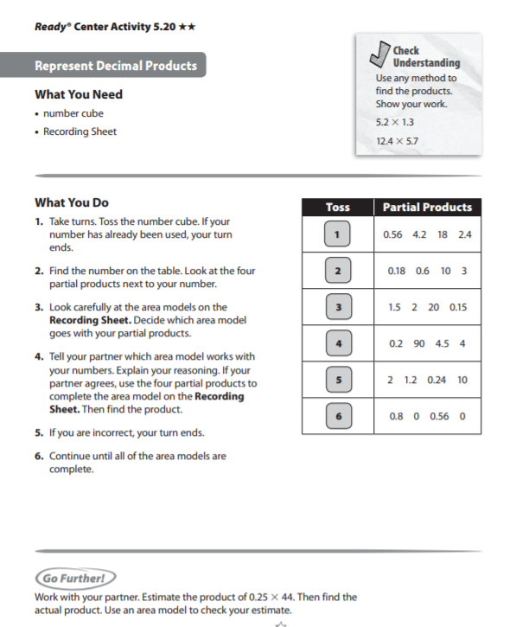

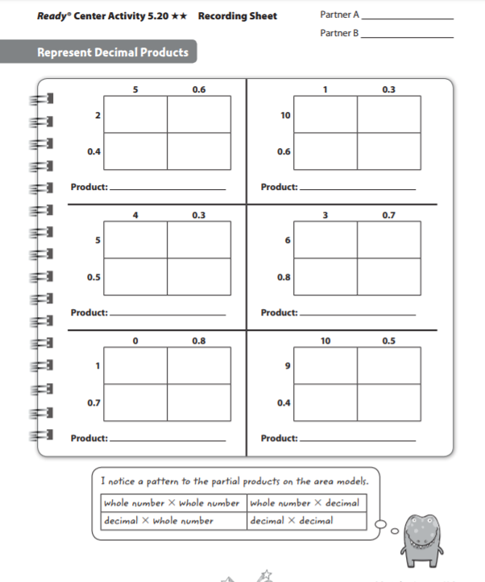

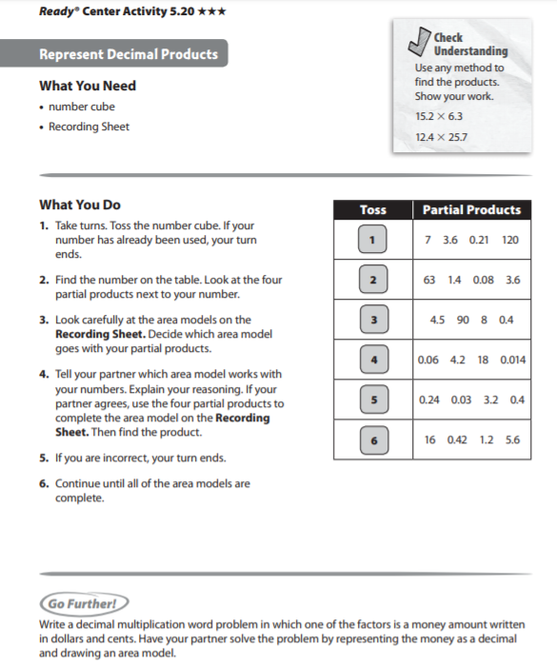

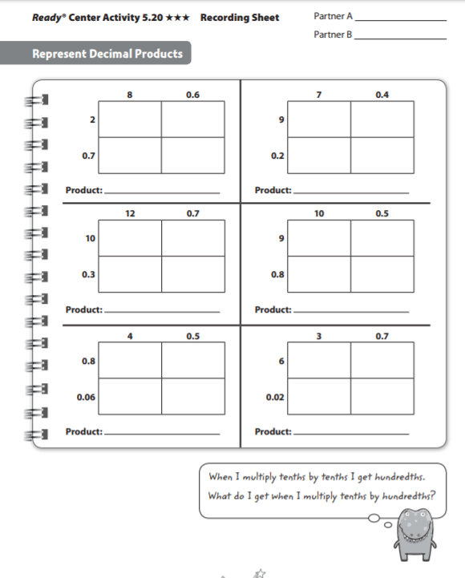
Week 9
Fifth Grade Math Standards-Aligned Learning: Quiz
Grade Level Standard(s) | 5.MD.A.1 Convert customary and metric measurement units within a single system by expressing measurements of a larger unit in terms of a smaller unit. Use these conversions to solve multi-step real-world problems involving distances, intervals of time, liquid volumes, masses of objects, and money (including problems involving simple fractions or decimals). For example, 3.6 liters and 4.1 liters can be combined as 7.7 liters or 7700 milliliters.
Caregiver Support Option | Encourage the students to read each question carefully. Remind the  students to show his/her work. Remind students to use the RDW  process when solving word problems- Read the problem, Draw a  model, and Write an equation and sentence.
Materials Needed | Lesson 21B Quiz, paper
Question to Explore | Why do you multiply to convert a larger unit to a smaller unit?  Students may explain that one larger unit is equivalent to a group of  smaller units. Each group of smaller units is a set. Multiplication is  the operation of finding the total of a set of equal numbers.
Student Directions | Read each problem and solve.

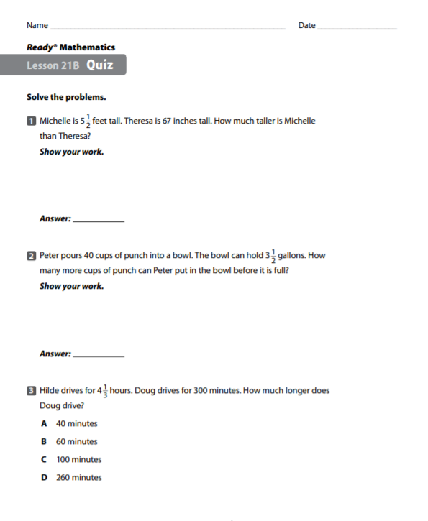

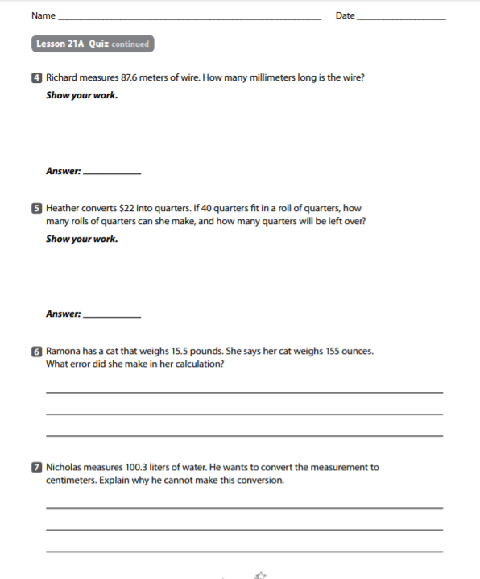


5th Grade Social Studies
Quarter 1
Remote Learning
Practice and Enrichment Packet

Hello SCS Family,

This resource packet was designed to provide students with activities which can be completed at home independently or with the guidance and supervision of family members or other adults. The activities are aligned to the TN Academic Standards for Social Studies and will provide additional practice opportunities for students to develop and demonstrate their knowledge and understanding.

A suggested pacing guide is included; however, students can complete the activities in any order over the course of several days. Below is a table of contents which lists each activity.

Table of Contents

Activity | Page Number | Suggested Pacing
The World in Your Hands | 3 | Week 1
Prehistoric People | 5 | Week 2

The World in Your Hands
Grade Level Standard(s) | Social Studies practice 6: Geographic Awareness
Caregiver Support Option | Students may need assistance with mixing supplies and materials for the Paper Mache’ globes.
Materials Needed | - A bucket of water and paper towel to rinse and dry hands.  - Skewer – used to pop the balloon when the globe is dry  - Paint brushes and paint, markers, or crayons  - Pencil  - Punch balloon or a small round balloon (from the local party store)  - Flour  - Water  - Newspaper cut into 1.5" strips  - Blue paint  - Paintbrushes  - Mod Podge  - Scissors  - Mason jar lid  - Whisk
Question to Explore | What makes up a globe?
Student Directions | Work to make a replica of a globe.

Student Instructional Task
Students will create a Paper Mache’ globe to replicate a real globe

Activity 1: Paper Mache’ Magic
Make a Paper Mache’ globe using the following directions:
- Blow up the punch balloon.
- In a large bowl, whisk together equal parts flour and water to make a paste.
- Dip the newspaper strips into the flour and water solution. Make sure to lay down extra newspaper, as this can get messy!
- Completely cover the entire area of the balloon with strips of coated newspaper. (For extra stability, set the balloon inside the mason jar lid and anchor on four sides with heavy jars or glasses).
- Allow the balloon to dry for 24 hours. Then paint it blue and allowing the paint to dry.
- Draw the continents on paper then cut them out. Paste the continent cut outs on the globe with glue or Mod Podge. Once the glue is dry, coat the entire globe with Mod Podge as well.
https://www.pbs.org/parents/crafts-and-experiments/paper-mache-earth-centerpiece

Activity 2: Globe Caption
You are going to write a cation for your globe. Please be sure to details for all continents and oceans. Feel free to highlight and other features on the globe

Prehistoric People
Grade Level Standard(s) | 5.27 Identify the cultures of the major indigenous settlements in Tennessee, including: the Paleo (Coats-Hines Site), Archaic, Woodland (Old Stone Fort, Pinson Mounds), and Mississippian (Chucalissa Indian Village).
Caregiver Support Option | Assist in the review of vocabulary: Woodland Indians, Mississippians, Chucalissa Village, Pinson Mounds, Old Stone Fort, settlement, indigenous
Materials Needed | - Paper  - Pencil  - Crayons or markers  - Scissors
Question to Explore | How did prehistoric people change over time?
Student Directions | Students will review the progression of prehistoric people over time. Students will also match descriptions to different groups of people

Student Instructional Task
Students will review the progression and different lifestyles of the Woodland Indians, Mississippians, Chucalissa Village, Pinson Mounds, Old Stone Fort, settlement, indigenous. Students will then draw pictures to explain or detail the progression.

Activity 1: Timeline Creation
- Create a timeline to show how prehistoric people changed over time using paper and pencil.
- Start with the first group of people and continue to add on the different groups of people.

Activity 2: Match Up
- Using paper, create name cards listing the names of the different groups of prehistoric people.
- Using paper, create a set of cards that describe the different groups of people. Put one description on each card. There should be at least three descriptions for each group.
- Place the name cards on a hard service and spread them across in a horizontal line
- Mix up the descriptions cards
- With a family member, work to match the description cards to the name cards.
- Once you thing you have the right description for the name card, place it in the column or under the group’s name card.

