Mathematics – Grade 4

Quarter 1

Remote Learning

Practice and Enrichment Packet



**Quarter 1 Fourth Grade Standards-Aligned Tasks**

Hello SCS Family,

This resource packet was designed to provide students with activities which can be completed at home independently or with the guidance and supervision of family members or other adults. The activities are aligned to the TN Academic Standards for Mathematics and will provide additional practice opportunities for students to develop and demonstrate their knowledge and understanding.

A suggested pacing guide is included; however, students can complete the activities in any order over the course of several days. Below is a table of contents which lists each activity.

**Pennies for the Garden and Tall Towers 2**

**Mighty Mountains and Park Patrons 5**

**Multi-step Word Problems 9**

**Multi-step Word Problems 14**

**Convert Table Measurements 16**

**Playing Basketball and Jack & the Beanstalk 21**

**Multiplication**   **24**

**Earning Money and Dividing by One-Digit Numbers**   **29**

**Dividing by One-Digit Numbers**  **34**

|  |  |
| --- | --- |
| **Week 1** | |
| **Fourth Grade Math Standards-Aligned Learning: Pennies for the Garden and Tall Towers** | |
| **Grade Level Standard(s)** | Standards for Task 1:  4.NBT.A.1 Recognize that in a multi-digit whole number (less than or equal to 1,000,000), a digit in one place represents 10 times as much as it represents in the place to its right. For example, recognize that 7 in 700 is 10 times bigger than the 7 in 70 because 700 ÷ 70 = 10 and 70 x 10 = 700.  4.NBT.A.2 Read and write multi-digit whole numbers (less than or equal to 1,000,000) using standard form, word form, and expanded form (e.g. the expanded form of 4256 is written as 4 x 1000 + 2 x 100 + 5 x 10 + 6 x 1). Compare two multidigit numbers based on meanings of the digits in each place and use the symbols >, =, and < to show the relationship. |
| **Caregiver Support Option** | 4th Grade students will solve real-world problems in which they have to consider the relationships between the digits in multi-digit numbers. They will use written and physical representations as well as mathematical reasoning to link the concept of place value to  comparisons and rounding. |
| **Materials Needed** | Recording sheet, pencil |
| **Question to Explore** | How does the position of a digit in a number affect its value? For any number, the place of a digit tells how many ones, tens, hundreds, and so forth are represented by that digit.  How can you represent the same number in different ways?  How did you decide how many pennies the 4th Grade donated for the garden project?  Why is multiplication an appropriate operation to use to solve this problem? |
| **Student Directions** | Use manipulatives or drawings to model multi-digit whole numbers.  Apply concepts of place value and multiplication to show that a  digit in one place represents ten times what it represents in the  place to its right.  Write multi-digit numbers in expanded form. |

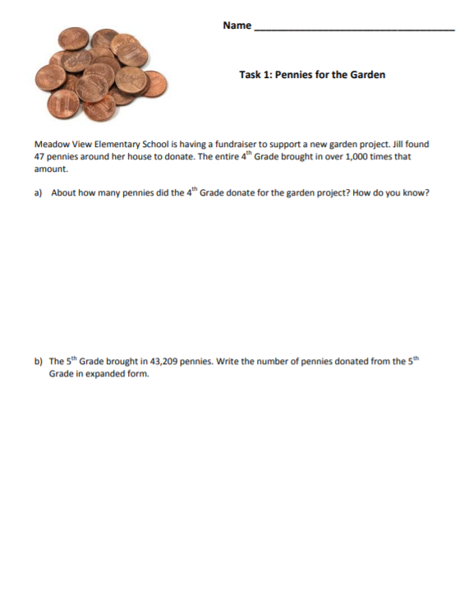

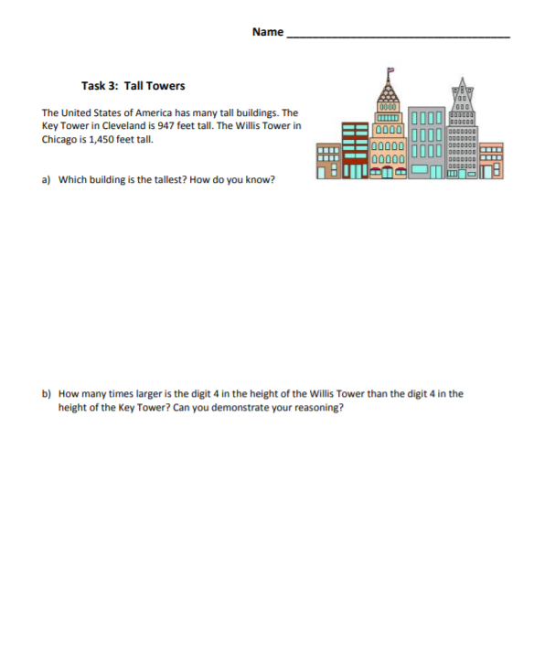

|  |  |
| --- | --- |
| **Week 2** | |
| **Fourth Grade Math Standards-Aligned Learning: Mighty Mountains, Park Patron** | |
| **Grade Level Standard(s)** | 4.NBT.A.1 Recognize that in a multi-digit whole number (less than or equal to 1,000,000), a digit in one place represents 10 times as much as it represents in the place to its right. For example, recognize that 7 in 700 is 10 times bigger than the 7 in 70 because 700 ÷ 70 = 10 and 70 x 10 = 700.  4.NBT.A.2 Read and write multi-digit whole numbers (less than or equal to 1,000,000) using standard form, word form, and expanded form (e.g. the expanded form of 4256 is written as 4 x 1000 + 2 x 100 + 5 x 10 + 6 x 1). Compare two multidigit numbers based on meanings of the digits in each place and use the symbols >, =, and < to show the relationship.  4.NBT.A.3 Round multi-digit whole numbers to any place (up to and including the hundred-thousand place) using understanding of place value. |
| **Caregiver Support Option** | If this task is too difficult for some students, consider using smaller  numbers. Use the language “close to” and “closest to” to help  them understand rounding as a useful and natural activity. |
| **Materials Needed** | Recording Sheet, pencil |
| **Question to Explore** | Could writing the numbers in expanded form help in comparing them? Why or why not?  How does moving one place to the left change the value of the same digit in a multi-digit number? The value of the digit increases ten times.  How does moving one place to the right change the value of the same digit in a multi-digit number? The value of the digit decreases. |
| **Student Directions** | Read each question and solve. |

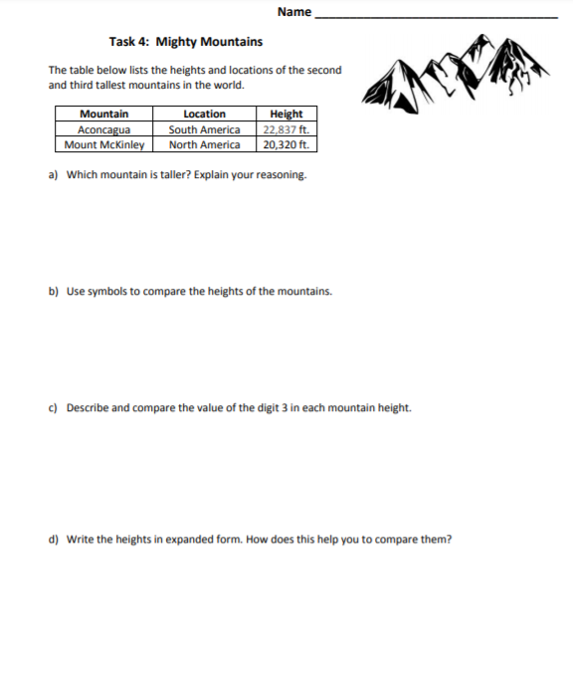

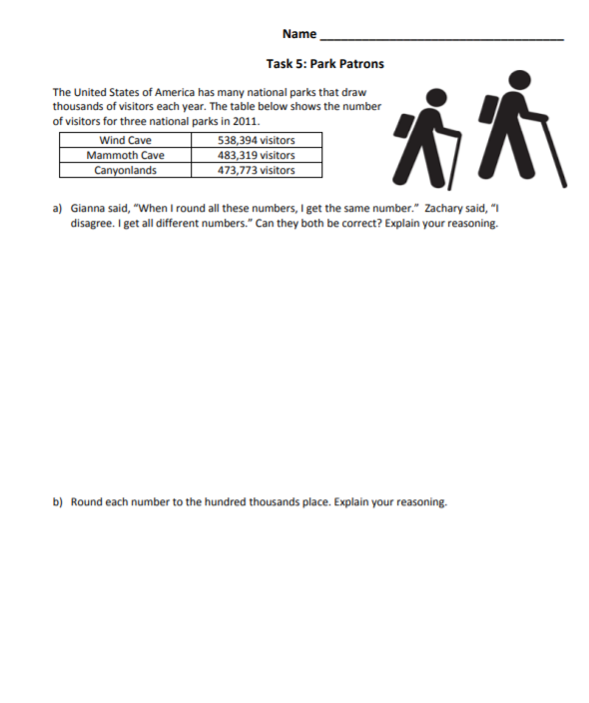

|  |  |
| --- | --- |
| **Week 3** | |
| **Fourth Grade Math Standards-Aligned Learning: Multi step Word Problems** | |
| **Grade Level Standard(s)** | 4.OA.A.3 Solve multi-step contextual problems posed with whole numbers and having whole-number answers using the four operations, including problems in which remainders must be interpreted. Represent these problems using equations with a letter standing for the unknown quantity. Assess the reasonableness of answers using mental computation and estimation strategies including rounding. |
| **Caregiver Support Option** | Students work by writing and solving equations for problems that  have more than two steps. Student write equations for multi-step  problems using letters to represent the unknown quantities. As with  all problem-solving, there may be more than one appropriate  approach. Give students time to think through their answers. |
| **Materials Needed** | Recording sheet, pencil |
| **Question to Explore** | Are you limited to using the same letter when writing equations? No, you can choose any letter you want to help you remember what quantity it stands for. |
| **Student Directions** | **Modeling Multistep problems**  Draw a model for the problem.  Use the model to write and solve the equation for the problem.  **Modeling Multi-step Problems**  Draw a line from the problem to an equation that represents the problems. Check all equations. |

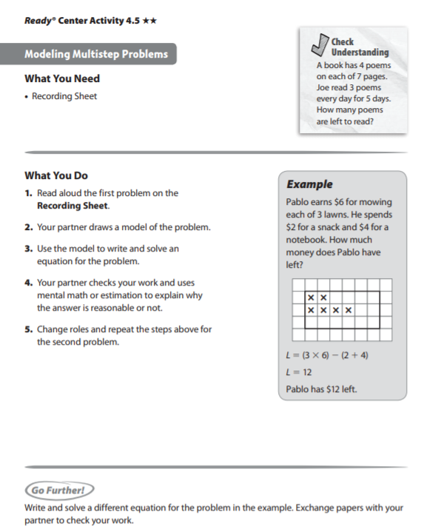

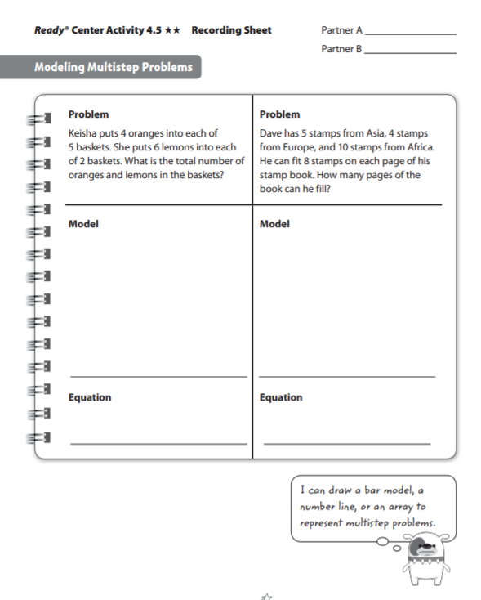

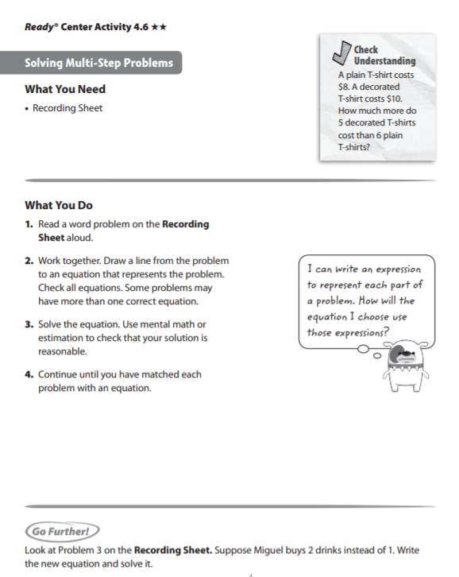

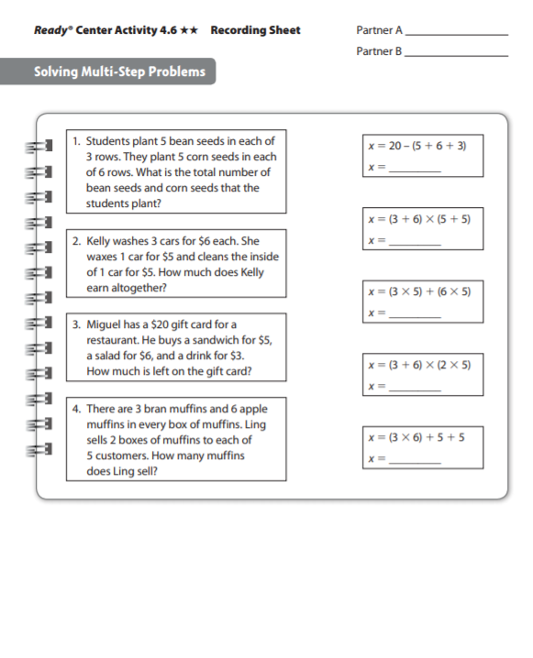

|  |  |
| --- | --- |
| **Week 4** | |
| **Fourth Grade Math Standards-Aligned Learning: Multi step Word Problems** | |
| **Grade Level Standard(s)** | 4.OA.A.3 Solve multi-step contextual problems posed with whole numbers and having whole-number answers using the four operations, including problems in which remainders must be interpreted. Represent these problems using equations with a letter standing for the unknown quantity. Assess the reasonableness of answers using mental computation and estimation strategies including rounding.  4.NBT.B.4 Fluently add and subtract within 1,000,000 using appropriate strategies and algorithms. |
| **Caregiver Support Option** | Students work by writing and solving equations for problems that  have more than two steps. Student write equations for multi-step  problems using letters to represent the unknown quantities. As with  all problem-solving, there may be more than one appropriate  approach.  Give students time to think through their answers. |
| **Materials Needed** | Recording sheet, pencil |
| **Question to Explore** | Are you limited to using the same letter when writing equations? No, you can choose any letter you want to help you remember what quantity it stands for. |
| **Student Directions** | Read the word problem carefully. Answer each question. |

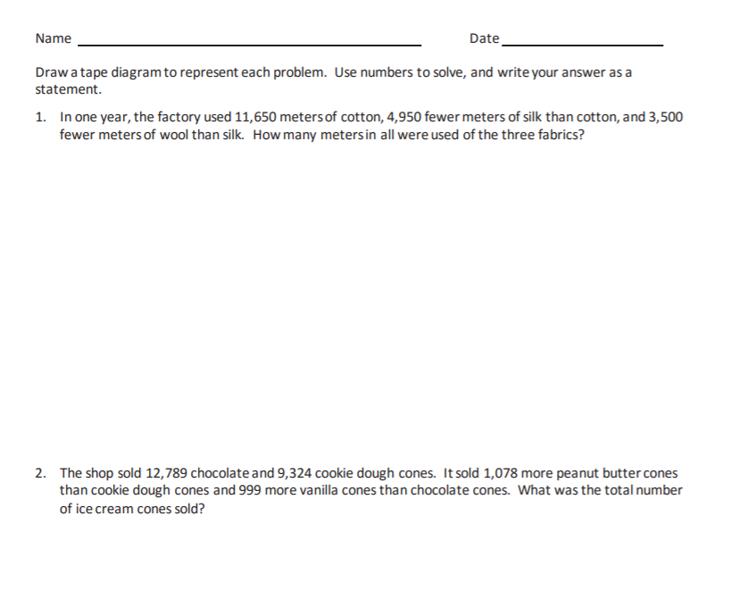

|  |  |
| --- | --- |
| **Week 5** | |
| **Fourth Grade Math Standards-Aligned Learning: Convert Table Measurements** | |
| **Grade Level Standard(s)** | 4.MD.A.1 Measure and estimate to determine relative sizes of measurement units within a single system of measurement involving length, liquid volume, and mass/weight of objects using customary and metric units.  4.MD.A.2 Solve one- or two-step real-world problems involving whole number measurements with all four operations within a single system of measurement including problems involving simple fractions. |
| **Caregiver Support Option** | Students use benchmark measures to estimate the number of  smaller unit; then they go on to express the relationship between  two measurement unit using multiplication. For example, an  object’s length in meters multiplied by 100 gives the length in  centimeters. Students use bar models, tables, and equations to  illustrate the multiplicative relationship and convert from the larger  unit to the smaller unit. |
| **Materials Needed** | Pencil, recording sheet, 6 game marker in one color, 6 game markers in a different color, game board |
| **Question to Explore** | How do you convert from a larger unit to a smaller unit? Multiply  the number of larger units by the number of smaller units in one  larger unit.  How can you calculate the number of ounces in one stick of  butter? There are 16 ounces in the entire box of butter, which is 4  sticks. Dividing 16 by 4 gives the number of ounces in one stick  of butter. Another method is to recognize that 4 pats of butter is  one ounce, and a stick of butter is 4 times as much, or 4 ounces. |
| **Student Directions** | Complete the table to show the measurement units are equivalent to the number of larger units.  Use the table to convert the measurement from the larger unit to the smaller unit. |

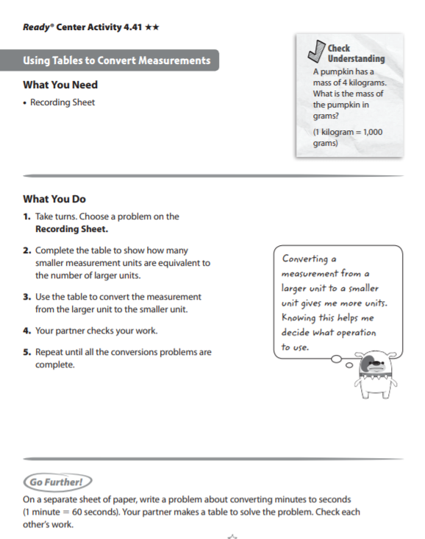

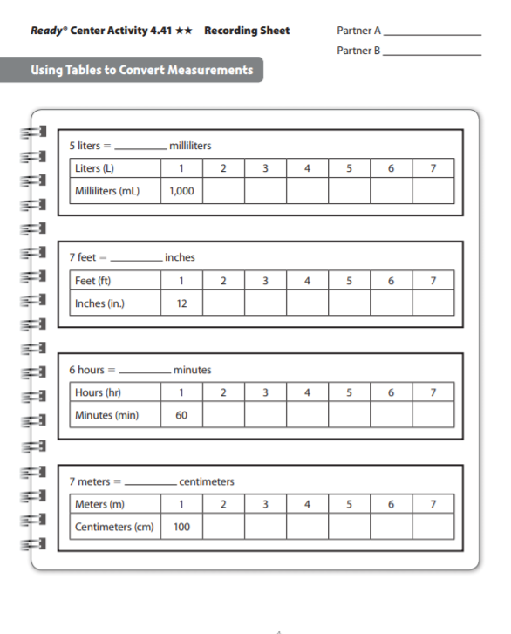

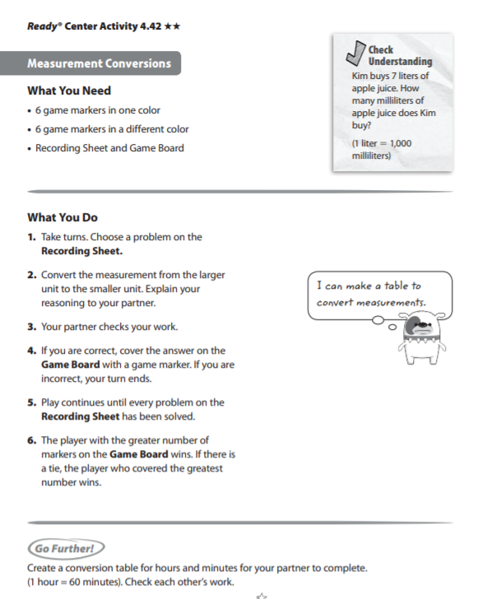

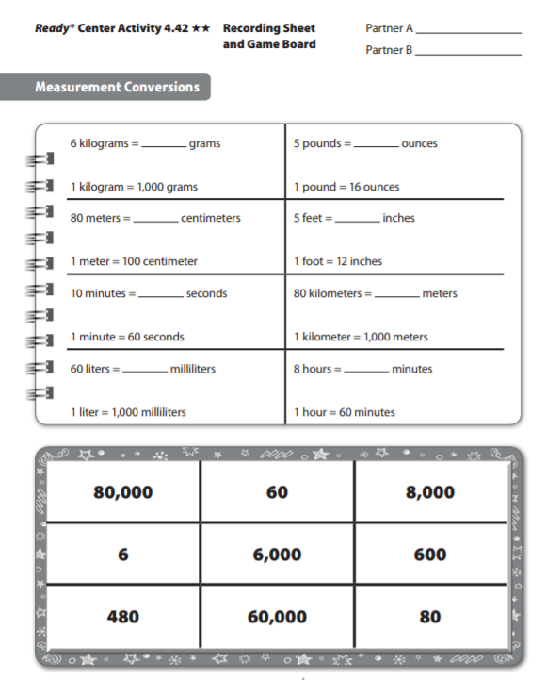

|  |  |
| --- | --- |
| **Week 6** | |
| **Fourth Grade Math Standards-Aligned Learning: Playing Basketball and Jack and the Beanstalk** | |
| **Grade Level Standard(s)** | 4.OA.A.1 Interpret a multiplication equation as a comparison (e.g., interpret 35 = 5 x 7 as a statement that 35 is 5 times as many as 7 and 7 times as many as 5). Represent verbal statements of multiplicative comparisons as multiplication equations.  4.OA.A.2 Multiply or divide to solve contextual problems involving multiplicative comparison, and distinguish multiplicative comparison from additive comparison. For example, school A has 300 students and school B has 600 students: to say that school B has two times as many students is an example of multiplicative comparison; to say that school B has 300 more students is an example of additive comparison. |
| **Caregiver Support Option** | Students are introduced to the concept of multiplicative comparison  when the product is unknown. Task: Playing Encourage students to  identify the patterns shown in the visual representation as they  describe their thinking to others. Encourage students to continually  reference the context when thinking through the problem and  explaining their thinking. |
| **Materials Needed** | Recording sheet, pencil |
| **Question to Explore** | Why can we write 4 x 2? (We can write this because he did 4 and  then 4 more.) What made you write 4 + 4 or 2 groups of 4? (Uncle  David made two times the number of shots that Gabe made.) How  can we write this as a multiplication equation? (2 x 4 or 4 x 2) |
| **Student Directions** | Read each problem below. Read each question and respond. Use the RDW process- Read the problem, Draw a model, Write an equation and a sentence. |

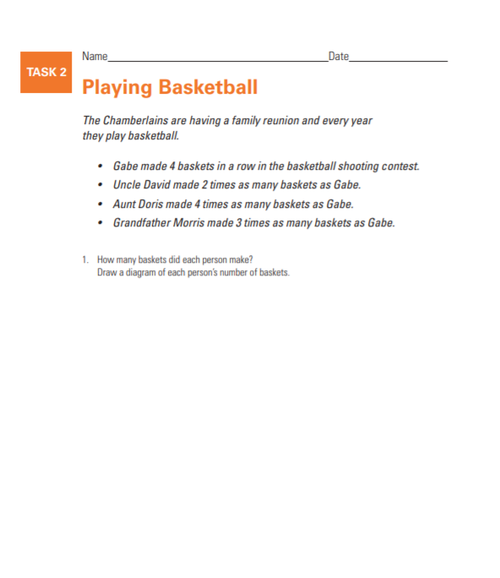

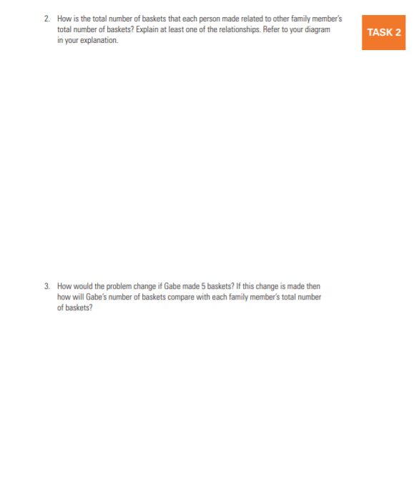

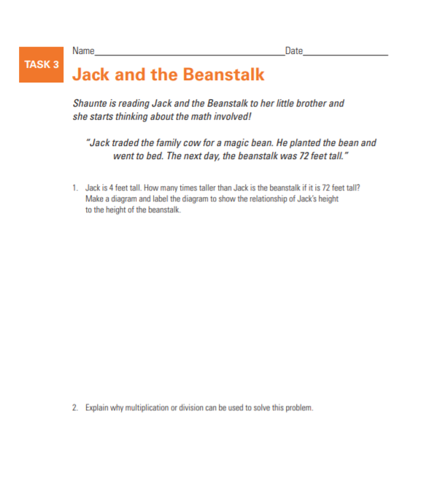

|  |  |
| --- | --- |
| **Week 7** | |
| **Fourth Grade Math Standards-Aligned Learning: Multiplication** | |
| **Grade Level Standard(s)** | 4.NBT.B.5 Multiply a whole number of up to four digits by a one-digit whole number and multiply two two-digit numbers, using strategies based on place value and the properties of operations. Illustrate and explain the calculation by using equations, rectangular arrays, and/or area models. |
| **Caregiver Support Option** | Student broadened their conceptual understanding of multiplication  to include the idea of multiplication as a comparison of two  numbers. Students use area models and partial products to multiply.  They apply their understanding of place value to multiply three- and  four-digit numbers by a one-digit number and to multiply a two- digit  number. |
| **Materials Needed** | Recording Sheet, game board, two different color game markers |
| **Question to Explore** | How can you relate partial products methods to the distributive  property? The partial products method is an example of the  distributive property. The distributive property states that you can  multiply a number and sum by multiplying the number by each  part of the sum and then adding these products. |
| **Student Directions** | Multiply. Tell what method you used. Have a partner check your work with a different method. |

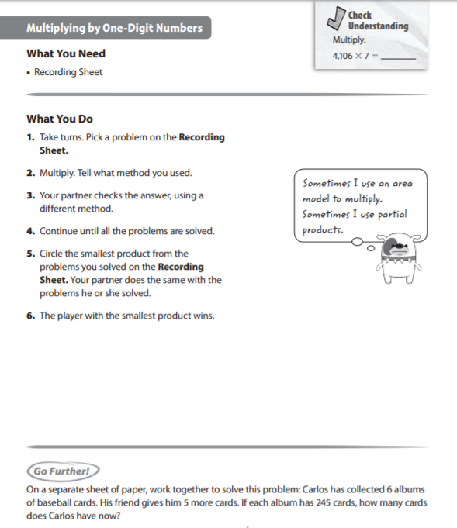

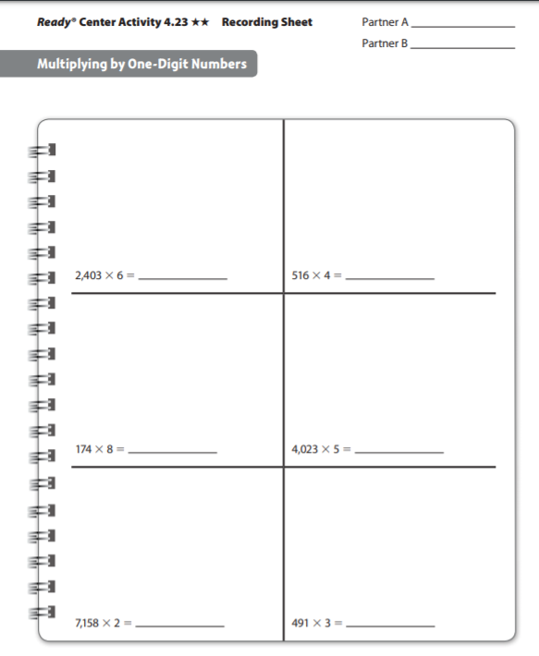

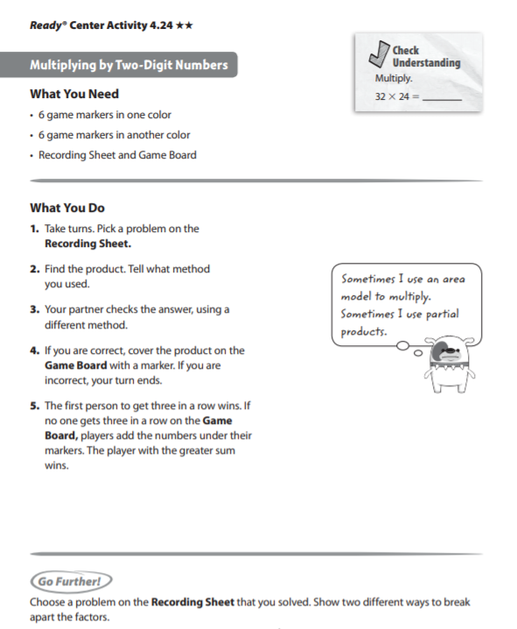

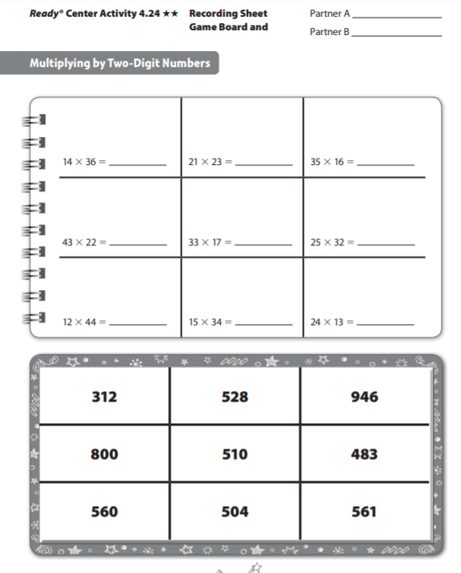

|  |  |
| --- | --- |
| **Week 8** | |
| **Fourth Grade Math Standards-Aligned Learning: Earning Money and Dividing by One-Digit Numbers** | |
| **Grade Level Standard(s)** | 4.OA.A.1 Interpret a multiplication equation as a comparison (e.g., interpret 35 = 5 x 7 as a statement that 35 is 5 times as many as 7 and 7 times as many as 5). Represent verbal statements of multiplicative comparisons as multiplication equations.  4.OA.A.2 Multiply or divide to solve contextual problems involving multiplicative comparison, and distinguish multiplicative comparison from additive comparison. For example, school A has 300 students and school B has 600 students: to say that school B has two times as many students is an example of multiplicative comparison; to say that school B has 300 more students is an example of additive comparison.  4.NBT.B.6 Find whole-number quotients and remainders with up to four-digit dividends and one-digit divisors, using strategies based on place value, the properties of operations, and/or the relationship between multiplication and division. Illustrate and explain the calculation by using equations, rectangular arrays, and/or area models. |
| **Caregiver Support Option** | Be sure to help students understand the parts of a division problem.  Use the following references so students can differentiate the  terminology:  Dividend ÷ divisor = quotient |
| **Materials Needed** | Recording sheet, 6 game markers in one color, 2 game markers in a different color, game board |
| **Question to Explore** | Why do you subtract partial products to divide? Students’  responses should mention that the goal is to find products that add  up to the dividend. After finding each product, subtract the  amount from the dividend to see if you can find another product.  You repeat this product until the difference is a number less that  the divisor. |
| **Student Directions** | Earning money all parts carefully. Answer each question. Use the  RDW process to solve the problems. Read the problem. Draw a  model. Write an equation and a sentence. |

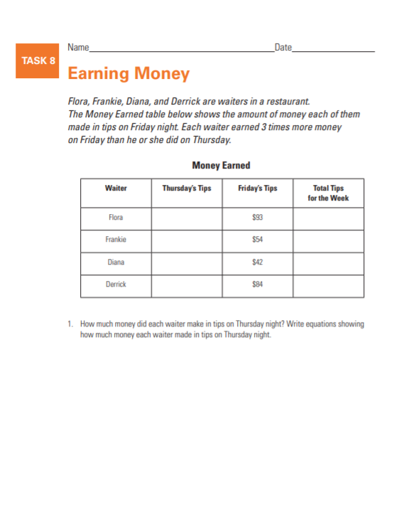

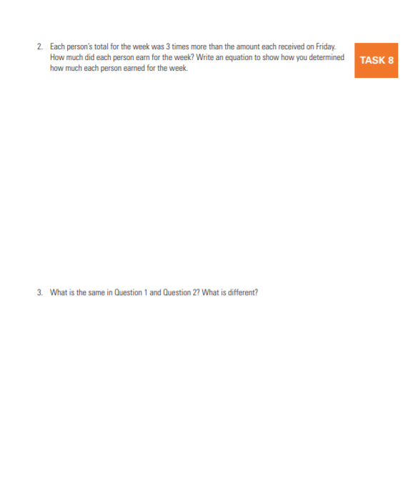

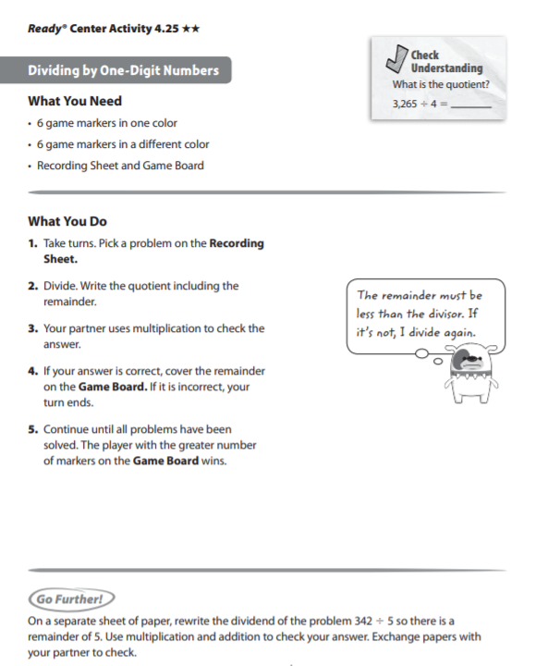

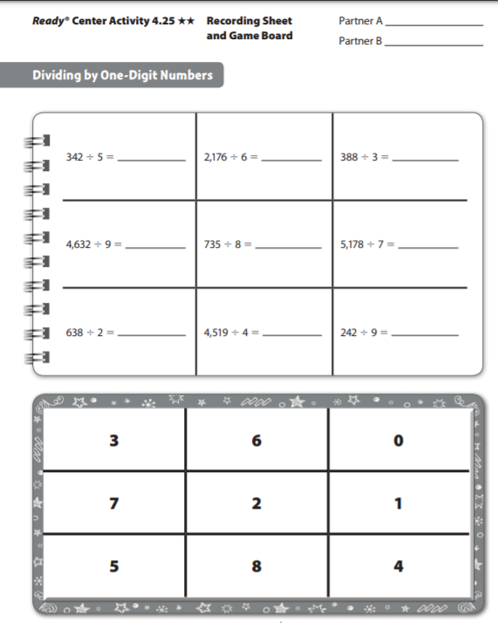

|  |  |
| --- | --- |
| **Week 9** | |
| **Fourth Grade Math Standards-Aligned Learning: Dividing by one-Digit Numbers** | |
| **Grade Level Standard(s)** | 4.NBT.B.6 Find whole-number quotients and remainders with up to four-digit dividends and one-digit divisors, using strategies based on place value, the properties of operations, and/or the relationship between multiplication and division. Illustrate and explain the calculation by using equations, rectangular arrays, and/or area models. |
| **Caregiver Support Option** | Students apply their knowledge of basic facts, along with place-  value understanding of properties of operations, to solve multi-digit  division problems. Students divide three- and four-digit number by  one-digit numbers. They are area models to divide, apply the idea of  subtracting partial products to divide, and learn how to find partial  quotients to divide. |
| **Materials Needed** | Recording Sheet, 6 game markers in one color, 2 game markers in a different color, game board |
| **Question to Explore** | Think of times when you need to use division in everyday life.  Cooking (splitting ingredients or cutting the recipe down in size),  sharing of distributing a number of objects to a number of people |
| **Student Directions** | Write the quotient including the remainder. Have a partner the  answers using multiplication. |

