Mathematics – Grade 3

Quarter 1

Remote Learning

Practice and Enrichment Packet



**Quarter 1 Third Grade Standards-Aligned Tasks**

Hello SCS Family,

This resource packet was designed to provide students with activities which can be completed at home independently or with the guidance and supervision of family members or other adults. The activities are aligned to the TN Academic Standards for Mathematics and will provide additional practice opportunities for students to develop and demonstrate their knowledge and understanding.

A suggested pacing guide is included; however, students can complete the activities in any order over the course of several days. Below is a table of contents which lists each activity.

**Pick and Match 2**

**Birthday Party Surprise 7**

**All about Rounding 9**

**Making Groups 13**

**Telling Time 15**

**Measurement 20**

**Revisiting Rounding 25**

**Adding and Subtracting 30**

**Multiplying and Dividing 35**

|  |  |
| --- | --- |
| **Week 1** | |
| **Third Grade Math Standards-Aligned Learning: Pick and Match** | |
| **Grade Level Standard(s)** | 3.OA.A.1 Interpret the factors and products in whole number multiplication equations (e.g., 4 x 7 is 4 groups of 7 objects with a total of 28 objects or 4 strings measuring 7 inches each with a total of 28 inches.)  3.OA.A.2 Interpret the dividend, divisor, and quotient in whole number division equations (e.g., 28 ÷ 7 can be interpreted as 28 objects divided into 7 equal groups with 4 objects in each group or 28 objects divided so there are 7 objects in each of the 4 equal groups). |
| **Caregiver Support Option** | Support is optional, but recommended for the following:  ● Reviewing activity and directions with your student.  ● Create a vocabulary booklet.  ● Engaging in discussions with the student around the vocabulary  words included in the activity (siblings and other members of the household can be engaged in the dialogue as well). |
| **Materials Needed** | Recording Sheet, pencil |
| **Question to Explore** | What are key vocabulary words that relate to multiplication? |
| **Student Directions** | Discover how math is useful in their own lives. Create a math vocabulary notebook/booklet. |

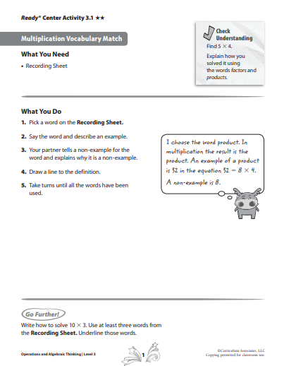

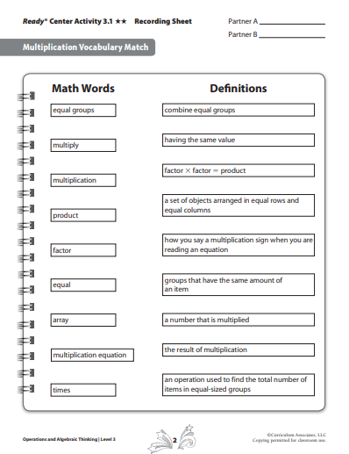

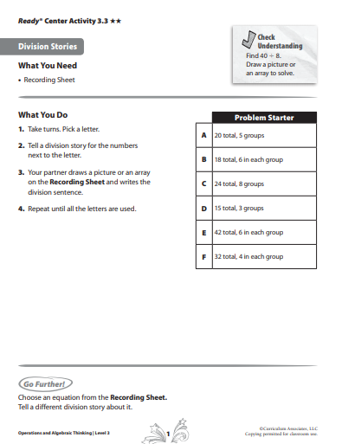

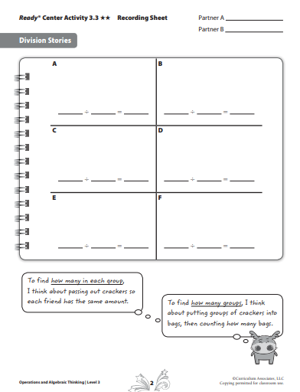

|  |  |
| --- | --- |
| **Week 2** | |
| **Third Grade Math Standards-Aligned Learning: Surprise Birthday Party** | |
| **Grade Level Standard(s)** | **3.OA.A.2** Interpret whole number quotients of whole numbers, e.g., interpret 56÷8 as the number of objects in each share when 56 objects are partitioned equally into 8 shares, or as a number of shares when 56 objects are partitioned into equal shares of 8 objects.  **3.OA.A.3** Use multiplication and division within 100 to solve word problems in situations involving equal groups, arrays, and measurement quantities, e.g., by using drawings and equations with a symbol for the unknown number to represent the problem.  **3.OA.A.4** Determine the unknown whole number in a multiplication or division equation relating three whole numbers. For example, determine the unknown number that makes the equation true in each of the equations 8 × ? = 48, 5 = _ ÷ 3, 6 × 6 = ?  **3.OA.B.6** Understand division as an unknown-factor problem. For example, find 32 ÷ 8 by finding the number that makes 32 when multiplied by 8. |
| **Caregiver Support Option** | Encourage students to use words and drawings to explain their  thoughts. Remind students about solving the problem for the  unknown. |
| **Materials Needed** | Recording Sheet, pencil |
| **Question to Explore** | How can you use division when solving problems? Division can be used to find how many equal groups (measurement-­‐repeated subtraction) or how many are in each group (partitive-­‐sharing).  What are division problems? Any division problem can be thought of as a multiplication fact with a missing factor |
| **Student Directions** | Discover how math is useful in their own lives. Plan a pizza party with four friends. Determine the amount of pizza that is needed if each person receive the same amount. |

**Recording Sheet**

**Task 1: Surprise Birthday Party**

Miranda’s parents bought 24 balloons for Miranda and some friends to share at her birthday party.

1. If she and 5 friends share the balloons, how many will each child receive? Write an equation and explain your reasoning.
2. Miranda decides instead to make bundles of 3 balloons to tie around the room. How many bundles would she be able to make?

**Task 2: Pin the Number on the Chart**

|  |  |  |  |
| --- | --- | --- | --- |
| **Item** | **Cost per Pack** | **Number of packs purchased** | **Total Cost** |
| Bowls | $4 |  |  |
| Cups | $3 |  | $9 |
| Napkins |  | 2 | $6 |

Miranda’s mother needs to get some supplies for the surprise birthday party for her daughter. Help her complete the supply list based on the information.

1. What is the cost of each pack of napkins if she spent $6 buying 2 packs of napkins? Solve by writing an equation with an unknown and fill in the chart.
2. If each pack of cups cost $3, how many packs can she buy with $9? Solve by writing an equation with an unknown and fill in the chart.
3. There are 6 bowls in one pack and 18 napkins in one pack. If Miranda’s mother has 2 packs of napkins, how many packs of bowls will she need to buy if she wants to have an equal amount of bowls and napkins? Solve by writing an equation with an unknown and fill in the chart.

|  |  |
| --- | --- |
| **Week 3** | |
| **Third Grade Math Standards-Aligned Learning: All About Rounding** | |
| **Grade Level Standard(s)** | 3.NBT.A.1 Round whole numbers to the nearest 10 or 100 using understanding of place value. |
| **Caregiver Support Option** | Read the questions with your child to ensure he/she understands  what is being asked. |
| **Materials Needed** | Recording sheet, pencil |
| **Question to Explore** | How is rounding to the nearest hundred different from rounding to the nearest ten?  Why is a vertical number line a good tool to use for rounding?  How does labeling the halfway point help you to round? |
| **Student Directions** | Discover how math is useful in their own lives. Create riddles about rounding and see if your friends can guess your number. |

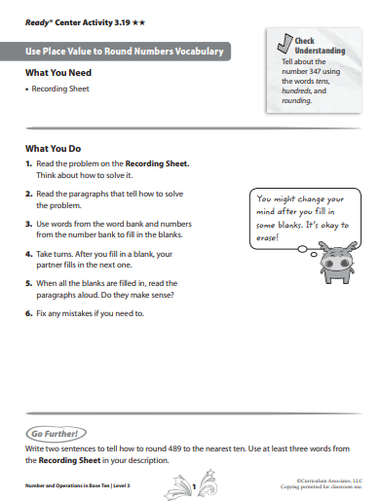

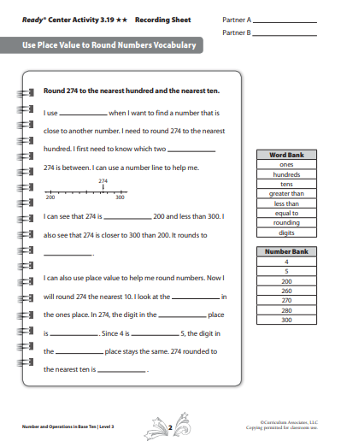

|  |
| --- |
| **Rounding to the Nearest Ten** |
| Round the following numbers to the closest 10. Draw a vertical number line to show your thinking. |
| 63 |
| 38 |
| 94 |
| 5 |
| 71 |
| 87 |
| 645 |

|  |  |
| --- | --- |
| **Week 4** | |
| **Third Grade Math Standards-Aligned Learning: Making Groups** | |
| **Grade Level Standard(s)** | 3. OA.A.1 Interpret products of whole numbers, e.g., interpret 5 × 7 as the total number of objects in 5 groups of 7 objects each. For example, describe a context in which a total number of objects can be expressed as 5 × 7.  3.OA.A.2 Interpret whole‐number quotients of whole numbers, e.g., interpret 56 ÷ 8 as the number of objects in each share when 56 objects are partitioned equally into 8 shares, or as a number of shares when 56 objects are partitioned into equal shares of 8 objects each. For example, describe a context in which a number of shares or a number of groups can be expressed as 56 ÷ 8.  3. OA.A.3 Use multiplication and division within 100 to solve word problems in situations involving equal groups, arrays, and measurement quantities, e.g., by using drawings and equations with a symbol for the unknown number to represent the problem.  3. OA.B.5 Apply properties of operations as strategies to multiply and divide. Example: If 6 × 4 = 24 is known, then 4 × 6 = 24 is also known. (Commutative property of multiplication.) 3 × 5 × 2 can be found by 3 × 5 = 15, then 15 × 2 = 30, or by 5 × 2 = 10, then 3 × 10 = 30. (Associative property of multiplication.) Knowing that 8 × 5 = 40 and 8 × 2 = 16, one can find 8 × 7 as 8 × (5 + 2) = (8 × 5) + (8 × 2) = 40 + 16 = 56. (Distributive property.)  3.OA.B.6 Understand division as an unknown‐factor problem. For example, find 32 ÷ 8 by finding the number that makes 32 when multiplied by 8. |
| **Caregiver Support Option** | Read the word problem and discuss what is being asked. Review the  completed work to ensure multiple ways to make equal groups are  included. Encourage the students to think and model their answers. |
| **Materials Needed** | Recording Sheet, pencil |
| **Question to Explore** | How can multiplication be used? |
| **Student Directions** | Create flashcards to help with building automaticity and fluency. Use a deck of cards to play Multiplication War with a partner. See page 40 for directions to play Multiplication War. |

**Task: Selling Vegetables**

Easton has been raising vegetables in his garden all summer. He plans to sell some of his vegetables at a local farmer’s market. He has selected 24 radishes, 30 onions, 16 heads of lettuce and 25 tomatoes to sell. He wants to display the radishes together, the onions together the lettuce together and the tomatoes together and to place them in sets with equal rows for each kind of vegetable. He plans to put each kind of vegetable in at least 2 rows. Show all the different ways that he can display equal rows for each kind of the vegetables at the market. Write an equation for each way you find.

**Task: Matthew’s Dilemma**

3rd Grade Matthew did not know the answer to 72 divided by 8. Are each of the following an appropriate way for Matthew to think about the problem? Explain why or why not by drawing a picture and writing an explanation for each one. 1) “I know 8 x 9 = 72, so 72 divided by 8 must be 9.” 2) “I know 8 x 10 = 80. If I take away a group of 8, that means I have 8 x 9 = 72. So 72 divided by 8 is 9.” 3) “I know that 8 x 5 = 40. 72 – 40 = 32. I know that 8 x 4 = 32. So if I add 8 x 5 and 8 x 4, I get 72. That means that 8 x 9 is 72 or 72 ÷ 8 = 9

|  |  |
| --- | --- |
| **Week 5** | |
| **Third Grade Math Standards-Aligned Learning: Telling Time** | |
| **Grade Level Standard(s)** | 3.MD.A.1. Tell and write time to the nearest minute and measure time intervals in minutes. Solve contextual problems involving addition and subtraction of time intervals in minutes. For example, students may use a number line to determine the difference between the start time and the end time of lunch. |
| **Caregiver Support Option** | Remind students that the two hands on the clock should distinguish  an hour hand (short- hand) and a minute hand (long- hand) when  telling time.  . |
| **Materials Needed** | Pencil, recording sheet |
| **Question to Explore** | Discuss what you understand about the hour hand.  Discuss what you understand about the minute hand.  What is the difference between am and pm? |
| **Student Directions** | **Time Match**  Choose a letter and read the time on the clock next to the letter in  the table.  Tell the time in another way using the word before or after.  Find the matching letter on the Recording Sheet and then draw the hour hand and minute hands on the clock to match the time read**.**  **Solving Time Word Problems**  Use the number line to help you solve your problems. |

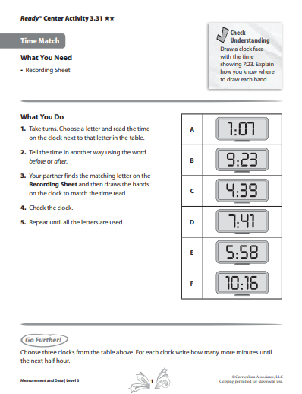

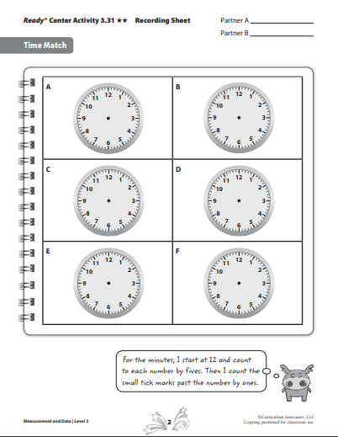

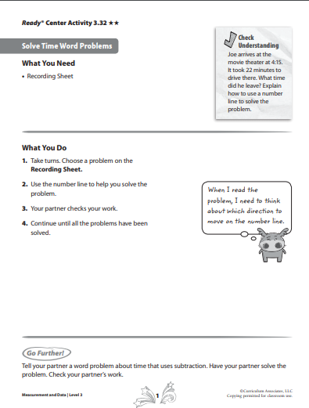

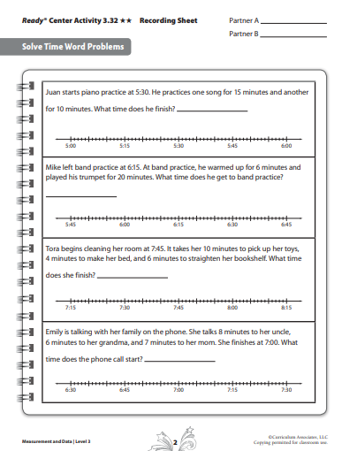

|  |  |
| --- | --- |
| **Week 6** | |
| **Third Grade Math Standards-Aligned Learning: Measurement** | |
| **Grade Level Standard(s)** | 3.MD.A.2 Measure the mass of objects and liquid volume using standard units of grams (g), kilograms (kg), milliliters (ml), and liters (l). Estimate the mass of objects and liquid volume using benchmarks. For example, a large paper clip is about one gram, so a box of about 100 large clips is about 100 grams. |
| **Caregiver Support Option** | Have a discussion with students using measurement vocabulary that  will be needed to understand liquid volume and mass of an  object. Encourage students to think of ways they could measure  liquid in an object and provide hands -on experiences with liquid  measurement tools and the process of measuring liquid volume. |
| **Materials Needed** | Recording sheet, pencil, number cubes |
| **Question to Explore** | How is measuring the amount of water in the buckets different  from measuring the length of a piece of wood? One is measuring  a liquid, the other is measuring a solid. How is it the same? You  need to keep track of the number of measured units (such as cups  or inches. You need to measure carefully. |
| **Student Directions** | **Measurement Vocabulary**  Use words and numbers from the word bank and the number bank to fill in the blanks.  When all the blanks are filled in, read the sentences. Do they make sense?  **Solve Measurement Problems**  Write an equation to solve the problem in the matching numbered space on the Recording Sheet**.** |

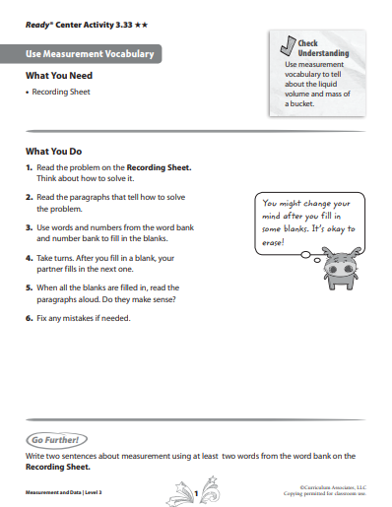

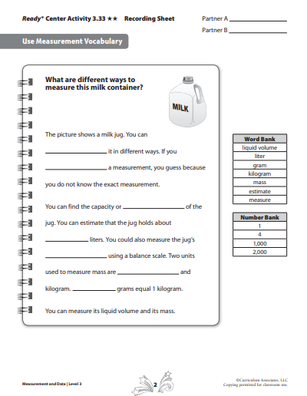

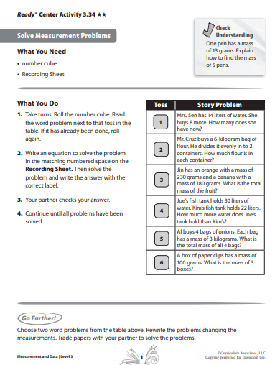

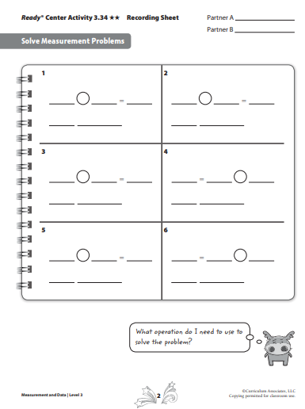

|  |  |
| --- | --- |
| **Week 7** | |
| **Third Grade Math Standards-Aligned Learning: Rounding** | |
| **Grade Level Standard(s)** | 3.NBT.A.1 Round whole numbers to the nearest 10 or 100 using understanding of place value. |
| **Caregiver Support Option** | In this lesson, students apply their place value knowledge to round  numbers to the nearest ten or hundred, Students can use a number  line or place value chart to round two digit numbers to the nearest  ten. They learn the rules for rounding, using the halfway number to  decide whether to round a number up or down. Students use similar  reasoning to round three- digit numbers to the nearest ten or  hundred.  . |
| **Materials Needed** | Recording Sheet, base ten blocks (optional) |
| **Question to Explore** | How can you use place value to determine what two hundreds  a three-digit number falls between? Given a number, students  should be able to place the digits into a place value chart and  identify the number of ones, tens and hundreds represented by  the digits. To determine the two hundred the number falls  between they should recognize the lesser hundred has the same  number of hundreds as the given number, but 0 tens and 0 ones.  The greater hundred is 100 more than the lesser hundred. |
| **Student Directions** | Round the number to the nearest ten.  Round the number to the nearest hundred. |

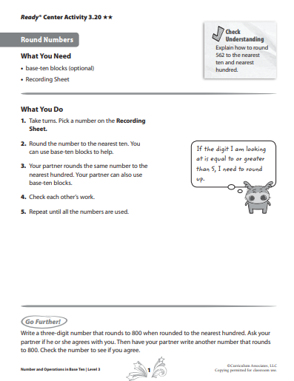

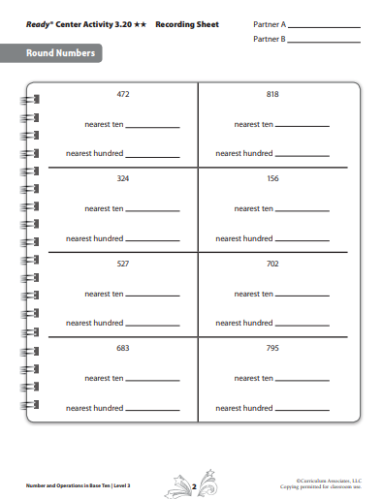

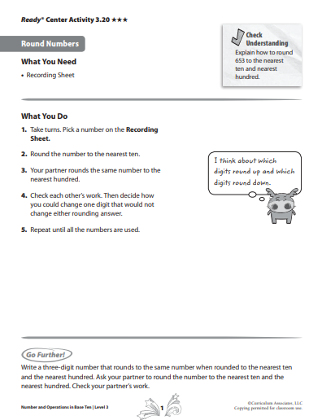

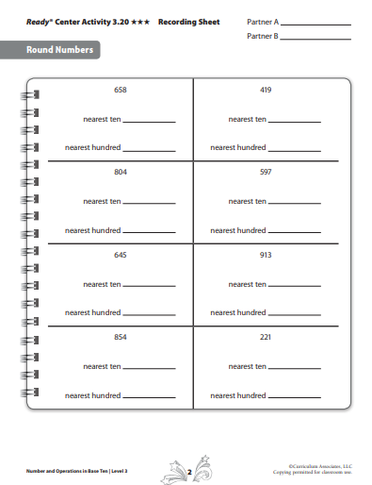

|  |  |
| --- | --- |
| **Week 8** | |
| **Third Grade Math Standards-Aligned Learning: Adding and Subtracting** | |
| **Grade Level Standard(s)** | 3.NBT.A.2 Fluently add and subtract within 1000 using strategies and algorithms based on place value, properties of operations, and/or the relationship between addition and subtraction. |
| **Caregiver Support Option** | This work is continued with the focus on achieving fluency with the  strategies students have learned. Students will break apart three-  digit numbers into hundreds, tens, and ones in order to add and  subtract. Students first used base ten blocks and then place value  understanding to add and subtract. When regrouping is required,  students show regrouped ones and tens as digits in the tens and  hundreds column in an addition problem. For subtraction, students  regroup and subtract hundreds, tens, and ones, combining the  differences to solve the problem. |
| **Materials Needed** | Recording Sheet, base ten blocks, number cube (1-6) |
| **Question to Explore** | Ask student to identify two situations with friends where they  needed to add three-digit numbers, Response might include  keeping score in a game or buying items in a store. |
| **Student Directions** | **Model Addition and Subtraction**  Take turns tossing a number cube to create 3-digit numbers. The two number created must a have sum of 999 or a difference of 111.  **Add and Subtract Numbers within 1000**  Choose a letter and sole the problem in the appropriate space. |

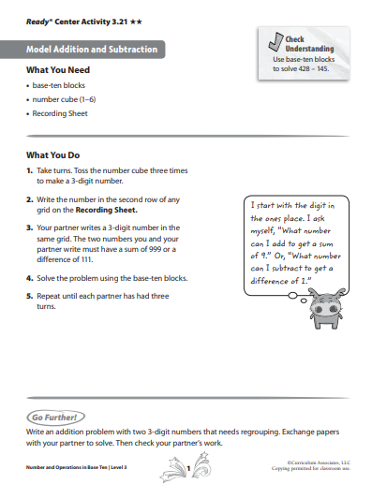

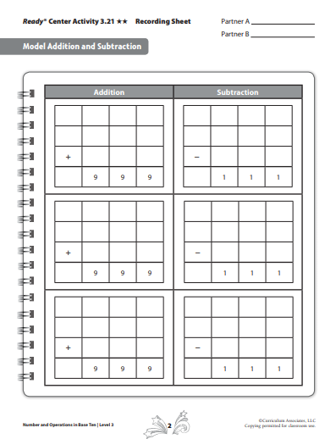

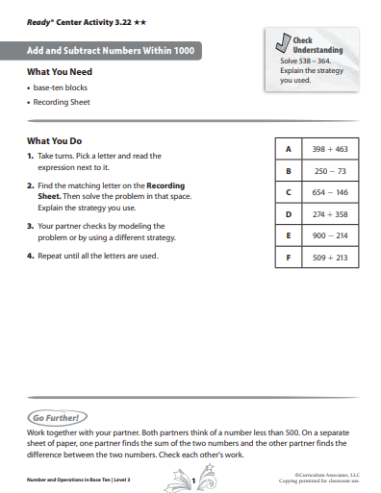

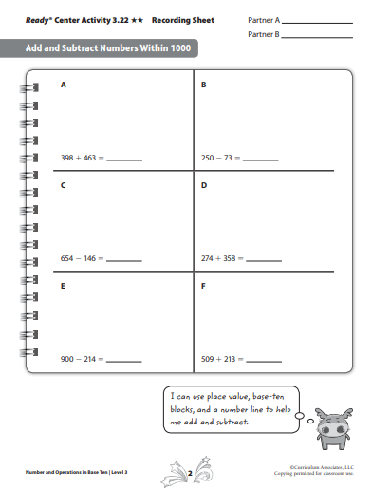

|  |  |
| --- | --- |
| **Week 9** | |
| **Third Grade Math Standards-Aligned Learning: Multiplying and Dividing** | |
| **Grade Level Standard(s)** | 3.OA.A.4 Determine the unknown whole number in a multiplication or division equation relating three whole numbers within 100. For example, determine the unknown number that makes the equation true in each of the equations: 8 x ? = 48, 5 = ? ÷ 3, 6 x 6 =?  3.OA.C.7 Fluently multiply and divide within 100, using strategies such as the relationship between multiplication and division (e.g., knowing that 8 x 5 = 40, one knows 40 ÷ 5 = 8) or properties of operations. By the end of 3rd grade, know from memory all products of two one-digit numbers and related division facts. |
| **Caregiver Support Option** | Students use fact families and multiplication tables to solve  multiplication and division problems and to write related  multiplication and division facts. Students learn how to use the rows  and columns in a multiplication table to find missing numbers in  multiplication and division facts. Students then apply that  understanding to finding the third number in fact families. |
| **Materials Needed** | Recording Sheet, Counters (optional), number cubes, game markers (two different colors), game board |
| **Question to Explore** | How can knowing a multiplication fact help you to find the missing  number in a division fact? The same three numbers are used in  related multiplication and division facts, so you look for the number  that is in the multiplication fact, but missing from the division fact.  Why is the total amount in different positions in the multiplication  and division equations? In multiplication, the total is the result of  combining equal groups. In division, you start with the total and  divide it into equal groups. |
| **Student Directions** | **Complete a Fact Family**- Choose fact families.  Complete the number sentences for that fact family using only the  two numbers given.  **Placing Missing Numbers**- Find all missing facts |

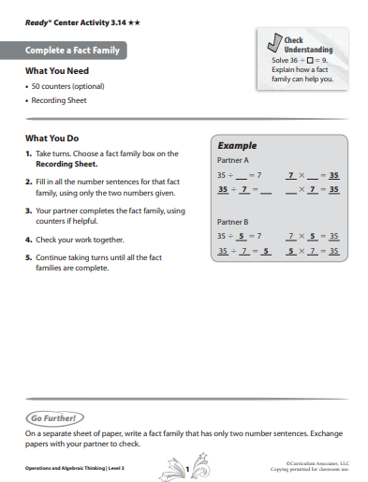

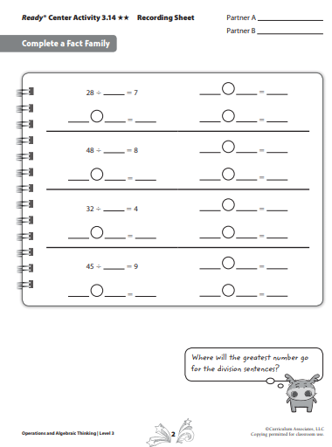

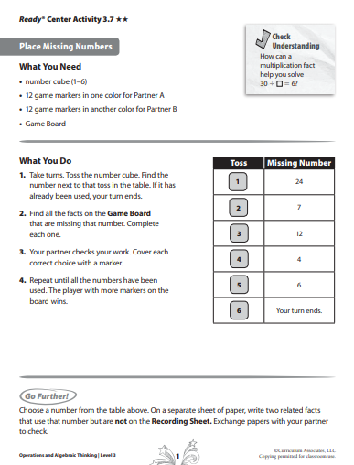

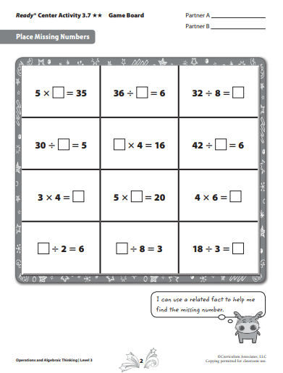

**Additional Resource:**

**Multiplication War Card Game:  How to Play**

1. **Remove the Jacks, Kings and Queens from a regular deck of cards.**
2. **Shuffle.**
3. **Players place cards face down in a pile.**
4. **At the count of three, both players flip over their first card.**
5. **The first person to say the product of the 2 cards receives both cards and puts them in a separate pile.**
6. **If both players say the answer at the same time, the cards are put in the middle of the table.**
7. **The next player to win the "flip" gets the cards in the middle of the table in addition to the cards just played.**
8. **The winner is the person with the most cards at the end of play.**