**Student Absence Form**

This document explains how to access student absence forms that are submitted via PowerSchool Parent portal.

1. From the **Start Page**, select **Data and Reporting, Reports** and then **Form Reports**.

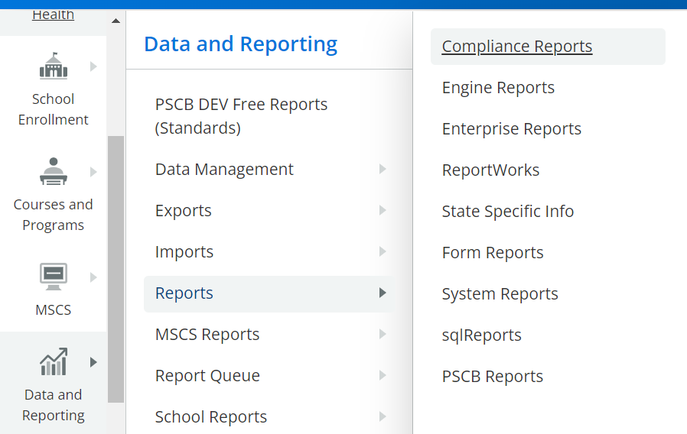

1. A screenshot of a web page

   Description automatically generatedOne the Response Reports tab, select **Student Absence Form**.

1. Click Generate Report to display any submitted forms.

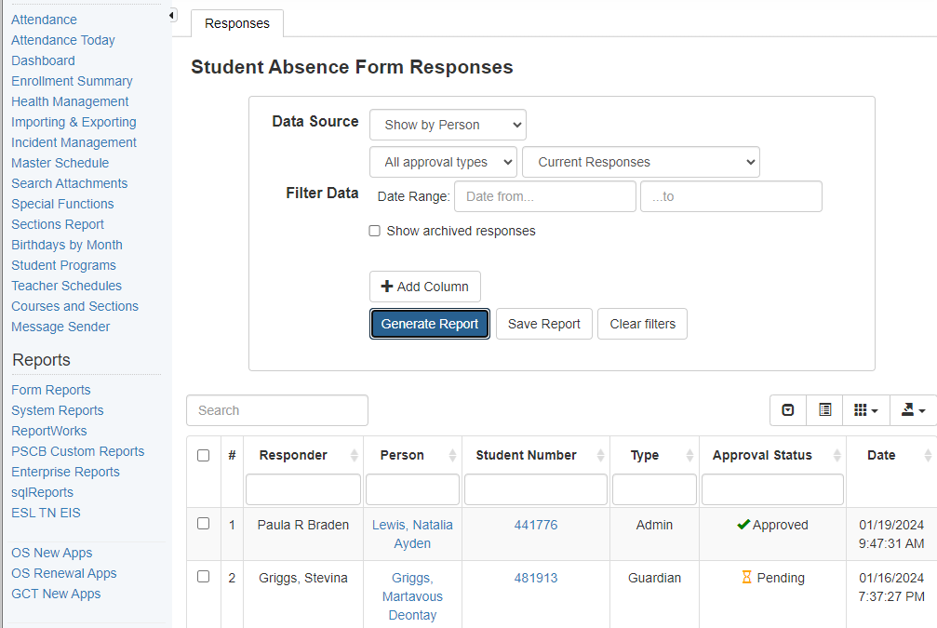

1. Click the student number to open the absence form. Click OK at the warning to approve/reject the absence form.

1. Select approve/reject based on the Reason for Absence in accordance with our District’s policy.

1. If approve is selected, you must enter the password “aes” to approve and proceed.

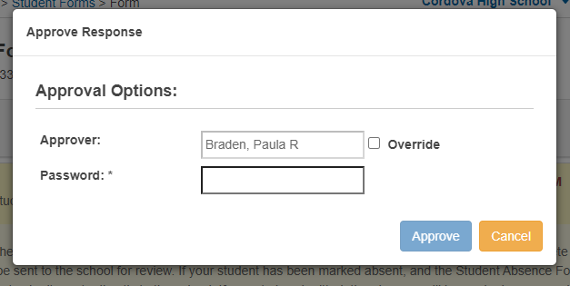

1. If reject is selected, you must enter the password “aes” and the reason before proceeding.

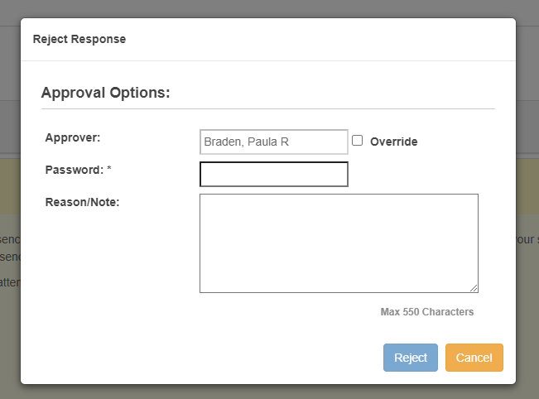

1. You can select desired students from the generated report to make Current Selection to update the daily attendance code.

